**Set Up Quota Limits On The User-**

**Name Quotas**

The name quota is a hard limit on the number of file and directory names in the tree rooted at that directory. File and directory creations fail if the quota would be exceeded. Quotas stick with renamed directories; the rename operation fails if operation would result in a quota violation. The attempt to set a quota will still succeed even if the directory would be in violation of the new quota. A newly created directory has no associated quota. The largest quota is Long.Max_Value. A quota of one forces a directory to remain empty. (Yes, a directory counts against its own quota!)

Quotas are persistent with the fsimage. When starting, if the fsimage is immediately in violation of a quota (perhaps the fsimage was surreptitiously modified), a warning is printed for each of such violations. Setting or removing a quota creates a journal entry.

**Space Quotas**

The space quota is a hard limit on the number of bytes used by files in the tree rooted at that directory. Block allocations fail if the quota would not allow a full block to be written. Each replica of a block counts against the quota. Quotas stick with renamed directories; the rename operation fails if the operation would result in a quota violation. A newly created directory has no associated quota. The largest quota is Long.Max_Value. A quota of zero still permits files to be created, but no blocks can be added to the files. Directories don’t use host file system space and don’t count against the space quota. The host file system space used to save the file meta data is not counted against the quota. Quotas are charged at the intended replication factor for the file; changing the replication factor for a file will credit or debit quotas.

Quotas are persistent with the fsimage. When starting, if the fsimage is immediately in violation of a quota (perhaps the fsimage was surreptitiously modified), a warning is printed for each of such violations. Setting or removing a quota creates a journal entry.

**Administrative Commands**

Quotas are managed by a set of commands available only to the administrator.

* hdfs dfsadmin -setQuota <N> <directory>...<directory>

Set the name quota to be N for each directory. Best effort for each directory, with faults reported if N is not a positive long integer, the directory does not exist or it is a file, or the directory would immediately exceed the new quota.

* hdfs dfsadmin -clrQuota <directory>...<directory>

Remove any name quota for each directory. Best effort for each directory, with faults reported if the directory does not exist or it is a file. It is not a fault if the directory has no quota.

* hdfs dfsadmin -setSpaceQuota <N> <directory>...<directory>

Set the space quota to be N bytes for each directory. This is a hard limit on total size of all the files under the directory tree. The space quota takes replication also into account, i.e. one GB of data with replication of 3 consumes 3GB of quota. N can also be specified with a binary prefix for convenience, for e.g. 50g for 50 gigabytes and 2t for 2 terabytes etc. Best effort for each directory, with faults reported if N is neither zero nor a positive integer, the directory does not exist or it is a file, or the directory would immediately exceed the new quota.

* hdfs dfsadmin -clrSpaceQuota <directory>...<directory>

Remove any space quota for each directory. Best effort for each directory, with faults reported if the directory does not exist or it is a file. It is not a fault if the directory has no quota.

**Reporting Command**

An an extension to the count command of the HDFS shell reports quota values and the current count of names and bytes in use.

* hadoop fs -count -q [-h] [-v] <directory>...<directory>

With the -q option, also report the name quota value set for each directory, the available name quota remaining, the space quota value set, and the available space quota remaining. If the directory does not have a quota set, the reported values are none and inf. The -h option shows sizes in human readable format. The -v option displays a header line.

# Commissioning and Decommissioning Nodes in a Hadoop Cluster

One of the most attractive features of Hadoop framework is its utilization of commodity hardware. However, this leads to frequent DataNode crashes in a Hadoop cluster. Another striking feature of Hadoop Framework is the ease of scale in accordance to the rapid growth in data volume. Because of these two reasons, one of the most common task of a Hadoop administrator is to commission (Add) and decommission (Remove) Data Nodes in a Hadoop Cluster.

## Commissioning and Decommissioning Nodes in a Hadoop Cluster:

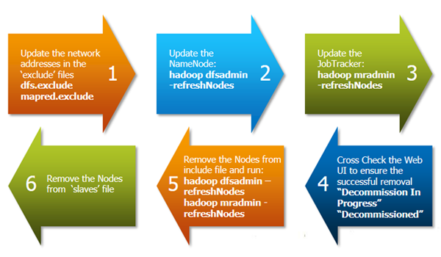

Above diagram shows a step by step process to decommission a DataNode in the cluster.

The first task is to update the ‘exclude‘ files for both HDFS (hdfs-site.xml) and MapReduce (mapred-site.xml).

The ‘exclude’ file:

* for jobtracker contains the list of hosts that should be excluded by the jobtracker. If the value is empty, no hosts are excluded.
* for Namenode contains a list of hosts that are not permitted to connect to the Namenode. Here is the sample configuration for the exclude file in hdfs-site.xml and mapred-site.xml:

**hdfs-site.xml**

<property>

<name>dfs.hosts.exclude</name>

<value>/home/hadoop/excludes</value>

<final>true</final>

</property>

**mapred-site.xml**

<property>

<name>mapred.hosts.exclude</name>

<value>/home/hadoop/excludes</value>

<final>true</final>

</property>

Note: The full pathname of the files must be specified.

**Practical portion is done in the projects as suggested by mentor.**