अभिज्ञान
A B H I J Ñ Ā N A
“Recognition of the Known”
National Registry & Verification System for Flagged Synthetic Media
A Provenance-Based Countermeasure to the Deepfake Crisis

Comprehensive System Design & Implementation Plan
Prepared for Law Enforcement & Government Agencies
Version 1.0 • Confidential Concept Document
July 2026

Table of Contents
1. Executive Summary 3
2. The Problem 3
2.1 The Failure of Detection-Only Approaches 3
2.2 What Is Actually Needed 3
3. Solution Overview 4
3.1 The Two Sides of the Platform 4
3.2 End-to-End Flow 4
4. System Architecture 5
4.1 Layer 1 — Ingestion & Pre-processing 5
4.2 Layer 2 — The Matching Engine (Core) 5
Fingerprint Extraction 5
Indexing & Search 5
4.3 Layer 3 — Robustness & Anti-Evasion 5
4.4 Layer 4 — Trust, Legal & Governance 6
4.5 Layer 5 — Public Interface & Distribution 6
4.6 Layer 6 — Administration & Federation 6
4.7 Layer 7 — Optional Language-Model Assistance 6
Where an SLM Adds Value 7
Where No Language Model Is Used — At Any Size 7
Why Small Serves This System 7
Architectural Stance 8
5. System Architecture Diagrams 9
5.1 The Layered Structure 9
5.2 End-to-End Matching Flow 9
5.3 Sub-Clip Localisation 10
6. Indicative Technology Stack 11
7. Phased Implementation Roadmap 11
8. Key Challenges & Mitigations 12
9. Naming: The Sanskrit Rationale 13
9.1 Recommended Names 13
9.2 Alternative Names 13
10. Conclusion 13

1. Executive Summary
Deepfakes and synthetic media have moved from novelty to national-security concern. Fabricated videos of public figures, forged evidence, non-consensual imagery, and manipulated statements now spread faster than any manual verification process can respond. Existing defences rely overwhelmingly on detection classifiers — machine-learning models that attempt to guess whether a video is fake. These systems are locked in a losing arms race: every improvement in detection is met by an improvement in generation, and their probabilistic verdicts are difficult to defend in a courtroom or a public dispute.
ABHIJÑĀNA takes a fundamentally different approach. It is not a detector — it is an authoritative registry and matching system. Verified authorities (law-enforcement bodies, designated government agencies, and accredited fact-checking units) formally mark a specific video as fake. That video is then fingerprinted and stored in a secure national registry. Any member of the public can subsequently submit a video and instantly learn whether it — or any segment within it — matches a record that has been officially flagged.
The Core Distinction
Detection systems answer: “Does this video look fake?” — a probabilistic guess.
ABHIJÑĀNA answers: “Has a competent authority already declared this exact footage to be fake?” — a verifiable fact.

The system’s defining technical capability is sub-clip localisation: even when a flagged clip has been trimmed, re-encoded, resized, or embedded inside a longer, unrelated video, ABHIJÑĀNA identifies the match and returns the exact timestamp range where the flagged content appears. This makes the system resilient to the most common evasion tactics and useful in real investigative and public-facing contexts.

2. The Problem

2.1 The Failure of Detection-Only Approaches
Purely algorithmic detection of synthetic media suffers from four structural weaknesses that limit its usefulness for government and legal applications:
- The arms race is unwinnable. Generative models improve continuously; a detector trained on today’s artefacts degrades against tomorrow’s outputs, requiring perpetual retraining.
- Verdicts are probabilistic, not authoritative. A model output of “87% likely fake” carries little evidentiary weight and is difficult to communicate to the public or defend under scrutiny.
- No accountability chain. A detector cannot explain who decided a video was fake, on what basis, or under whose authority.
- High-stakes error costs. False accusations against genuine footage — or false clearance of fabricated footage — both carry serious consequences when the output is treated as official.

2.2 What Is Actually Needed
Government agencies do not primarily need a machine’s opinion. They need an authoritative, auditable, rapidly queryable record of media that competent authorities have already investigated and formally declared to be fabricated — together with the technical means to recognise that media wherever it reappears, however it has been altered.

3. Solution Overview
ABHIJÑĀNA is a two-sided national platform built around a known-fake registry with sub-clip matching. It borrows its core technology from the content-identification systems that power large media platforms (the same family of perceptual-fingerprinting technology behind automated copyright matching and audio recognition), and applies it to the authenticated flagging of synthetic media.

3.1 The Two Sides of the Platform
 | Authority Side (Restricted) | Public Side (Open)
Who | Law enforcement, designated government agencies, accredited fact-checkers | Any citizen, journalist, platform, or institution
Primary action | Investigate and formally MARK a video as fake, with evidence and legal metadata | SUBMIT a video (file or URL) to CHECK it against the registry
Access control | Strong identity verification, role-based access, multi-factor authentication, full audit logging | Open access; optional lightweight rate-limiting to prevent abuse
Output | A signed, immutable registry record | A match / no-match result with timestamps and the official record

3.2 End-to-End Flow
- Flagging. An authorised agency uploads a confirmed fake video and attaches a case reference, the issuing authority, the reason for the determination, jurisdiction, and legal status.
- Fingerprinting. The system decomposes the video into short overlapping windows and computes a robust perceptual fingerprint for each, across both the visual and audio tracks.
- Indexing. Fingerprints are written to a similarity-search index and the record is cryptographically signed and committed to an append-only audit log.
- Querying. A member of the public submits a video. It is fingerprinted with the identical pipeline.
- Matching. The query fingerprints are searched against the index using a sliding window. Consecutive matching windows are stitched into a matched segment.
- Result. The user receives a clear verdict. If matched, the response includes the exact timestamp range within their video and the official record explaining the determination.

4. System Architecture
The platform is organised into seven logical layers, each independently scalable and separately secured. The first six form the operational core; the seventh is an optional assistance layer that sits deliberately outside the critical path.

4.1 Layer 1 — Ingestion & Pre-processing
All incoming media — whether an authority flagging a fake or a citizen submitting a query — passes through a common normalisation pipeline. Videos are decoded, standardised for frame rate and resolution sampling, split into keyframes and audio streams, and prepared for fingerprinting. Using one identical pipeline for both sides is essential: a query fingerprint can only match a registry fingerprint if both were produced the same way.

4.2 Layer 2 — The Matching Engine (Core)
This is the heart of the system and the source of its most important capability: finding a flagged clip inside a longer video and reporting where it occurs.

Fingerprint Extraction
- Windowing. Each video is divided into short overlapping segments (on the order of one to two seconds). A fingerprint is computed for every window rather than for the video as a whole, which is what makes sub-clip matching possible.
- Visual fingerprints. For representative keyframes, compact perceptual hashes (or learned visual embeddings) are computed. These are designed to remain stable under re-encoding, resolution changes, watermarks, and minor visual edits.
- Audio fingerprints. The audio track is fingerprinted independently. Audio fingerprinting is cheap, extremely robust, and often survives manipulations that defeat the video track — providing a powerful second channel.

Indexing & Search
- Vector index. Fingerprints are stored in an approximate-nearest-neighbour index engineered for fast similarity search across many millions of segments.
- Sliding-window search. An incoming video’s window fingerprints are matched against the index. Runs of consecutive matches are merged into a single matched segment, and the start and end timestamps within the query video are reported.
Why This Design Meets Every Requirement
- Trimmed clips match because fingerprints are per-window, not per-whole-video.
- Embedded clips (a fake inside a longer video) are located, with exact timestamps, by the sliding-window search.
- Re-encoded / resized clips match because the perceptual fingerprints are transformation-tolerant.
- Audio-only survivors are still caught through the independent audio channel.

4.3 Layer 3 — Robustness & Anti-Evasion
Adversaries will deliberately alter flagged videos to defeat matching. This layer is the system’s defensive moat.
- Transformation-invariant fingerprints tuned to survive cropping, flipping, speed changes, colour shifts, overlaid captions, and picture-in-picture framing.
- Multi-modal fusion: if the video track is manipulated beyond recognition but the audio still matches (or the reverse), the system still raises a flag.
- Tiered thresholds: beyond a confident automatic match, a “possible match” band routes borderline cases to human review rather than forcing a binary answer.

4.4 Layer 4 — Trust, Legal & Governance
Because a government-operated “mark this as fake” capability carries obvious potential for misuse, the integrity layer is not optional — it is central to the system’s legitimacy.
- Immutable audit trail. Every flagging action is recorded in an append-only, tamper-evident log, optionally anchored using a Merkle-tree structure so the integrity of records can be independently verified.
- Chain of custody. Each record captures who flagged the video, under what authority, on what date, and on what evidentiary basis.
- Cryptographic signing. Every verdict is digitally signed by the issuing authority, so results cannot be forged or altered downstream.
- Dispute & appeal mechanism. A formal channel to contest a “fake” designation — indispensable for correcting errors and protecting legitimate expression.
- Privacy & retention. Sensitive media is handled under a defined retention policy aligned with India’s Digital Personal Data Protection Act, 2023.

4.5 Layer 5 — Public Interface & Distribution
The registry is only useful if it is easy to query at the moment of doubt. ABHIJÑĀNA meets users where the content is:
- Web portal and mobile application for direct file or URL checks.
- Browser extension to verify a video in place on a social-media feed.
- Public API so news organisations and platforms can automatically screen content against the registry at scale.
- Shareable verification results (via link or QR code) so an official “flagged as fake” finding can be circulated to counter a viral video.

4.6 Layer 6 — Administration & Federation
A management layer governs agency onboarding, role assignment, inter-agency coordination, and system monitoring. Over time this enables a federated model in which multiple state and national bodies contribute to and draw upon a shared registry under common governance rules.

4.7 Layer 7 — Optional Language-Model Assistance
The core of ABHIJÑĀNA performs no language processing whatsoever. Fingerprinting, indexing, sliding-window search, and timestamp localisation are signal-processing and vector-search operations; they are deterministic, auditable, and cheap by design. Introducing a language model into that path would add cost, latency, and failure modes while weakening the legal defensibility of the verdict. The core engine is therefore, and must remain, model-free.
A small language model (SLM) — a compact, low-powered model in roughly the one-to-eight-billion-parameter range — nonetheless earns a place at the edges of the system, as an optional assistance layer that never touches the matching path. Its defining constraint is simple:
The Governing Principle
A small language model may describe, translate, draft, and route — but it must never decide. The match verdict, the “fake” determination, and every audit-log entry remain outside its reach.

Where an SLM Adds Value
Use Case | Role of the SLM
Metadata assistance | Drafts the case summary, suggests a category or tags, and normalises the free-text “reason” field into consistent language when an authority flags a video.
Public-facing explanation | Renders a raw match result into a plain-language sentence a citizen can understand — a description of the official record, never a verdict of its own.
Multilingual output | Delivers results and notices in Hindi, Bengali, Tamil, and other Indian languages from a single compact multilingual model.
Registry search & triage | Converts an administrator’s natural-language request (“show flagged political videos from last month”) into a structured query over the case database.
Duplicate-report clustering | Groups many citizen submissions that describe the same underlying fake, using embeddings and lightweight classification.
Dispute intake | Structures a free-text appeal into fields ready for human review.

Where No Language Model Is Used — At Any Size
- The match verdict. Match or no-match is decided solely by the fingerprint engine and must stay deterministic for evidentiary integrity.
- The “is this fake” determination. By design a human authority decides; no model may infer or override that judgement.
- Audit-log entries. These are exact and machine-generated, never paraphrased by a model.

Why Small Serves This System
Because the users are government agencies, a compact model unlocks deployment properties that a large hosted model cannot offer:
- On-premise and air-gapped hosting. A model of this size can run inside government infrastructure — or on modest local hardware — with no sensitive metadata leaving the perimeter, an often non-negotiable requirement for law enforcement.
- Data sovereignty. Everything stays within controlled infrastructure, aligning with the Digital Personal Data Protection Act, 2023.
- Cost at public scale. The public “check” side may see very high volume; keeping the language layer tiny or absent holds per-query cost near zero.
- Domain fine-tuning. A small model can be cheaply fine-tuned on the system’s own case categories, legal phrasing, and Indian-language needs.

Architectural Stance
The assistance layer is designed as an optional, pluggable module that sits beside the pipeline, never inside it. The system remains fully functional with the model switched off, falling back to templates and manual entry. A clean interface allows the model to be swapped — or later upgraded to a larger one — without touching the engine. Any model-generated text shown to the public is always presented as a description of an authoritative record, not as the determination itself. Given the sovereignty and privacy constraints, open-weight, self-hostable models with strong Indic-language coverage should be preferred over hosted APIs, with the specific model chosen through a short evaluation rather than fixed in advance, since the landscape evolves quickly.

5. System Architecture Diagrams
The three diagrams in this section render the architecture visually: the layered structure of the platform, the end-to-end flow that connects the two sides through a shared registry, and the sub-clip localisation capability that defines the system.

5.1 The Layered Structure
The platform’s six operational layers form a single deterministic pipeline. The optional language-model layer is drawn deliberately to one side, connected only by “assists” links — a visual statement of the governing principle that it supports the system without ever sitting on the path that produces a verdict.
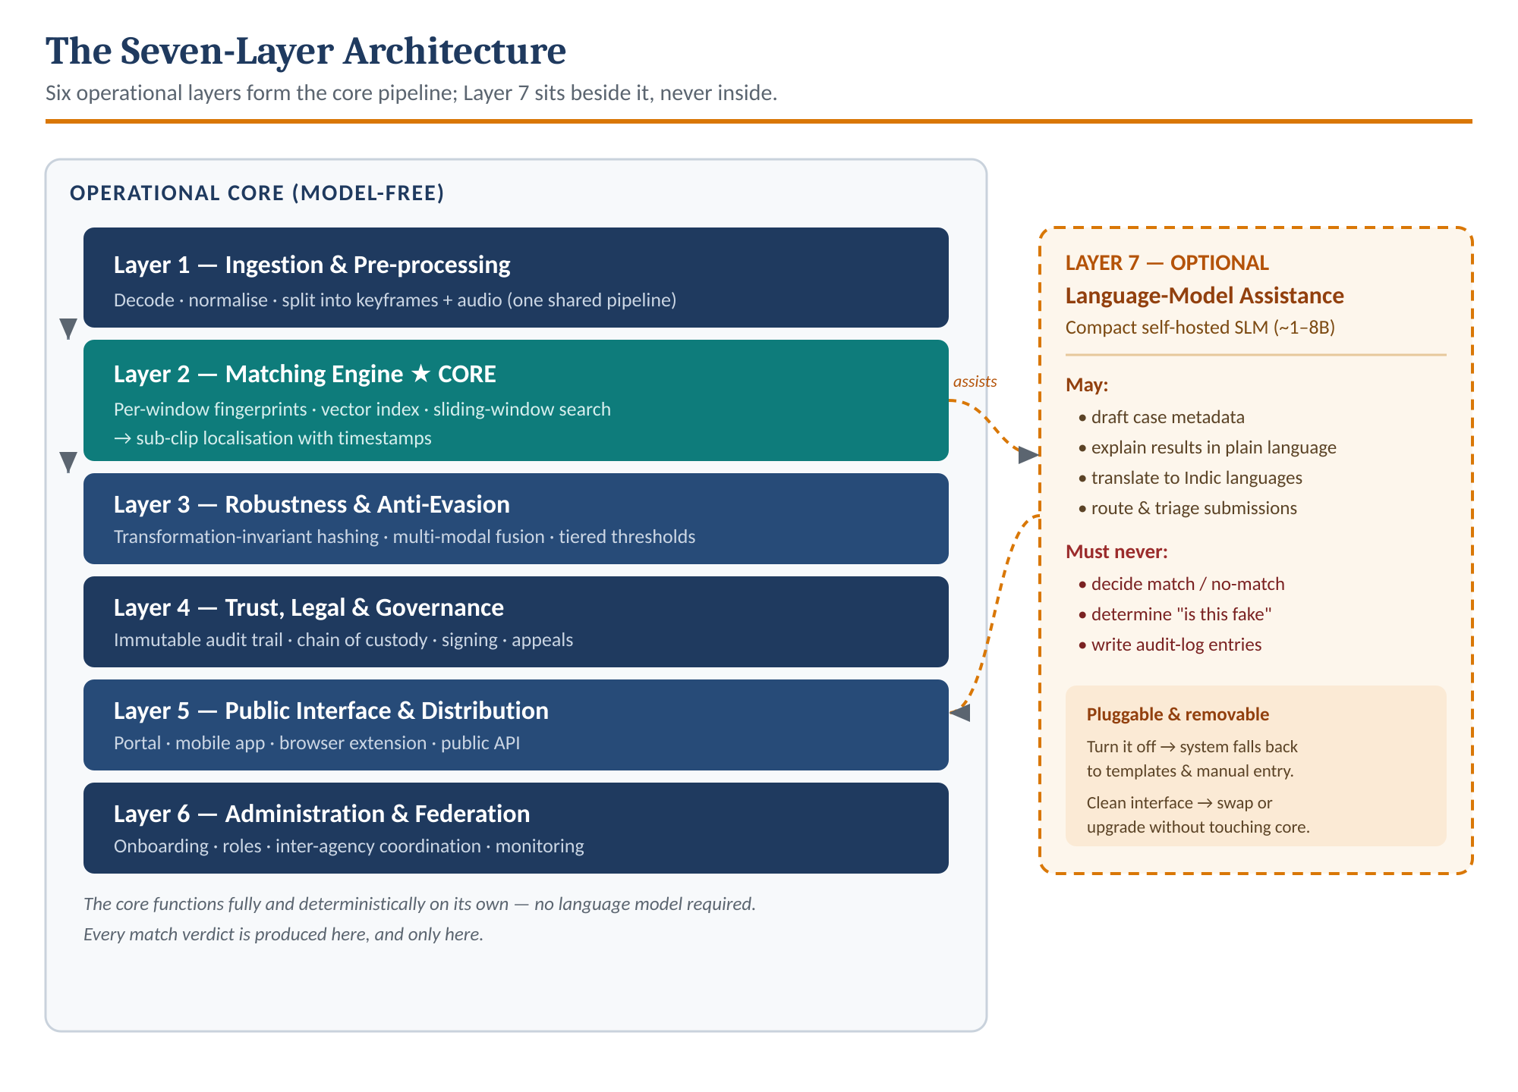
Figure 1 — The seven-layer architecture. The model-free operational core produces every match verdict; Layer 7 assists from beside the pipeline and can be removed without affecting it.

5.2 End-to-End Matching Flow
The authority side and the public side never share credentials or interfaces, but they converge on one secure registry built through an identical fingerprinting pipeline. Authorities write signed records into the registry; the public reads against it and receives a plain, timestamped result.
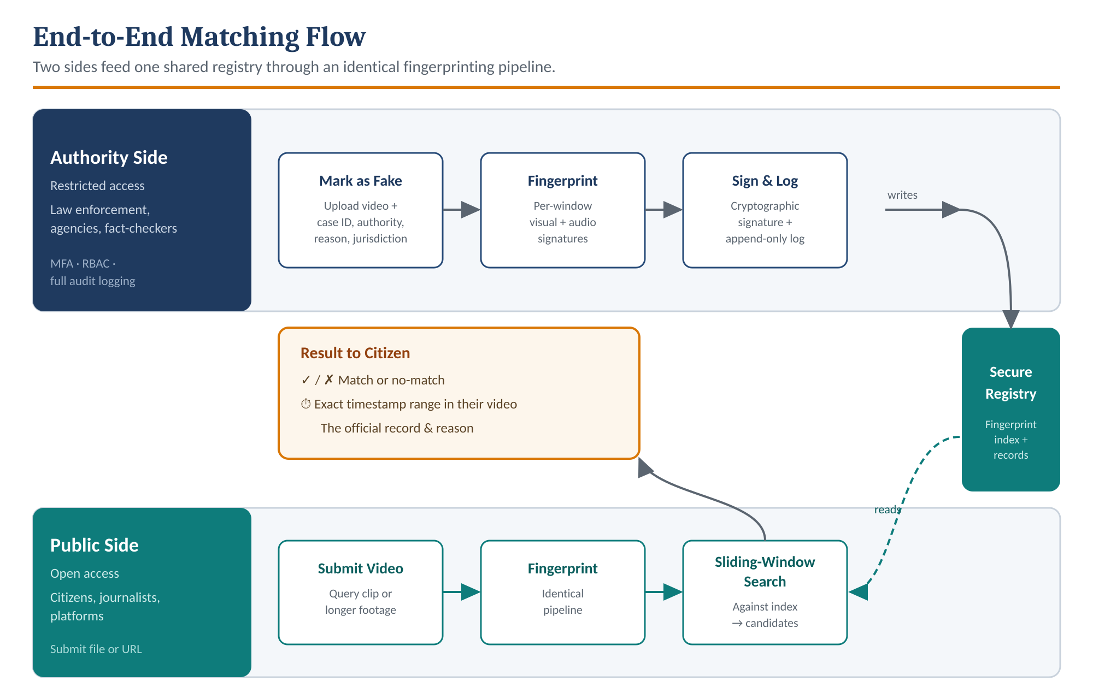
Figure 2 — End-to-end flow. Authorities flag, fingerprint, sign, and log; citizens submit, fingerprint, and search; the registry sits between them and every public result points back to an official record.

5.3 Sub-Clip Localisation
This is the capability that separates ABHIJÑĀNA from a simple file-blocklist. Because every video is stored as per-window fingerprints rather than a single whole-video hash, a flagged clip can be recognised even after it has been trimmed, re-encoded, and dropped into the middle of a long, otherwise-innocent video — and the system reports the exact timestamp range where it appears.
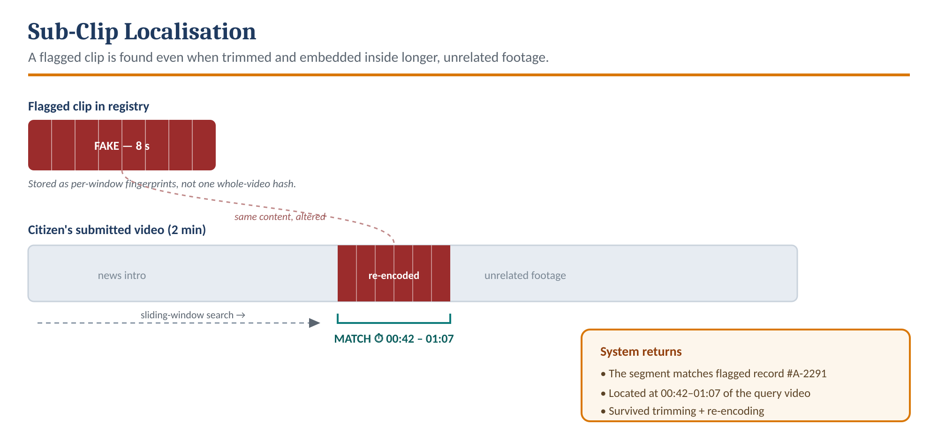
Figure 3 — Sub-clip localisation. An eight-second flagged clip, re-encoded and embedded inside a two-minute video, is located by sliding-window search and returned with its precise in-video timestamps.

6. Indicative Technology Stack
The following components are indicative; final selection should follow a formal evaluation. The architecture is deliberately technology-agnostic so individual components can be substituted without redesigning the system.
Layer | Function | Indicative Options
Video processing | Decoding, frame sampling, audio extraction | FFmpeg, OpenCV
Visual fingerprinting | Transformation-tolerant frame signatures | Perceptual hashing (pHash / dHash) or learned video embeddings
Audio fingerprinting | Robust audio signatures | Chromaprint-style acoustic fingerprinting
Similarity search | Fast nearest-neighbour matching at scale | FAISS, Milvus, or ScaNN
Backend services | Ingestion, matching, API orchestration | Python (FastAPI) or Go for the matching service
Metadata store | Records, cases, verdicts, users | PostgreSQL
Media storage | Secure storage of flagged videos | S3-compatible object storage
Language assistance (optional) | Metadata drafting, plain-language & multilingual output, triage — never on the critical path | Compact open-weight SLM (~1–8B), self-hosted, with Indic-language support
Integrity layer | Tamper-evident audit trail | Append-only log with Merkle anchoring
Frontend | Public portal & admin console | React (web); React Native or Flutter (mobile)
Identity & access | Authentication and authorisation | OAuth2 / OIDC, role-based access control, MFA

7. Phased Implementation Roadmap
Delivery is structured so that a useful system reaches authorities early, with sophistication layered on in deliberate stages.
Phase | Theme | Scope & Outcome
Phase 1 | Minimum Viable Platform | Authority upload and fake-marking workflow; exact and near-duplicate whole-video matching; public check portal. Establishes the core loop end to end.
Phase 2 | Sub-clip Localisation | Sliding-window fingerprint matching with timestamp reporting; independent audio fingerprinting. Delivers the signature “find the clip inside a longer video” capability.
Phase 3 | Robustness Hardening | Transformation-invariant fingerprints, adversarial-evasion resistance, and multi-modal fusion. Turns the system into a durable defence.
Phase 4 | Ecosystem & Trust | Public API, browser extension, platform integrations, cryptographic verifiability, and the formal dispute/appeal mechanism.
Phase 5 | Scale & Federation | Multi-agency federation, inter-state and national coordination, and formal integration with legal and evidentiary processes.

8. Key Challenges & Mitigations
Challenge | Description | Mitigation
Adversarial evasion | Deliberate alteration of flagged videos to defeat matching. | Transformation-invariant fingerprints and multi-modal fusion (Layer 3) form the core defensive moat.
False positives | A legitimate video that lawfully contains the flagged footage — e.g. a news report about the deepfake that shows it. | Context flags and result nuance rather than blunt blocking; the result explains the match instead of condemning the container.
Scale | Fingerprint indices grow rapidly and search must stay fast. | Sharding and efficient approximate-nearest-neighbour search designed in from the outset.
Coverage limits | The registry catches known fakes, not novel ones. | This is by design; expectations are set accordingly, and rapid authority onboarding maximises coverage.
Governance & misuse | A state “mark as fake” power can be abused. | Immutable audit trails, cryptographic signing, and a formal appeal mechanism (Layer 4) keep the power accountable.

9. Naming: The Sanskrit Rationale
The recommended name for the system is ABHIJÑĀNA (अभिज्ञान). In Sanskrit, abhijñāna means recognition, identification, or a token of proof by which something is known again. It is the very act the system performs — recognising previously identified footage wherever it reappears — and it carries a dignified, authoritative resonance well suited to a national institution. The term is culturally resonant: it is the root of the classical title Abhijñānaśākuntalam, where recognition through a token drives the entire narrative.

9.1 Recommended Names
Name | Devanagari | Meaning & Fit
ABHIJÑĀNA | अभिज्ञान | Recognition; a token of proof. Precisely captures the matching function. (Primary recommendation.)
SATYANVESHAK | सत्यान्वेषक | “Seeker of Truth.” Investigative and active — strong fit for a law-enforcement tool.
SATYAPRAMANA | सत्यप्रमाण | “Proof of Truth.” Pramana is the classical concept of valid evidence — authoritative and apt.
PRATYAYA | प्रत्यय | “Conviction, certainty, verification.” Short, clean, and highly brandable.

9.2 Alternative Names
Name |  | Devanagari | Meaning & Fit
VIVEKA |  | विवेक | “Discernment” — the faculty of distinguishing the real from the false. Philosophically ideal.
SATYADRISHTI |  | सत्यदृष्टि | “Vision of Truth.” Evokes seeing through deception.
SATYAMUDRA |  | सत्यमुद्रा | “Seal of Truth.” Mudra = seal/stamp — fits the certified-verdict concept.
SATYASHODHAK |  | सत्यशोधक | “Truth-investigator.” Carries historical civic resonance.
NETRA |  | नेत्र | “Eye.” Short and memorable; adapts well to an official acronym.
Recommendation
Adopt ABHIJÑĀNA as the system name — it names the exact function (recognising known content) with cultural depth and institutional gravity. If a more overtly investigative identity is preferred for the law-enforcement audience, SATYANVESHAK is the strongest alternative; PRATYAYA is the best choice where a short, modern, brandable name is the priority.

10. Conclusion
ABHIJÑĀNA reframes the deepfake problem from an unwinnable detection contest into a tractable provenance and recognition problem. By grounding every verdict in the decision of a competent authority, preserving a tamper-evident chain of accountability, and matching flagged content wherever and however it reappears — down to the exact timestamp inside a longer video — the system offers something detection alone cannot: results that are authoritative, auditable, and defensible.
It will not catch every novel fabrication, and it is not intended to. Its purpose is to ensure that once a piece of synthetic media has been investigated and formally declared fake, that determination can never be quietly outrun by a trim, a re-encode, or a splice into other footage. In an information environment where a fabricated video can reach millions before the truth is dressed, a fast, authoritative, and honest system of recognition is a foundation worth building.

अभिज्ञान — Recognition of the Known

