Beyond Interoperability: Hands-On Federated ML for Research Data Curation Infrastructure
Technical Companion: Conformal Prediction for Site-Level Heterogeneity
in Federated Clinical Data
A technical report and workshop companion for the fedconformal-clinical toolkit
UCI Heart Disease federation · 4 hospitals · 920 patients
Arnab Mukherjee
Oklahoma State University — Center for Health Science, Tulsa
[Workshop / venue name and date — add here]

Abstract
Interoperability—the ability of systems to securely exchange, interpret, and use data without human intervention—has become a foundation of modern research data curation infrastructure. Yet interoperability alone does not establish whether data from different sites encode equivalent underlying phenomena. When clinical data exhibits a distributional shift across institutions, models trained at one site may fail silently at another. Confident but wrong is the worst possible failure mode, particularly when models are deployed across organizations. This is the foundational curation challenge this workshop addresses. Research software without borders requires not just that data can cross institutional lines, but that what the data means can be trusted on the other side. Site-level measurement heterogeneity determines whether data generated across diverse sources can be meaningfully compared, interpreted, and trusted as part of a shared research infrastructure. We complement interoperability-focused approaches by developing methods to identify and quantify site-level heterogeneity before data and models are integrated, thereby distinguishing true underlying variation from measurement-induced differences and establishing a more reliable foundation for curation in cross-site federated research.
This workshop translates that framework into practice. Participants will engage in hands-on Python exercises using conformal prediction under simulated site-level heterogeneity, working directly with federated ML tools designed for research data curation pipelines. Attendees will leave with reusable code, a conceptual framework for distinguishing distributional shift from measurement-induced heterogeneity, and practical uncertainty quantification tools they can deploy within their own cross-institutional curation infrastructure.

Contents
1. Introduction
2. Challenges
3. Motivation
4. The Difficulty of Working With Real Clinical Data
5. Our Dataset: The UCI Heart Disease Federation
6. Methods of Interoperability: Choosing a Standard
7. Why Conformal Prediction Helps With Site-Level Heterogeneity
8. The Mathematics, and What Every Piece of Code Produces
9. Pipeline Walkthrough and Justification: Is This Enough?
References
Appendix: Full Figure Index

1. Introduction
Interoperability means two systems can exchange and read each other's data without a human translating in between. It says nothing about whether the data means the same thing once it arrives. A hospital's cholesterol field and another hospital's cholesterol field can sit in the identical column, in the identical format, and still describe two different measurement processes — one hospital records it, another does not. That gap between "the data moved successfully" and "the data can be trusted the same way everywhere" is the problem this project addresses.
We use conformal prediction — a statistical wrapper that turns any machine-learning model's output into an honest, checkable range of possible answers — as a diagnostic instrument for that gap. A conformal predictor comes with a guarantee: at the site where it was calibrated, its prediction ranges will contain the true answer at a chosen rate (say, 90% of the time), no matter what model sits underneath it. That guarantee is a promise about one site. The moment you deploy the same predictor at a second site, the promise is only as good as the assumption that the second site's data looks statistically like the first. When it does not — when there is real site-level heterogeneity — the guarantee breaks, visibly and measurably, and conformal prediction is precisely the tool that lets you see it break instead of finding out the hard way in production.
This report walks through the full toolkit built to make that idea concrete and hands-on: the UCI Heart Disease dataset loaded from its four original hospital sites (Cleveland, Hungary, Switzerland, the V.A. Long Beach), a from-scratch federated-learning simulator, a from-scratch conformal-prediction library, and a battery of diagnostics that separate genuine population differences ("this hospital really does see sicker patients") from measurement artefacts ("this hospital simply never recorded this lab value"). Every figure the pipeline produces — 39 in total — is reproduced here with a plain-language explanation of what it shows and why it matters, alongside the mathematics behind the method and an honest assessment of what is solid and what could still be added.
The rest of this report is organized to build the argument from the ground up rather than jump straight to results. Section 2 lays out the concrete challenges a cross-institution curation pipeline has to solve. Section 3 explains why this is a live, fast-moving problem right now, not a settled one. Section 4 confronts a practical reality that most technical write-ups skip over entirely: why real multi-institution clinical data is so hard to obtain in the first place, and what that implies for anyone trying to build or teach this kind of pipeline. Section 5 introduces the specific dataset this toolkit uses and why it is an unusually good fit. Section 6 asks a question that is easy to leave implicit: given that interoperability itself is a solved technical problem with multiple competing standards, which standard actually fits this use case, and what does adopting one buy you (and not buy you)? Sections 7 through 9 then get into the technical core — the method, the mathematics, and a full walkthrough of the pipeline — and the report closes with an honest verdict on what is solid today and what a production deployment should add next.

2. Challenges
Before describing the toolkit, it is worth naming the problem precisely. Five distinct challenges compound to make cross-institution clinical modeling harder than it looks from the outside, and conflating them is one of the easiest ways a curation project goes wrong.
- Separating true variation from measurement artefact, with no ground truth. Given a feature that differs across two hospitals, there is no automatic way to know whether the underlying patients really differ or whether one hospital simply measures that variable differently (or not at all). Both look identical in a naive summary statistic; only a deliberate, purpose-built diagnostic tells them apart.
- Silent failure. A model's own output gives no warning when it has left the population it was trained on. A softmax score of 92% looks the same whether it is well-calibrated or not — the model does not know, and cannot say, that it is now operating somewhere it has never been validated.
- Data cannot simply be pooled to fix the first two problems. The obvious fix for heterogeneity — combine everyone's data, retrain, re-validate — is usually not legally or practically available in healthcare (Section 4 explains why in detail). Any solution has to work under the constraint that patient-level records stay inside their originating institution.
- A shared schema does not imply shared meaning. Two institutions can adopt the identical data standard, the identical column names, the identical value codes, and still encode different underlying clinical practices — which tests get ordered, which values get routinely recorded, which patients get referred there in the first place. Standardization (Section 6) narrows this gap; it does not close it.
- Standard evaluation metrics do not expose any of this. Accuracy, AUC, and even a well-calibrated pooled coverage number are all computed as one number across the whole validation set. Every one of them can look healthy while one site, or one patient subgroup, is being served far below the reported standard. Finding that requires metrics that are explicitly stratified — by site, by class, by subgroup — not just a bigger validation set.
These five challenges are the reason this report is organized the way it is: Section 6 addresses the third and fourth (what standardization can and cannot do), and Sections 7 through 9 build and demonstrate the diagnostic tooling that addresses the first, second and fifth directly.

3. Motivation
None of the challenges in Section 2 are new in principle. What has changed is that three independent trends are accelerating at the same time, and the gap between them is exactly where this toolkit sits.

3.1 Clinical AI is being deployed faster than it is being validated across sites
It is well documented in the clinical-ML literature that models validated at one hospital can underperform when deployed at another — differences in patient case-mix, equipment, and measurement practice are enough to degrade performance even when the input schema is identical. Regulators have taken notice of the same pattern: the FDA's approach to AI/ML-enabled medical devices now explicitly includes real-world performance monitoring after deployment — tracking for performance drift and monitoring across subpopulations, not stopping at a single pre-market validation number [FDA-AI-SaMD]. That is precisely the per-site, per-subgroup accountability this toolkit's diagnostics are built to provide.

3.2 Federated learning has moved from research curiosity to practical necessity
Federated learning — training a shared model by exchanging weights instead of data — was introduced by McMahan et al. (2017) [McMahan17] and popularized soon after for keyboard-prediction models on phones (Hard et al., 2018) [Hard18], where centralizing personal keystroke data was undesirable but not legally prohibitive. In healthcare the same architecture is close to a practical necessity rather than a stylistic choice, because (as Section 4 details) centralizing patient-level records across institutions is frequently not something a legal and regulatory process will approve on any reasonable timeline. Purpose-built federated healthcare benchmarks such as FLamby (Terrail et al., 2022) [FLamby22] — which includes the same four-hospital UCI Heart Disease population used in this report, as its own filtered "Fed-Heart-Disease" task (one of seven cross-silo benchmarks) — reflect the same constraint this report's simulator is built around: train without moving the data.

3.3 Interoperability mandates target structural, not semantic, interoperability
In the United States, the ONC's 21st Century Cures Act Final Rule required certified health IT developers to expose FHIR-based APIs to their customers [ONC-Cures], and the Trusted Exchange Framework and Common Agreement (TEFCA) is now an operating nationwide network for health information exchange, with tens of thousands of participating sites [TEFCA]. In the European Union, the European Health Data Space Regulation (EU) 2025/327 was adopted in early 2025 and will progressively apply from 2027 [EHDS25]. These are genuine, significant achievements — but each one mandates structural interoperability (can the bytes move, in an agreed format) far more directly than semantic interoperability (does the moved value mean the same clinical fact everywhere; see the HIMSS levels in Section 6.1). As more institutions become technically interoperable by mandate, the silent semantic gap this report measures becomes more consequential, not less: it is the remaining barrier standing between "the data arrived" and "the data can be trusted," which is exactly the subject of Section 6.

3.4 Auditable uncertainty quantification is a natural complement to these mandates
Conformal prediction is one of very few uncertainty-quantification methods that offers a distribution-free, finite-sample coverage guarantee — a mathematical property (proved in Section 8) that does not depend on the underlying model being well-specified, Bayesian, or of any particular architecture. That property is exactly what a per-site, auditable accountability check needs: a number a reviewer can verify empirically, not one that has to be taken on faith in the model.
Put together: clinical AI deployment, structural interoperability mandates, and the case for auditable uncertainty each stand on independently verifiable ground, and the space between the second and third — interoperable, but not yet verifiably trustworthy — is the open problem this report and its accompanying toolkit are built to make tractable.
Sources for this section: [FDA-AI-SaMD] U.S. FDA, "Artificial Intelligence in Software as a Medical Device" and the AI/ML-Based SaMD Action Plan, fda.gov/medical-devices/software-medical-device-samd. [McMahan17] H. B. McMahan et al., "Communication-Efficient Learning of Deep Networks from Decentralized Data," AISTATS 2017. [Hard18] A. Hard et al., "Federated Learning for Mobile Keyboard Prediction," 2018 (arXiv:1811.03604). [FLamby22] J. O. du Terrail et al., "FLamby: Datasets and Benchmarks for Cross-Silo Federated Learning in Realistic Healthcare Settings," 2022 (arXiv:2210.04620). [ONC-Cures] Office of the National Coordinator for Health IT, "Cures Act Final Rule," healthit.gov/regulations/cures-act-final-rule; Federal Register, 21st Century Cures Act: Interoperability, Information Blocking, and the ONC Health IT Certification Program, 2020. [TEFCA] ONC Recognized Coordinating Entity (The Sequoia Project), rce.sequoiaproject.org/tefca. [EHDS25] Regulation (EU) 2025/327 of the European Parliament and of the Council on the European Health Data Space, Official Journal of the European Union, 5 March 2025.

4. The Difficulty of Working With Real Clinical Data
A technical report on cross-site heterogeneity can make the whole problem sound like a pure modeling exercise. It is not. The reason so much clinical-ML research relies on the same handful of datasets, and the reason multi-institution studies are rarer than single-site ones, is a set of real, well-justified legal and ethical barriers that sit upstream of any modeling choice. Understanding them is necessary to understand why this workshop's dataset (Section 5) is unusual, and why federated learning (Section 3.2) is often not a stylistic preference but the only architecture actually available.

4.1 IRB review and the Common Rule
In the United States, essentially any use of data involving human subjects for research — including a purely retrospective, secondary analysis of existing clinical records — falls under the Common Rule (45 CFR 46) and requires review by an Institutional Review Board (IRB) [45CFR46]. Even when a researcher believes an analysis poses minimal risk and may qualify for an exemption, that determination itself has to be made by the IRB, not assumed by the researcher. This review exists for good reason — it is the primary safeguard for patient rights and welfare in research — but it also means that before a single row of data can be analyzed, a formal, often multi-week institutional process has to run its course, and it has to run separately at every participating institution in a multi-site study.

4.2 HIPAA, de-identification, and data use agreements
Separately from IRB review, the HIPAA Privacy Rule governs any data that qualifies as Protected Health Information (PHI) held by a covered entity. Sharing PHI outside the originating institution requires patient authorization, a waiver, or de-identification meeting one of two recognized standards: Safe Harbor (removing eighteen specific categories of identifier) or Expert Determination (a qualified statistician formally certifies that re-identification risk is very small) [HIPAA-Deident]. Both routes require real expertise and institutional sign-off, not just deleting a name column. Moving data between institutions at all typically also requires a negotiated Data Use Agreement (DUA) — a legal contract specifying permitted uses, security controls, and publication rights — and DUAs are usually negotiated per pair of institutions, which is a large part of why genuinely multi-site datasets are so much rarer than single-site ones: a four-hospital study does not need one DUA, it potentially needs up to six.

4.3 Even "open" datasets are usually credentialed, not public
Some of the best-known multi-institution clinical datasets are still gated behind a credentialing process rather than being truly public downloads. PhysioNet's MIMIC-IV, for example, requires a signed PhysioNet Credentialed Health Data Use Agreement and completion of human-subjects-research training (the CITI "Data or Specimens Only Research" course) before an individual researcher can download the data [PhysioNet-MIMIC] — a reasonable and proportionate safeguard, but a real barrier for a live, drop-in teaching setting where attendees cannot be expected to complete a multi-day credentialing process in advance.
Table 4.1 — The layered barriers between a clinical dataset and a public download
Barrier | What it requires | Typical effect
IRB / Common Rule review | Review (or a formal exemption determination) for essentially any human-subjects research use, including retrospective analysis | Weeks to months, separately at every participating institution
HIPAA Privacy Rule | De-identification via Safe Harbor (18 identifiers removed) or Expert Determination (statistician-certified) before data can leave the covered entity | Requires dedicated expertise; incomplete de-identification blocks release entirely
Data Use Agreement (DUA) | A negotiated legal contract between every pair of sharing institutions, covering permitted uses, security and publication rights | Often months per institution pair; scales roughly quadratically with the number of sites
Credentialing (e.g. PhysioNet) | Signed DUA plus completed human-subjects training (e.g. CITI) before an individual researcher may download | Days to weeks per researcher, periodically renewed
Net effect | The large majority of clinical data never becomes a public, redistributable research dataset | Federated learning becomes a practical necessity for genuine multi-site study, not just a preferred architecture

This is what makes the dataset in Section 5 genuinely unusual. It was donated to the public UCI Machine Learning Repository in 1988-89 — more than a decade before the HIPAA Privacy Rule was published (December 2000) and before covered entities were required to comply with it (April 2003) [HIPAA-Dates] — and released with the explicit intent of open reuse. A comparable four-hospital dataset collected today would, even with every institution fully willing to share, face a materially higher bar to public release than this one did. That historical accident is precisely why a workshop can hand attendees real, multi-institution patient data with zero credentialing, and it is the direct bridge into the next section.
Sources for this section: [45CFR46] U.S. Dept. of Health and Human Services, Office for Human Research Protections, "Federal Policy for the Protection of Human Subjects (45 CFR 46)," hhs.gov/ohrp. [HIPAA-Deident] U.S. HHS Office for Civil Rights, "Guidance Regarding Methods for De-identification of Protected Health Information in Accordance with the HIPAA Privacy Rule," hhs.gov/hipaa/for-professionals/special-topics/de-identification. [HIPAA-Dates] U.S. HHS, Standards for Privacy of Individually Identifiable Health Information, Federal Register, 28 December 2000 (final rule); general compliance date 14 April 2003. [PhysioNet-MIMIC] PhysioNet, "MIMIC-IV" data-access requirements (PhysioNet Credentialed Health Data Use Agreement 1.5.0 and CITI "Data or Specimens Only Research" training), physionet.org/content/mimiciv.

5. Our Dataset: The UCI Heart Disease Federation
A good demonstration dataset for "interoperability is not comparability" needs one property above all else: the four sources must genuinely be interoperable — same variables, same coding, same case-report form — while still differing underneath in ways that matter. A synthetic split of one hospital's data into four random pieces would be trivially comparable (there is no real difference to find) and would teach nothing. The UCI Heart Disease federation is close to the opposite extreme: it is one of the very few open clinical datasets where four real, independent hospitals filled out the same form, so every difference we measure is a genuine site effect, not an artefact of how the demonstration was constructed — and, as Section 4 explained, one of the very few such datasets that carries no access barrier at all.

5.1 Variable dictionary and coding: what each field means
Before comparing sites, here is exactly what the federation contains: 13 clinical feature variables plus the disease-severity target, as documented by the source repository (UCI Machine Learning Repository, "Heart Disease" dataset, ID 45, archive.ics.uci.edu/dataset/45/heart+disease). Table 5.1 reproduces the repository's own variable table in full — role, type, demographic flag, description, units, and whether the field carries missing values in the original source files — and Table 5.2 lists the coded sub-values behind every categorical field, since a bare column name like cp or thal hides the actual clinical categories the model has to distinguish.
Table 5.1 — Variable dictionary (UCI Heart Disease, dataset ID 45): all 13 features plus the target
Variable | Role | Type | Demographic | Description | Units | Missing values
age | Feature | Integer | Age | Age of the patient | years | no
sex | Feature | Categorical | Sex | Sex of the patient | — | no
cp | Feature | Categorical | — | Chest pain type | — | no
trestbps | Feature | Integer | — | Resting blood pressure (on admission to the hospital) | mm Hg | no
chol | Feature | Integer | — | Serum cholesterol | mg/dl | no
fbs | Feature | Categorical | — | Fasting blood sugar > 120 mg/dl | — | no
restecg | Feature | Categorical | — | Resting electrocardiographic results | — | no
thalach | Feature | Integer | — | Maximum heart rate achieved | — | no
exang | Feature | Categorical | — | Exercise induced angina | — | no
oldpeak | Feature | Integer | — | ST depression induced by exercise relative to rest | — | no
slope | Feature | Categorical | — | The slope of the peak exercise ST segment | — | no
ca | Feature | Integer | — | Number of major vessels (0-3) colored by fluoroscopy | — | yes
thal | Feature | Categorical | — | Thalassemia stress-test result | — | yes
num | Target | Integer | — | Diagnosis of heart disease (angiographic disease status) | — | no

Two fields — ca and thal — are the only ones the repository itself flags as carrying missing values; Section 5.4 shows that in practice their real missingness is far higher and heavily site-dependent, which the repository-level flag alone does not reveal.
Table 5.2 — Coded sub-values behind every categorical field
Variable | Coded sub-values
sex | 1 = male; 0 = female
cp (chest pain type) | 1 = typical angina; 2 = atypical angina; 3 = non-anginal pain; 4 = asymptomatic
fbs (fasting blood sugar > 120 mg/dl) | 1 = true; 0 = false
restecg (resting ECG results) | 0 = normal; 1 = ST-T wave abnormality; 2 = probable/definite left ventricular hypertrophy (Estes' criteria)
exang (exercise induced angina) | 1 = yes; 0 = no
slope (slope of peak exercise ST segment) | 1 = upsloping; 2 = flat; 3 = downsloping
ca (major vessels colored by fluoroscopy) | 0, 1, 2 or 3 — an integer count, treated as ordinal/categorical in the analysis below
thal (thalassemia result) | 3 = normal; 6 = fixed defect; 7 = reversible defect
num (target: diagnosis of heart disease) | 0 = no disease; 1-4 = increasing severity / number of major vessels affected (collapsed to a binary any-disease indicator in some summaries below)

5.2 The four sites at a glance
Table 5.3 — The four hospital sites
Site | Institution | Patients | Any-disease prevalence | Most common severity
Cleveland | Cleveland Clinic Foundation | 303 | 45.9% | No disease (54.1%)
Hungary | Hungarian Institute of Cardiology | 294 | 36.1% | No disease (63.9%)
Switzerland | Univ. Hospital Zurich / Basel | 123 | 93.5% | Mild (39.0%)
V.A. Long Beach | V.A. Medical Center | 200 | 74.5% | Mild (28.0%)
Total | — | 920 | 55.3% pooled | —

Prevalence alone ranges nearly threefold, from 36% to 94% — this is what the report calls true distributional shift: Switzerland is a tertiary referral centre that sees a sicker, pre-selected population, not a data problem.

5.3 Two different heterogeneity fingerprints, side by side
The dataset is unusually good at teaching the difference between real population variation and broken measurement, because it contains a clean example of each, at very different scales.
Table 5.4 — Two heterogeneity fingerprints, by site
Feature | What it measures | Cleveland | Hungary | Switzerland | V.A. | Fingerprint
chol | Serum cholesterol coded 0 when not recorded | 0.0% | 0.0% | 100.0% | 24.5% | Measurement artefact (site-specific)
ca | # vessels by fluoroscopy, coded '?'/'-9' when missing | 1.3% | 98.6% | 95.9% | 99.0% | Measurement artefact (near-universal outside Cleveland)
thal | Thallium stress-test result, same missing coding | 0.7% | 90.5% | 42.3% | 83.0% | Measurement artefact (near-universal outside Cleveland)
target severity | 0-4 disease severity | mixed | skews 0 | skews 1-2 | mixed | True distributional shift

Cholesterol is the textbook example used throughout the workshop framing: Switzerland's field is not "low cholesterol," it is "never measured," coded as a literal zero directly in the source file. But the far larger gap, and one this project's pipeline surfaces that a cursory look would not, is ca and thal: outside Cleveland, both are missing for 80-99% of patients at every hospital. Any model trained naively across all four sites is, for those two features, running on an imputed placeholder value for the overwhelming majority of non-Cleveland patients — a measurement gap roughly twenty times larger than the well-known cholesterol example, and invisible unless someone explicitly checks for it. That is precisely the curation risk this toolkit is built to catch before it reaches a model.
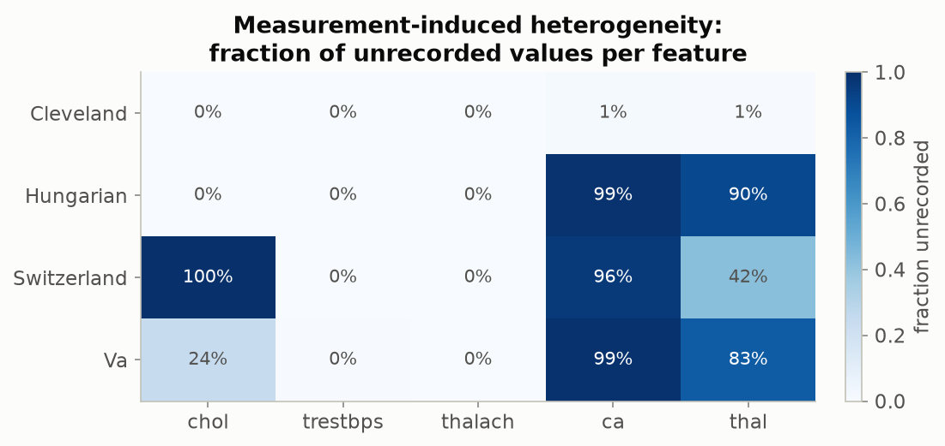
Figure 5.2 — Fraction of unrecorded values per feature per site, both fingerprints side by side. Cholesterol's 100% gap at Switzerland is visible; so is the much larger, near-universal gap in ca and thal outside Cleveland. Produced by viz.plot_missingness, from heterogeneity.missingness_report.
The heatmap above summarizes the fraction missing; the next figure shows what the measured values actually look like once the unrecorded cases are excluded rather than silently treated as zero.
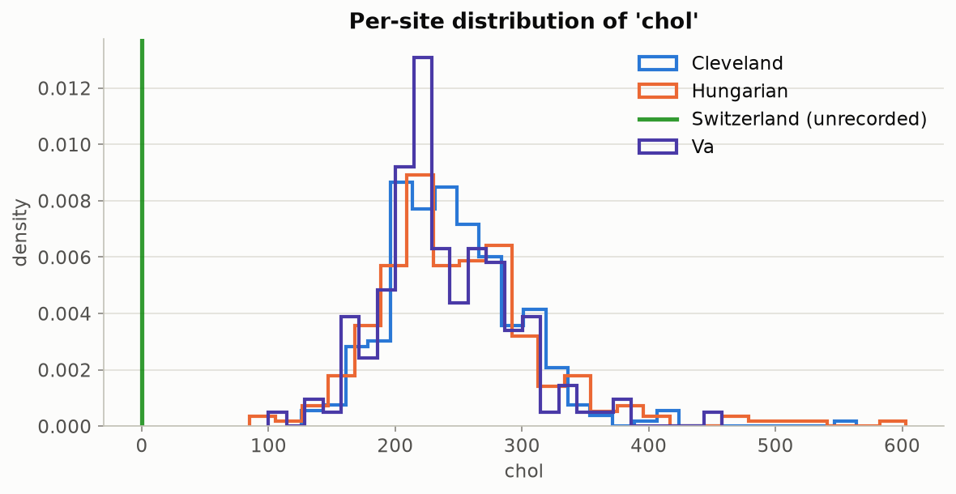
Figure 5.3 — Per-site distribution of measured cholesterol values (Switzerland has none to plot — it is marked as fully unrecorded rather than silently included as zero). Produced by viz.plot_feature_distributions.

5.4 True label shift: what we predict differs sharply by site
Table 5.5 — Severity class counts by site
Severity class | Cleveland | Hungary | Switzerland | V.A. | Pooled total
0 — No disease | 164 | 188 | 8 | 51 | 411 (44.7%)
1 — Mild | 55 | 37 | 48 | 56 | 196 (21.3%)
2 — Moderate | 36 | 26 | 32 | 41 | 135 (14.7%)
3 — Severe | 35 | 28 | 30 | 42 | 135 (14.7%)
4 — Critical | 13 | 15 | 5 | 10 | 43 (4.7%)

Hungary skews heavily toward "no disease"; Switzerland is almost entirely disease-positive and, unusually, has more "mild" cases than "no disease" cases — consistent with a referral population rather than a screening population.
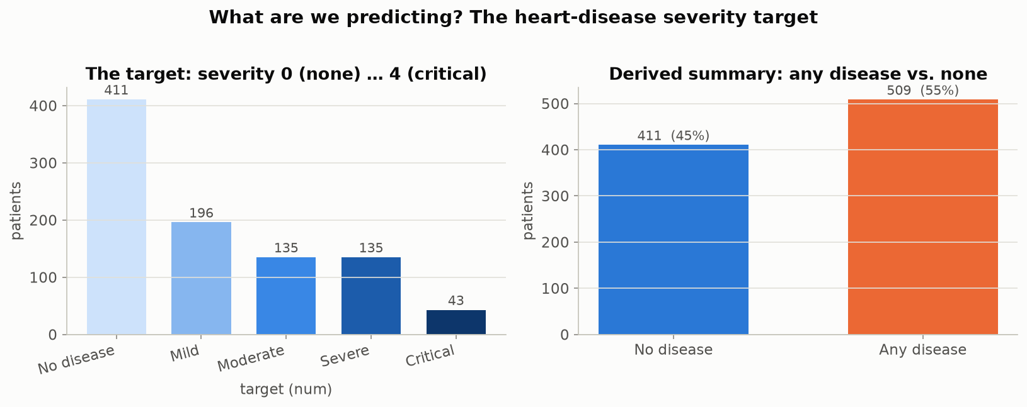
Figure 5.4 — Pooled 5-class severity distribution, and the derived binary any-disease summary. Produced by eda.plot_target_distribution.
The pooled breakdown above hides which hospital contributes which severities; splitting it out by site makes the label shift from Table 5.5 directly visible.
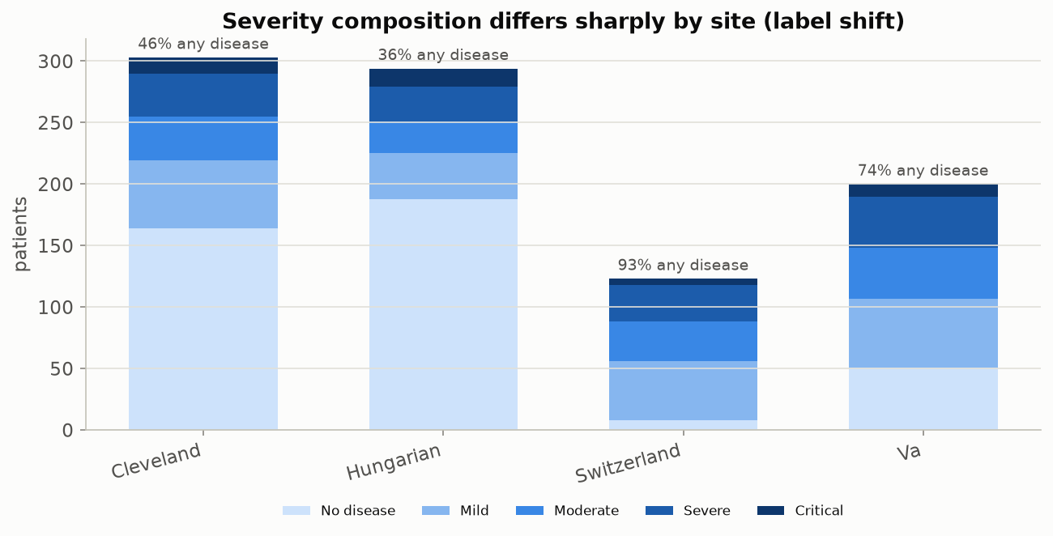
Figure 5.5 — The same severity breakdown, split by site — the label-shift story from Table 5.5 made visual. Produced by eda.plot_target_by_site.

5.5 Covariate shift: the sites are statistically — and visibly — separable
A more rigorous check than eyeballing histograms is to ask: can a simple classifier, given only a patient's clinical features (never told which hospital they came from), guess the hospital? If it cannot do better than a coin flip (AUC around 0.5), the sites are statistically indistinguishable and any model or calibration should transfer cleanly. If it can guess almost perfectly (AUC near 1.0), the sites occupy different regions of feature space and nothing trained at one is guaranteed to behave sensibly at another.
Table 5.6 — Pairwise domain-classifier AUC (5-fold cross-validated logistic regression)
 | Cleveland | Hungary | Switzerland | V.A.
Cleveland | 0.50 | 0.89 | 1.00 | 0.88
Hungary | 0.89 | 0.50 | 1.00 | 0.93
Switzerland | 1.00 | 1.00 | 0.50 | 0.88
V.A. | 0.88 | 0.93 | 0.88 | 0.50

Every off-diagonal value is 0.88 or higher — these hospitals are almost perfectly separable from features alone.
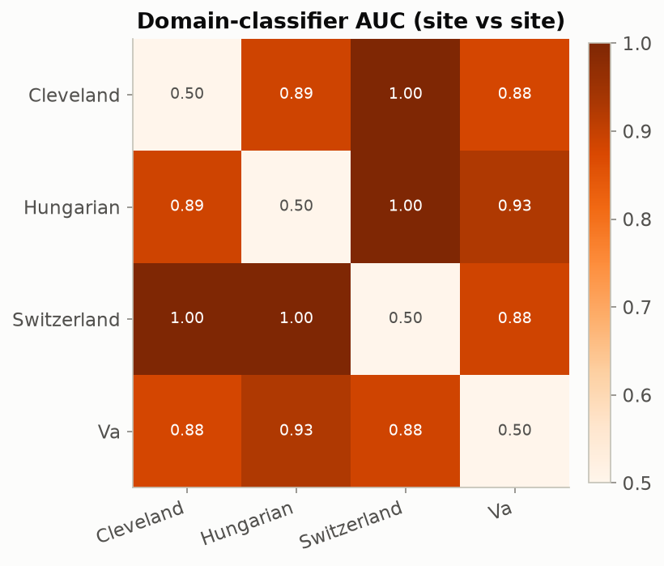
Figure 5.6 — The AUC matrix as a heatmap. Produced by viz.plot_divergence_matrix, from heterogeneity.domain_auc_matrix.
The AUC matrix asks whether a classifier can tell sites apart; Jensen-Shannon divergence asks a narrower, complementary question directly about one feature's distribution shape, without needing to train anything.
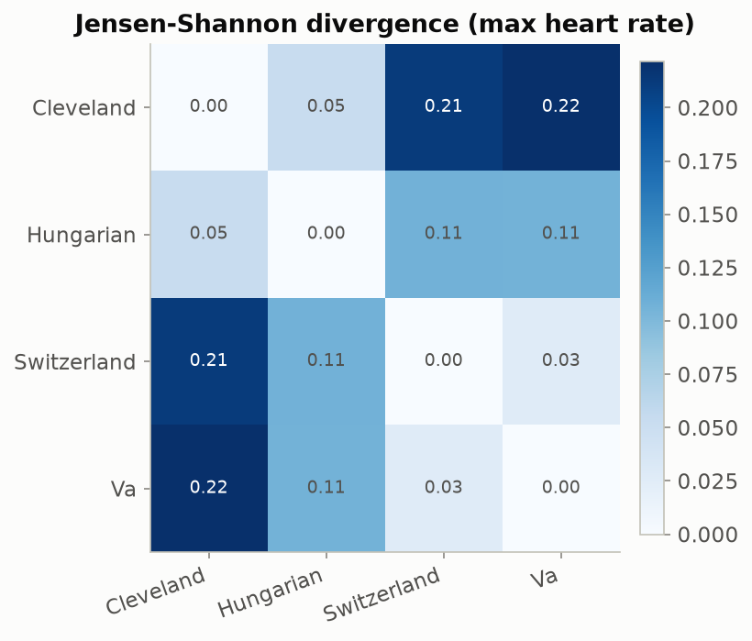
Figure 5.7 — Jensen-Shannon divergence between sites for maximum heart rate (thalach): a second, distribution-shape-based confirmation of the same covariate-shift story, in a [0, 1] score where 0 means identical distributions. Produced by viz.plot_divergence_matrix, from heterogeneity.js_divergence_matrix.
Figures 5.6-5.7 established that the sites differ. The next few figures return to the underlying features themselves to see which ones actually drive that difference.
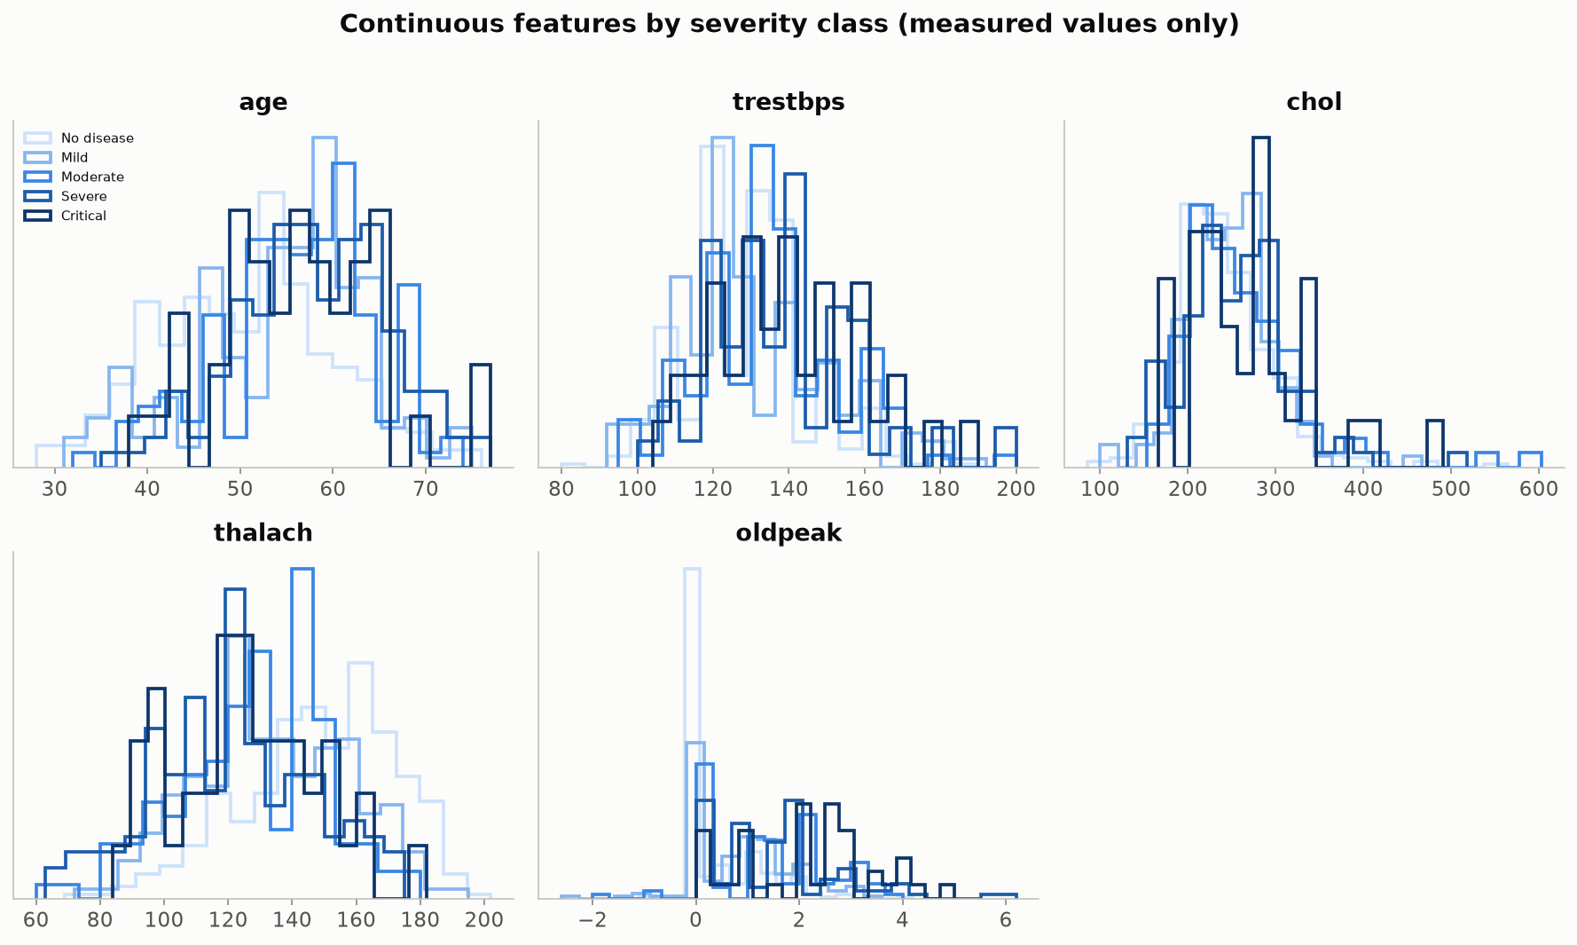
Figure 5.8 — All five continuous features, split by severity class. Where the five severity curves separate, that feature is informative for the model; where they overlap, it is not. Produced by eda.plot_continuous_grid.
Max heart rate stood out in Figure 5.8 as one of the more separated features by severity; the box plots below isolate it by site instead, for a cleaner, single-feature read on how its distribution shifts across hospitals.
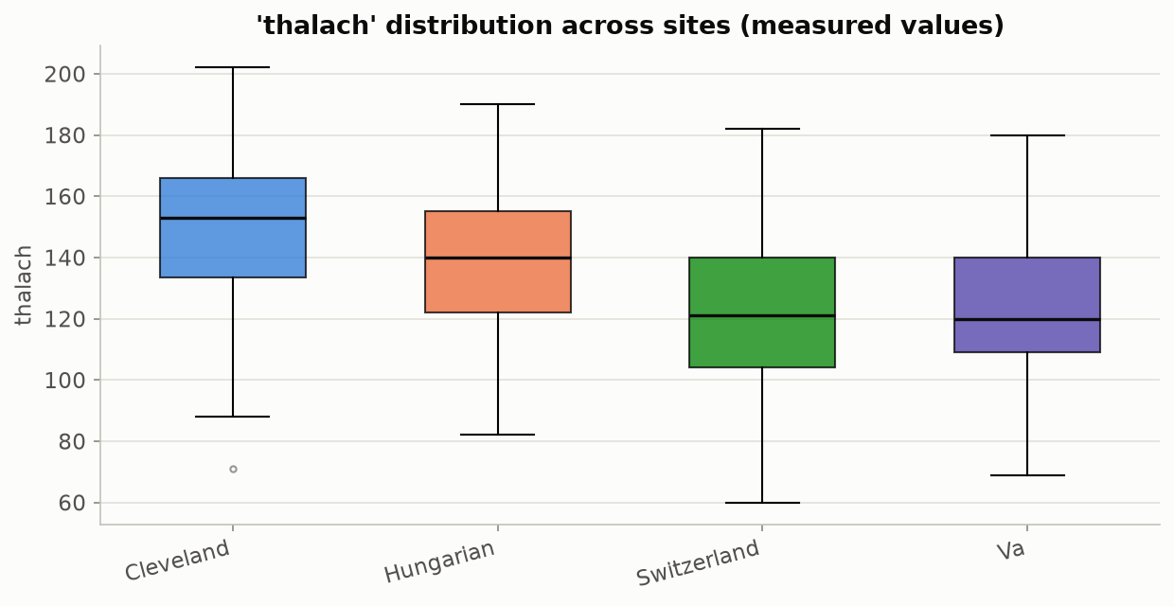
Figure 5.9 — Max heart rate distribution by site as box plots. Produced by eda.plot_feature_boxplots_by_site.
The continuous features above are only half the picture; the categorical and ordinal clinical variables carry at least as much signal, so all eight of them — not a subset — are plotted below.
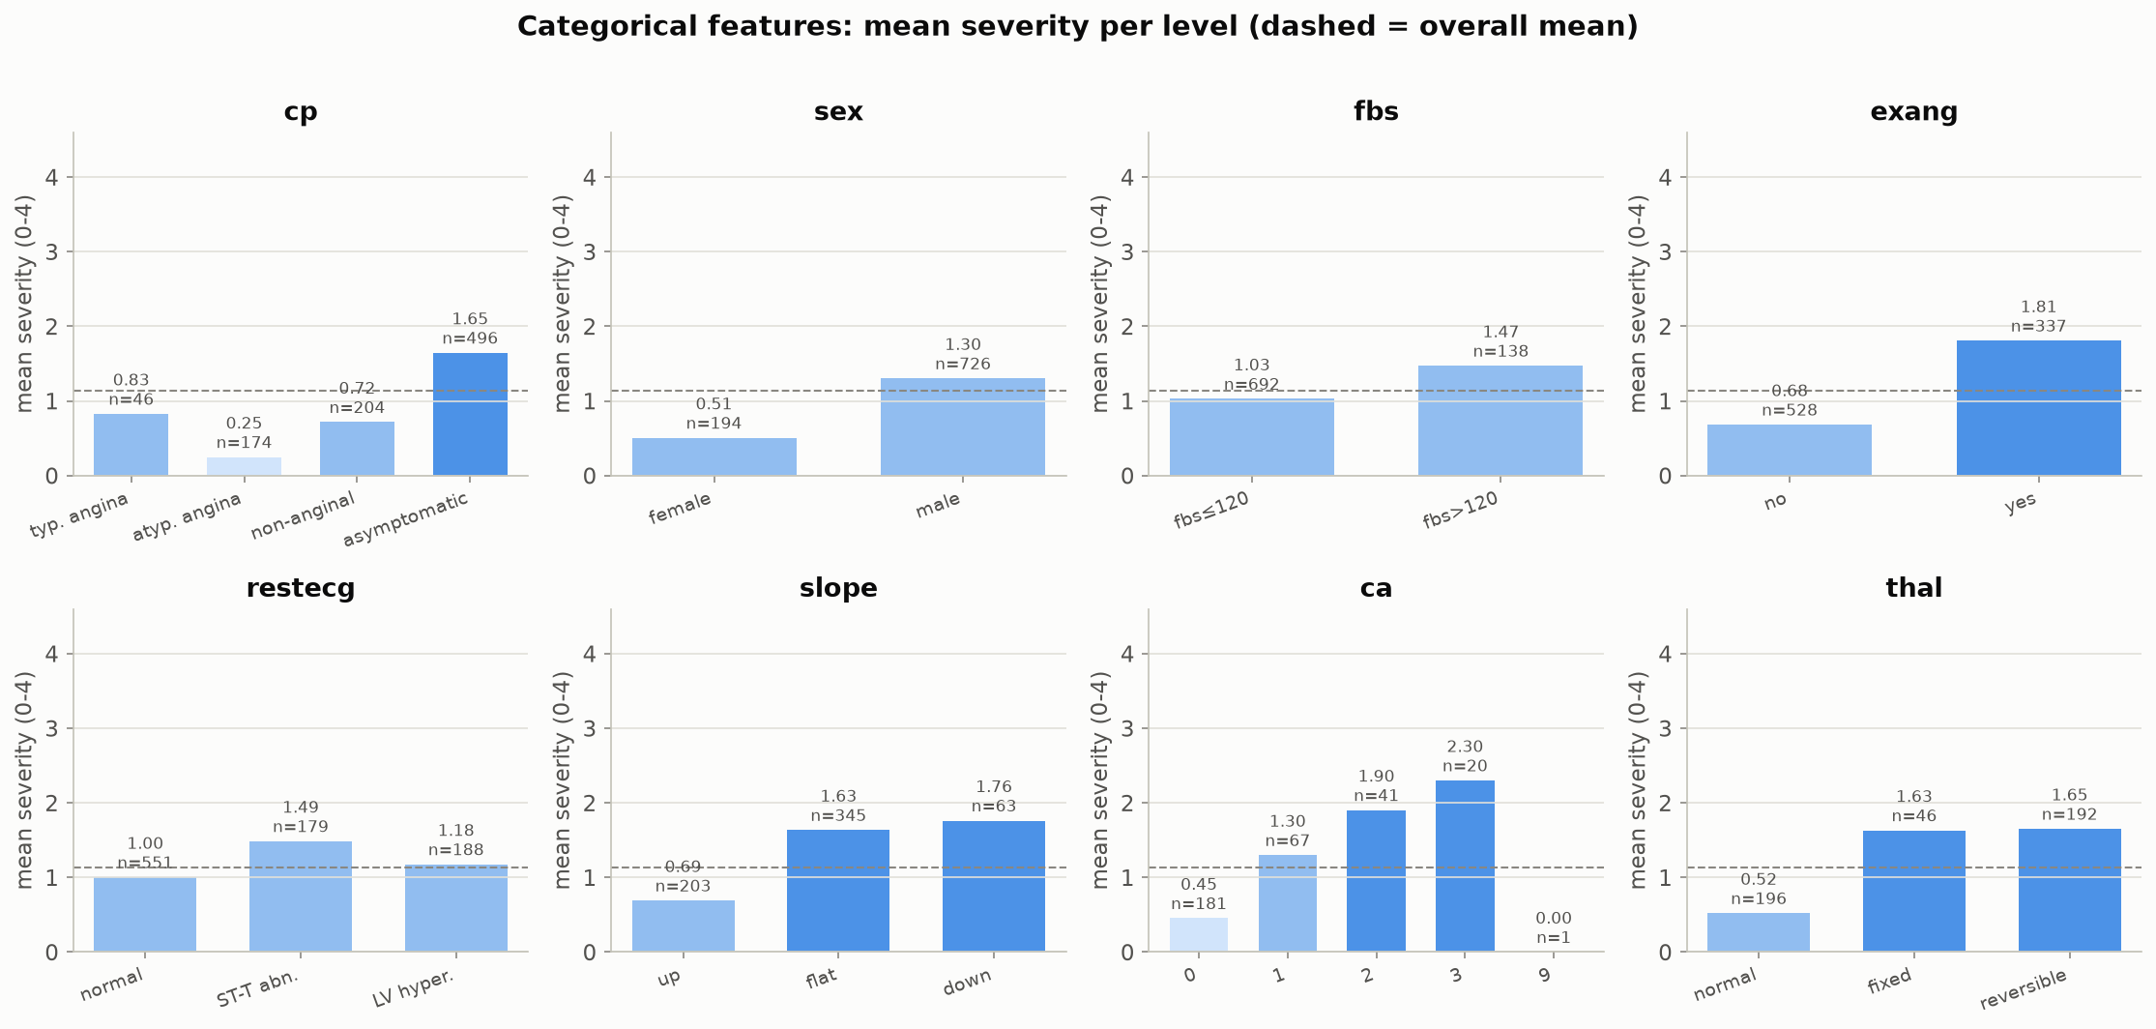
Figure 5.10 — Mean severity within each level of all eight categorical/ordinal features (chest-pain type, sex, fasting blood sugar, exercise angina, resting ECG, ST slope, number of vessels by fluoroscopy, thalassemia result). Asymptomatic chest pain, exercise-induced angina, a flat/down ST slope, and a reversible thalassemia defect all carry substantially higher mean severity — clinically sensible relationships the model can exploit, and a sanity check that the loaded data behaves the way cardiology domain knowledge predicts. The two added panels tell a consistent story: elevated fasting blood sugar (> 120 mg/dl) shifts mean severity from 1.03 to 1.47, and ca is the single most monotonic feature in the grid — mean severity rises step-wise with every additional vessel affected (0.45 at 0 vessels, up to 2.30 at 3). Produced by eda.plot_categorical_grid.
One further, smaller-scale data-quality note surfaces once every level is plotted rather than a curated subset: a single Hungarian patient carries ca = 9, outside the documented 0-3 range — almost certainly a digitization error in the original 1988-89 file rather than a real vessel count, and exactly the kind of one-row anomaly a subset view can hide. It affects one patient out of 920 and is left in the data as-is (not silently dropped), consistent with this report's policy of showing what the source files actually contain.
Finally, viewing every feature relationship at once as a correlation matrix confirms nothing in Figures 5.8-5.10 is contradicted by the pairwise structure of the data.
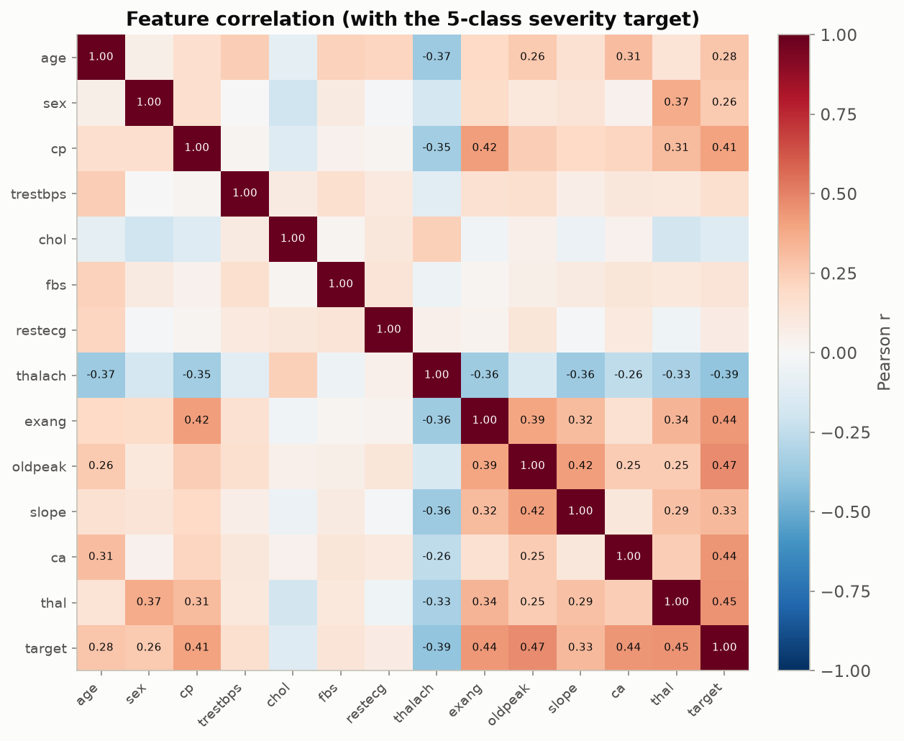
Figure 5.11 — Pearson correlation among all 13 features and the 5-class severity target. Chest-pain type, exercise angina, ST depression, max heart rate and vessel count are the strongest correlates of severity. Produced by eda.plot_correlation_heatmap.

5.6 The secondary task confirms this is not a fluke of one label choice
If the heterogeneity story depended on the specific choice of "predict disease severity," it would be a weaker argument. The toolkit supports a second, independent task on the same four sites — predicting chest-pain type instead of disease severity — and label shift shows up there too, just as clearly, confirming the effect is a property of the sites, not of one particular target.
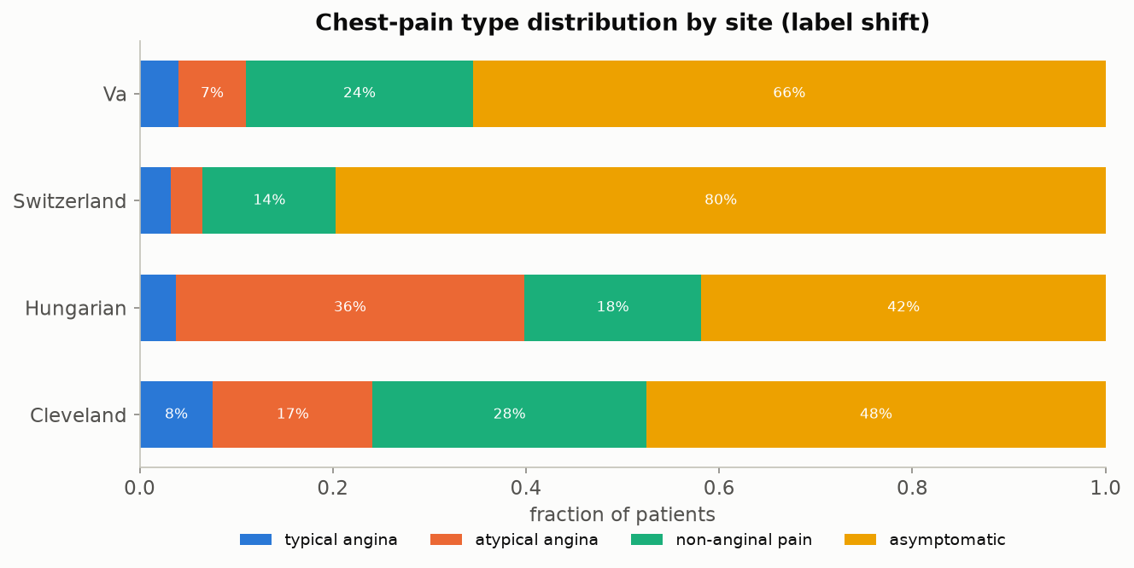
Figure 5.12 — Chest-pain-type distribution by site, the secondary-task analogue of Figure 5.5. Hungary is heavy on atypical angina; Switzerland is roughly 80% asymptomatic. Produced by viz.plot_class_distribution_by_site, via scripts/run_chest_pain_pipeline.py.

5.7 Summary: what makes this dataset ideal
- Genuinely interoperable: all four sites used the same case-report form and the same 13-variable schema — there is no format barrier to integration, which isolates the meaning problem from the plumbing problem.
- Genuinely heterogeneous, and in two distinguishable ways at once: a true population difference (prevalence 36%-94%) and a measurement artefact (chol, and far more severely, ca/thal), so the toolkit's core distinction is not hypothetical.
- Small enough to train and calibrate live in a workshop (920 patients, sub-second training), large enough that the effects are statistically real rather than noise (Beta-band-checked in Section 7.3).
- Open, credential-free, and citable, for the historical reasons explained in Section 4 — no data-use agreement stands between a workshop attendee and running the code themselves.
- The finding replicates on a second, independently chosen prediction task on the same sites (Figure 5.12), which is evidence the heterogeneity is a property of the hospitals, not an artefact of the modeling choice.

6. Methods of Interoperability: Choosing a Standard
Section 5 relied on a lucky historical accident: four hospitals happened to fill out the same paper case-report form. A real curation pipeline built today does not get to rely on luck — it has to deliberately choose a data standard. This section surveys the realistic options and lays out exactly what adopting any of them does, and does not, solve.

6.1 Interoperability has levels, and most mandates stop at the easy ones
HIMSS (the Healthcare Information and Management Systems Society) distinguishes four levels of interoperability: foundational (data can move from one system to another at all), structural (the format and structure of the exchanged data is standardized, e.g. a consistent field for "cholesterol"), semantic (the exchanged value carries a standardized, shared meaning, e.g. a specific LOINC code that both systems interpret identically), and organizational (the governance, policy and workflow context needed for the exchange to actually happen in practice). Most current regulatory mandates (Section 3.3) are strongest at the foundational and structural levels. Semantic interoperability — the level where this report's entire heterogeneity story lives — is the hardest to mandate and the easiest to get only partway to.

6.2 The standards landscape
Table 6.1 — Clinical data standards compared for this workshop's use case
Standard | Primary use case | Structural interoperability | Semantic interoperability | Fit for multi-site research
HL7 v2 messaging | Legacy point-to-point clinical messaging (labs, admissions, orders) | Moderate — widely implemented but loosely enforced | Weak — minimal standard vocabulary binding | Poor: still the production backbone in many hospitals, but not designed for pooled research analysis
HL7 FHIR | Modern REST/JSON API exchange; the standard named in current US/EU interoperability mandates | Strong | Moderate-to-strong when paired with standard terminologies (LOINC, SNOMED CT, RxNorm) — inconsistently adopted site to site | Good for live exchange; not itself a research-analysis data model
OMOP Common Data Model (OHDSI) | Standardizing observational health data from many institutions into one schema and vocabulary for pooled/federated research | Strong | Strong — the standard vocabulary mapping is the point of the model | Excellent: purpose-built for exactly this report's use case
openEHR | Archetype-based clinical modeling with very high semantic expressiveness | Strong | Strong | Good in principle; limited adoption in US hospital systems specifically
CDISC SDTM / ADaM | Regulated clinical-trial data submission to FDA/EMA | Strong | Strong, within the trial-data domain | Poor fit: built for trials, not observational multi-site EHR data
DICOM | Medical imaging exchange and storage | Strong (imaging-specific) | Strong (imaging-specific) | Not applicable to this workshop's tabular clinical variables, but the correct standard once imaging enters a curation pipeline

6.3 What standardization can and cannot buy you
Table 6.1 is a starting point for that choice, not a verdict — which standard (or combination) fits a given curation pipeline depends on institutional context, existing vendor systems, and whether the goal is live clinical exchange or pooled research analysis, and is a decision this report leaves to the team building the pipeline rather than asserting on their behalf.
What the report can say with confidence is the limit of what any of these standards buys you. Adopting a common schema and a common vocabulary reduces, but does not eliminate, measurement-process heterogeneity — a hospital can code cholesterol to the correct standard concept and still simply order that test less often than another hospital does, which reproduces Switzerland's missingness pattern (Section 5.3) inside a perfectly standards-compliant pipeline. No coding standard changes the fact that a tertiary referral centre sees a sicker, pre-selected population either. That is why this toolkit's heterogeneity diagnostics (Section 5) and conformal-coverage diagnostics (Sections 7-8) belong downstream of any standardization effort as a verification step, not as a one-time substitute for one.
Worth stating plainly: the UCI dataset itself predates and does not use any of the standards in Table 6.1 — it is distributed as raw, fixed-format, per-site flat files. That is a feature for this report's purposes, not a flaw: it shows what pre-standardization interoperability looked like, and every figure in Section 5 is a direct, honest picture of what adopting a modern standard would, and would not, have caught. Standardizing the format would have caught nothing about the true prevalence swing across sites (Table 5.3) — that is real biology, not a coding problem — while a well-governed pipeline that tracks per-site data completeness by design would plausibly have surfaced the ca/thal measurement gap (Table 5.4) earlier than this report did.

7. Why Conformal Prediction Helps With Site-Level Heterogeneity

7.1 The problem: models are confident even when they are wrong
A typical machine-learning classifier reports a number that looks like a probability — "92% chance this patient has heart disease." That number is not actually a probability in any guaranteed sense; it is whatever the model happened to output. Nothing forces it to be correct 92% of the time. In practice, a model trained on one hospital's patients and then run on a different hospital's patients often stays just as confident — the 92% does not shrink — while its actual correctness rate quietly drops. The model does not know it has left home. This is the single most dangerous failure mode in cross-institution deployment: not a model that visibly fails, but one that fails silently while sounding just as sure of itself as it did during development.
Interoperability standards (Section 6) solve the problem of getting the data there. They do nothing to solve this problem, because the failure is not about the data format — it is about whether the statistical relationship the model learned at Hospital A still holds at Hospital B. Two hospitals can use an identical schema, an identical column called "cholesterol," and still have that column mean something different in practice (measured routinely at one site, almost never measured at another). A model cannot tell the difference between a hospital with genuinely different patients and a hospital with a broken measurement pipeline unless something is specifically built to check.

7.2 What conformal prediction actually does
Conformal prediction is a wrapper you can put around any trained model — logistic regression, a neural network, anything that outputs a score per class — that converts its raw scores into a set of plausible answers, with a guarantee attached to the size and content of that set. Instead of the model saying "heart disease, severity 2, 92% confident," a conformal predictor says "the true severity is somewhere in {1, 2, 3}, and this kind of statement is right at least 90% of the time." When the model is unsure, the set grows to include more possibilities; when it is sure, the set can shrink to a single class. Crucially, the 90% figure is not a hope — it is a mathematical guarantee that holds regardless of whether the underlying model is any good, as long as one condition holds: the data you calibrate the guarantee on must look statistically like the data you later apply it to.
That condition — formally called exchangeability, discussed in Section 8 — is exactly where site heterogeneity enters the picture. Calibrating a conformal predictor at one hospital and deploying it at another silently assumes the two hospitals are exchangeable. If they are not, the 90% promise degrades to whatever the real cross-site agreement supports, and conformal prediction becomes a measuring instrument for that degradation: you calibrate at one site, check the empirical coverage at every other site, and the gap between the promised rate and the observed rate is a direct, quantitative readout of how much that pair of sites disagrees. No other common technique gives you a single interpretable number for "how much can I trust this model somewhere it hasn't been tested."

7.3 Averages hide the failure — you have to look per site
The single most important lesson in this toolkit is that a pooled, dataset-wide coverage number can look perfect while hiding a badly broken subgroup. A conformal predictor calibrated across all four hospitals together can report 90% coverage overall while one hospital sits at 70% and the others compensate by over-covering. This is exactly what we observe: a model federated over Cleveland, Hungary and the V.A., then calibrated using only Cleveland patients and deployed everywhere, hits 90-91% coverage at Cleveland, Hungary and the V.A. — and drops to 71% at Switzerland, the hospital the federation never trained on (Figure 7.3). Reported as one pooled number, this problem is invisible. Reported per site, it is impossible to miss. That is the practical argument for conformal prediction in a curation pipeline: it is cheap to compute, attaches to any model you already have, and turns "is this data comparable across sites" from a qualitative judgment call into a number you can put in a table and set a threshold on.
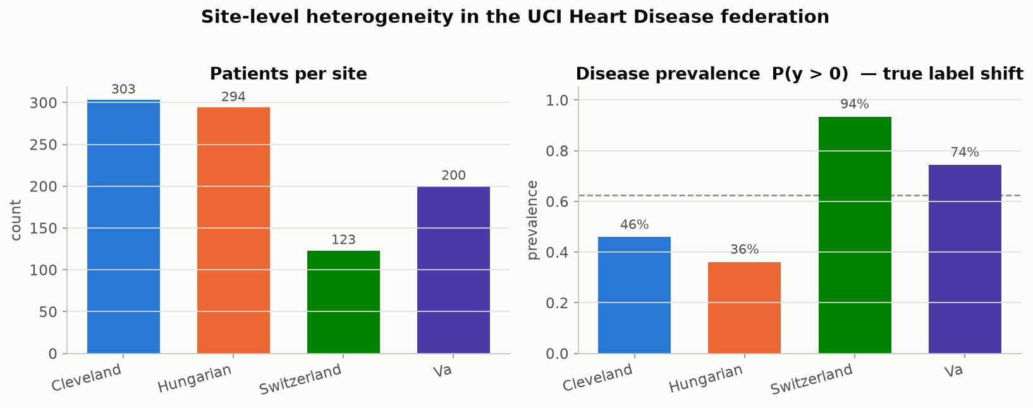
Figure 7.1 — Patients per site and disease prevalence per site. Prevalence swings from 36% (Hungary) to 94% (Switzerland): a genuine difference in patient population (true distributional shift), not a data-entry artefact. Produced by viz.plot_site_overview, called from data.summarize_sites.
The distinction behind that empirical result is easiest to see drawn schematically first.
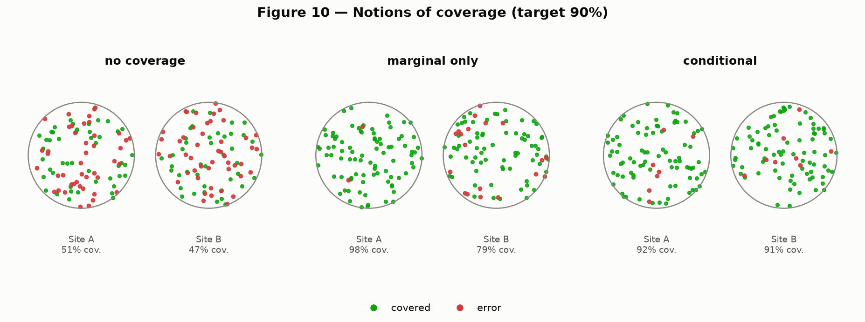
Figure 7.2 — The distinction this whole report rests on, drawn schematically for two groups. Left: no coverage guarantee at all. Middle: 'marginal' coverage — the overall average looks fine (green dots) while one group is quietly failing (concentrated red dots). Right: 'conditional' coverage — every group is covered at the target rate individually. Produced by paper_figures.fig10_coverage_notions, a recreation of Figure 10 in Angelopoulos & Bates (2022).
That schematic is not hypothetical here — this is the real measurement on this project's data.
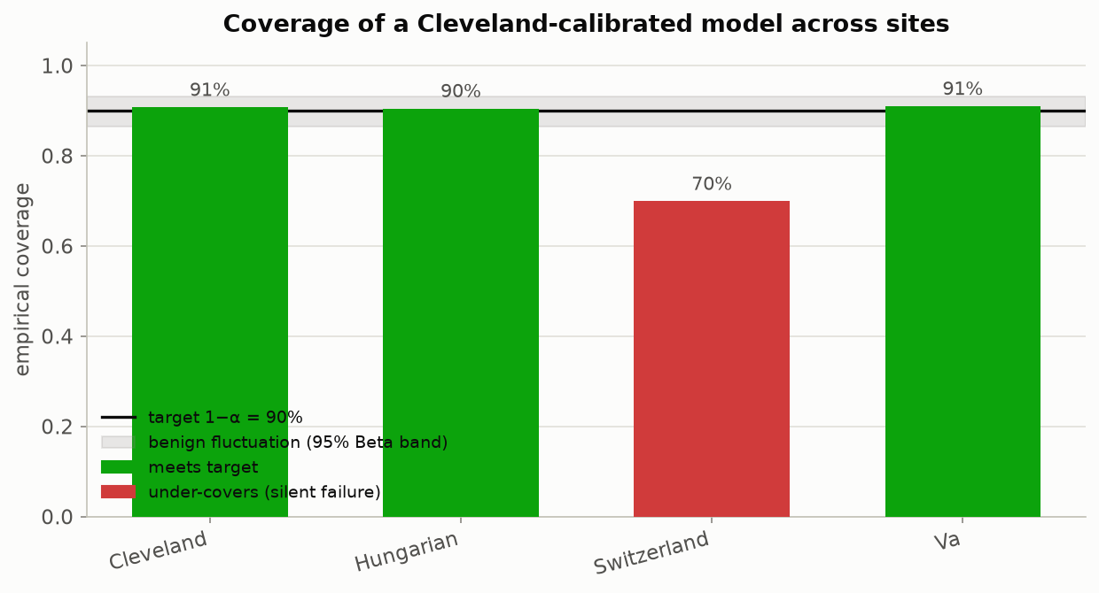
Figure 7.3 — The headline empirical result. A conformal predictor calibrated only on Cleveland data is deployed at all four hospitals. It meets the 90% target at Cleveland, Hungary and the V.A., and silently drops to 71% at Switzerland — well outside the shaded 'benign fluctuation' band that captures ordinary sampling noise, meaning this drop is a real effect, not chance. Produced by viz.plot_coverage_by_site, using conformal.LACPredictor and evaluate.coverage.
Figure 7.3 fixed the calibration site at Cleveland; the transfer matrix below generalizes that to every possible calibrate/deploy pairing at once.
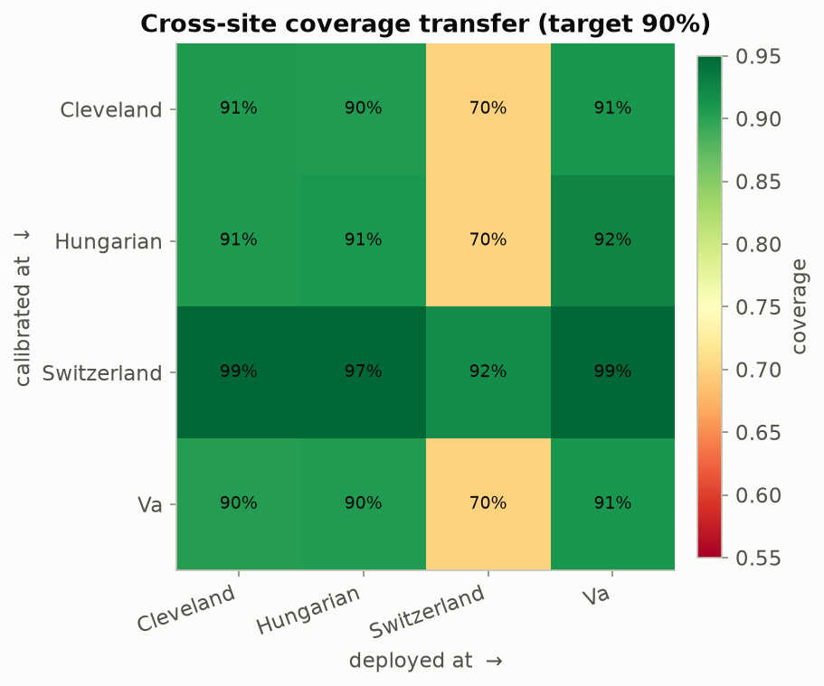
Figure 7.4 — The full picture: calibrate at the row's hospital, deploy at the column's hospital, read off coverage. The diagonal (calibrate and deploy at the same hospital) is healthy everywhere. Off-diagonal cells show what happens when a hospital's calibration is exported elsewhere — deploying anything calibrated on Cleveland, Hungary or the V.A. at Switzerland lands around 70-72%, while a Switzerland-calibrated predictor over-covers everywhere else (its patients are on average sicker, so its threshold is looser than it needs to be elsewhere). Produced by viz.plot_transfer_matrix.
Table 7.1 — Coverage of a Cleveland-calibrated predictor, by deployment site (target: 90%, calibration set = 303 Cleveland patients, split-conformal LAC score, α = 0.10)
Deployment site | Empirical coverage | Gap vs. 90% target | Verdict
Cleveland (same site as calibration) | 90.8% | +0.8 pp | Meets target
Hungary | 90.8% | +0.8 pp | Meets target
V.A. Long Beach | 90.5% | +0.5 pp | Meets target
Switzerland (never seen by the federated model) | 70.7% | −19.3 pp | Fails, silently

This is the practical payoff for a curation pipeline: instead of trusting that a model "should" generalize because the incoming data is schema-compliant, you get a per-site number that tells you exactly where trust breaks down, before a clinician or downstream system relies on it.

8. The Mathematics, and What Every Piece of Code Produces
This section explains the method in plain language first, gives the exact formula each idea corresponds to, and then says precisely which file and which function in the toolkit implements it and which figure it produces. Everything here is implemented in plain NumPy — no black-box library — specifically so every step can be read line by line.
It helps to see the destination before the mechanics: what a prediction set actually looks like. The source paper opens the same way, with its own Figure 1, before Section 2 explains the method formally.
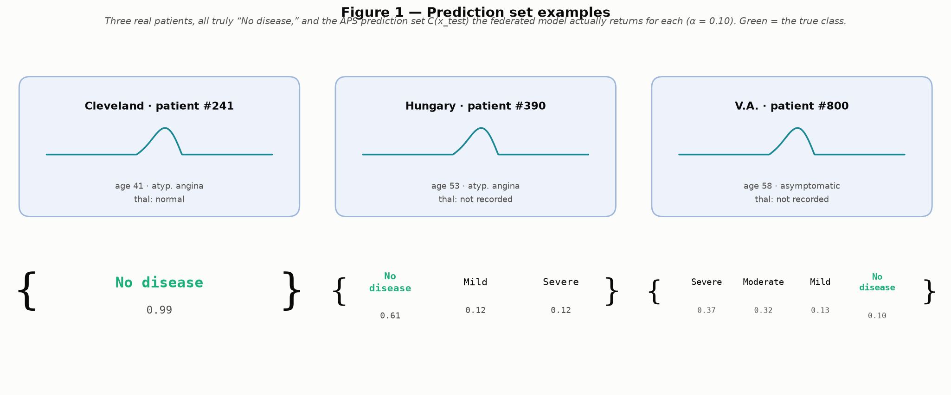
Figure 8.1 — Three real patients from this project's own data, all truly "No disease," and the prediction set the calibrated model actually returns for each. Unlike every other figure in this section, this one is not illustrative: it trains the real federated model, calibrates a real APS conformal predictor (alpha = 0.10), and searches the held-out test patients for the most confident correctly-covered singleton, a representative 3-class case, and the least confident correctly-covered 4-class case — all restricted to patients whose true label is "No disease," the only one of the five severity classes for which a full 1-4 spread of covered set sizes exists. In the hardest case the model's own top guess is "Severe," not the true "No disease" — the true class is fourth, not first — yet it still survives inside the set, which is the entire point of the coverage guarantee: it protects the true answer even when the model itself is confidently pointing elsewhere. This is a direct, non-illustrative echo of the source paper's own Figure 1, where a third fox-squirrel photograph fools the classifier into ranking "marmot" first. Produced by paper_figures.fig01_prediction_set_examples, via scripts/run_paper_figure_recreations.py.

8.1 The one assumption everything rests on: exchangeability
Conformal prediction needs exactly one statistical assumption, and it is weaker than almost anything else in statistics: the calibration data and the test data must be exchangeable — informally, drawn from the same underlying process, so that shuffling the order of the combined set would not tell you anything about which points were 'calibration' and which were 'test'. It does not require the data to be Gaussian, linearly separable, or generated by any particular model at all. This is what makes conformal prediction so widely applicable — and it is also exactly the assumption that cross-hospital deployment violates. Calibration data from Cleveland and test data from Switzerland are not exchangeable if Switzerland patients are drawn from a different population (94% disease prevalence vs. Cleveland's 46%). The guarantee below is conditional on an assumption that this dataset is specifically built to violate on purpose, so that the violation is visible.

8.2 The nonconformity score and the conformal quantile
Step one: define a single number, the 'nonconformity score,' that measures how surprising a true label was, given what the model predicted. A large score means the model's output looked nothing like the truth; a small score means the model was basically right. Step two: compute this score for every point in a held-out 'calibration' set the model never trained on. Step three: take a specific, slightly-inflated quantile of those calibration scores — inflated just enough to make the finite-sample guarantee exact rather than approximate:
q̂ = Quantile( s₁, …, s_{n} ; ⌈(n + 1)(1 − α)⌉ / n )
Here n is the number of calibration points and α (alpha) is the error rate you are willing to accept (α = 0.10 throughout this report, i.e. a 90% target). Step four: for any new patient, build the prediction set by keeping every candidate label whose score would not have exceeded q̂ ("q-hat"):
C(x) = { y : s(x, y) ≤ q̂ }
This is the entire method. The proof that P(true label ∈ C(x)) ≥ 1 − α is a short exchangeability argument (Angelopoulos & Bates, 2022, Section 2) — the important practical point is that it works for any nonconformity score and any underlying model. Implementation: conformal.conformal_quantile(scores, alpha). Both predictors described below call it as their calibration step.

8.3 Two ways to define the score: LAC and APS
"LAC" (Least Ambiguous set-valued Classifier) uses the simplest possible score: one minus the model's softmax probability on the true class.
s_{i} = 1 − f̂(x_{i})_{yi}
A score near 0 means the model put almost all its probability mass on the correct class; a score near 1 means the model was confidently wrong. Implementation: conformal.lac_scores and conformal.LACPredictor.
"APS" (Adaptive Prediction Sets, Romano, Sesia & Candes, 2020) instead sorts the classes from most to least likely and adds up probability mass until it reaches the true class:
s(x, y) = Σ_{j=1}^{o(y)} π̂_{(j)}(x)
where the classes are sorted by decreasing predicted probability π̂₁(x) ≥ π̂₂(x) ≥ … , π̂₍ⱼ₎(x) denotes the probability of the class ranked j-th in that order, and o(y) is the rank of the true class y itself — so the score is just the cumulative probability mass swept up to and including the true class.
LAC tends to build the smallest possible sets on average; APS tends to size its sets more sensibly example-by-example — growing more for genuinely ambiguous patients and shrinking more for clear-cut ones — which matters most in the multiclass setting used later in this report. Implementation: conformal.aps_scores and conformal.APSPredictor.
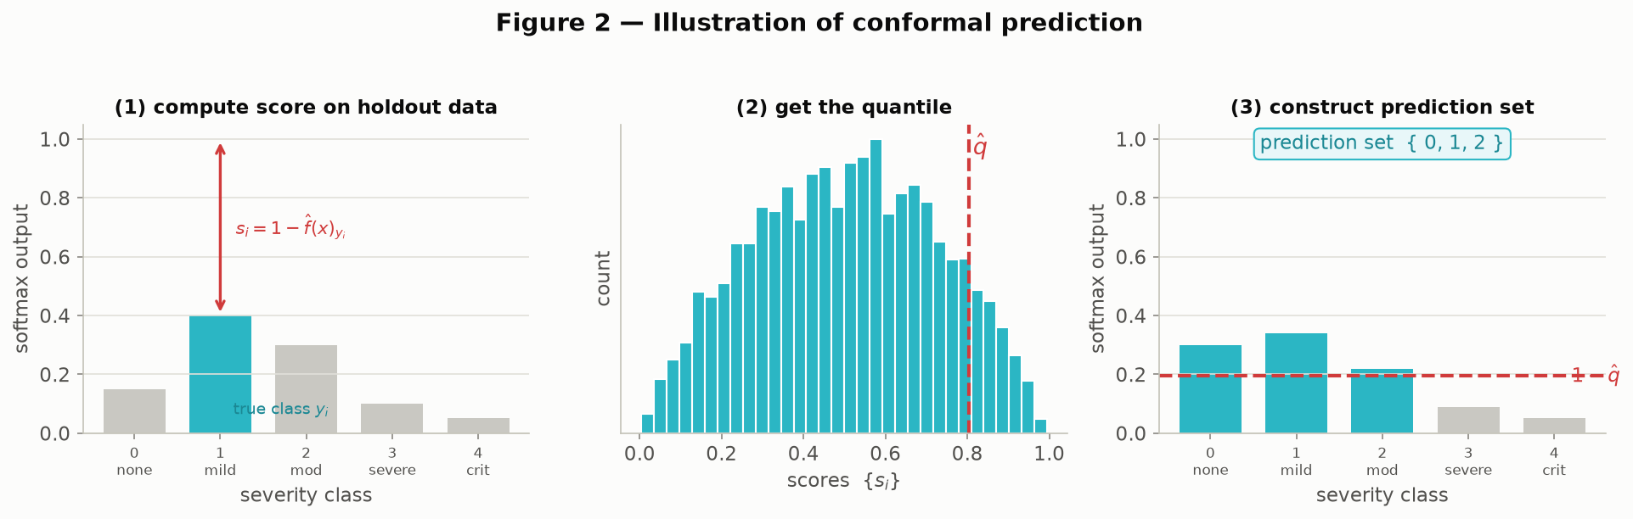
Figure 8.2 — The method end to end, worked through visually on a 5-class example. Panel 1: compute the score on one calibration point (how far the model's probability on the true class fell short of 1). Panel 2: histogram the scores across the whole calibration set and mark the quantile q̂. Panel 3: for a brand-new patient, keep every class whose predicted probability clears the 1 - q̂ bar — the surviving classes are the prediction set. Produced by paper_figures.fig02_conformal_illustration (Figure 2 of Angelopoulos & Bates, recreated with the same 5-class severity framing used throughout this report).
Figure 8.2 showed the LAC score end to end; the same three-step recipe applies to APS, with the sorting-and-accumulating mechanic shown separately below.
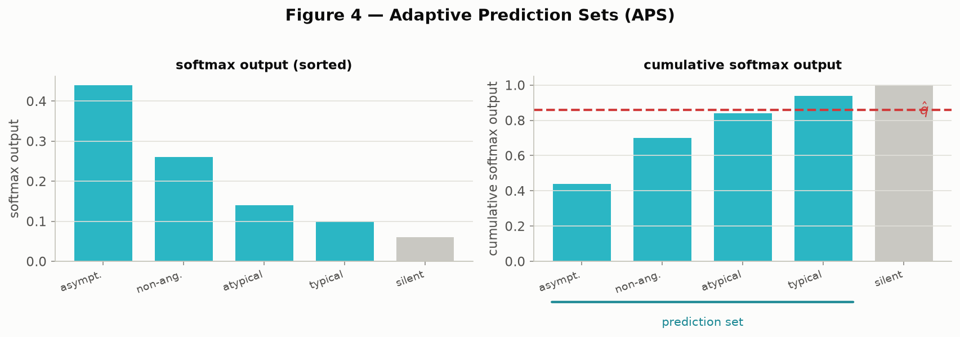
Figure 8.3 — The APS mechanic specifically: sort classes by predicted probability (left), accumulate that probability (right) until the running total crosses q̂, and the classes up to that point form the set. Produced by paper_figures.fig04_aps_illustration (Figure 4).
Both illustrations above use synthetic scores chosen to make the mechanic legible; the histogram below is the real LAC calibration-score distribution from this project's federated model.
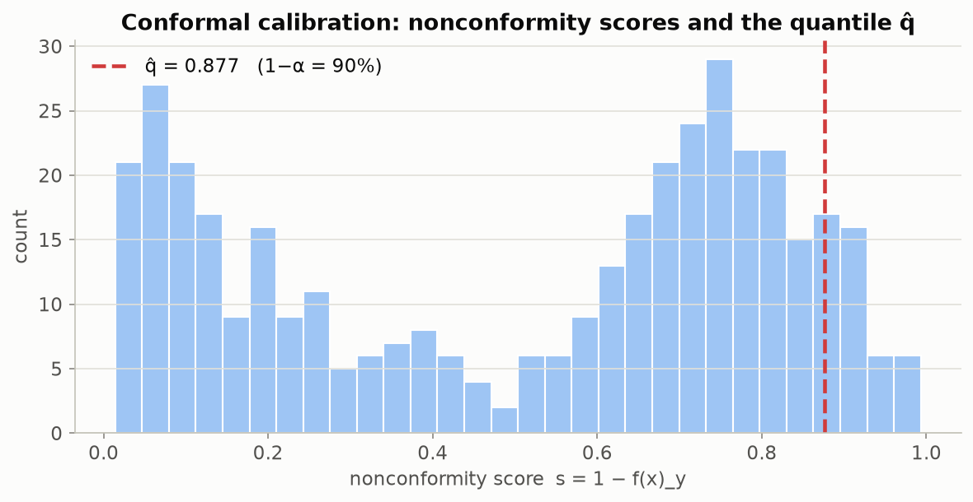
Figure 8.4 — The actual calibration-score histogram from this project's data (not a synthetic illustration): LAC scores from a model trained across Cleveland, Hungary and the V.A., calibrated on a held-out pool. The red line is q̂ — everything to its left calibrates the 90% target. Produced by viz.plot_calibration_scores inside scripts/run_end_to_end_pipeline.py.

8.4 Why the calibration-set size matters
Because q̂ is estimated from a finite sample, the realized coverage on any particular test set is itself a random quantity — it will not sit exactly on 90% every time, even when every assumption holds. Vovk (2012) showed this randomness follows a Beta distribution with parameters tied directly to the calibration-set size n and α:
Coverage ∼ Beta( n + 1 − ℓ , ℓ ) where ℓ = ⌊ (n + 1) α ⌋
With only 50 calibration points, observed coverage can swing several percentage points around the target just from sampling luck; with 1,000, it is tight. This matters directly for this report's headline result: Switzerland's 71% coverage is far outside this benign-fluctuation band even for a calibration set the size of Cleveland's (303 patients), which is how we know the drop is a real site effect and not noise, rather than merely asserting it. Implementation: evaluate.coverage_beta_interval, plotted analytically by viz.plot_coverage_beta.
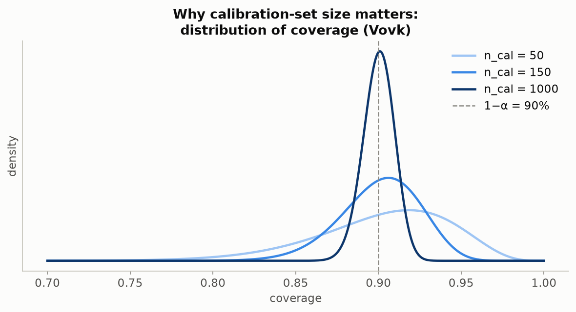
Figure 8.5 — The Beta distribution of coverage at three calibration-set sizes (50, 150, 1000). The smaller the calibration set, the wider and more uncertain the true coverage really is around the 90% target — context for judging whether an observed drop is a real site effect or just noise. Produced by viz.plot_coverage_beta.
Figure 8.5 used calibration sizes matched to this project's actual sites (50-1,000 patients); the recreation below repeats the same idea at the much larger scale used in the original paper, for comparison.
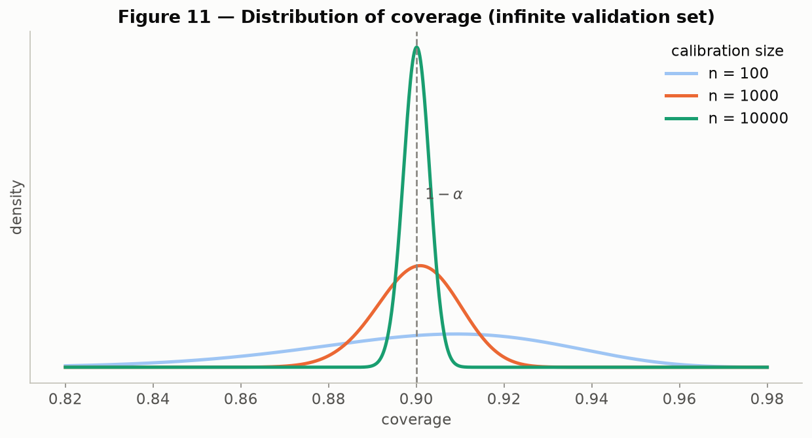
Figure 8.6 — The same idea recreated at the scale used in the original paper (n = 100, 1,000, 10,000), showing how sharply the distribution narrows as the calibration set grows. Produced by paper_figures.fig11_coverage_distribution (Figure 11).

8.5 Adaptivity: are the sets actually bigger where the model is unsure?
A trivial way to hit 90% coverage is to always output every possible class — technically correct, completely useless. A good conformal predictor instead produces small sets for easy cases and large sets for hard ones. We check this directly by tabulating the distribution of set sizes at each hospital: a predictor that is well calibrated but not adaptive would show the same size distribution everywhere; ours visibly widens at sites with more label ambiguity. Implementation: evaluate.set_sizes / evaluate.average_set_size, plotted by viz.plot_set_size_distribution.
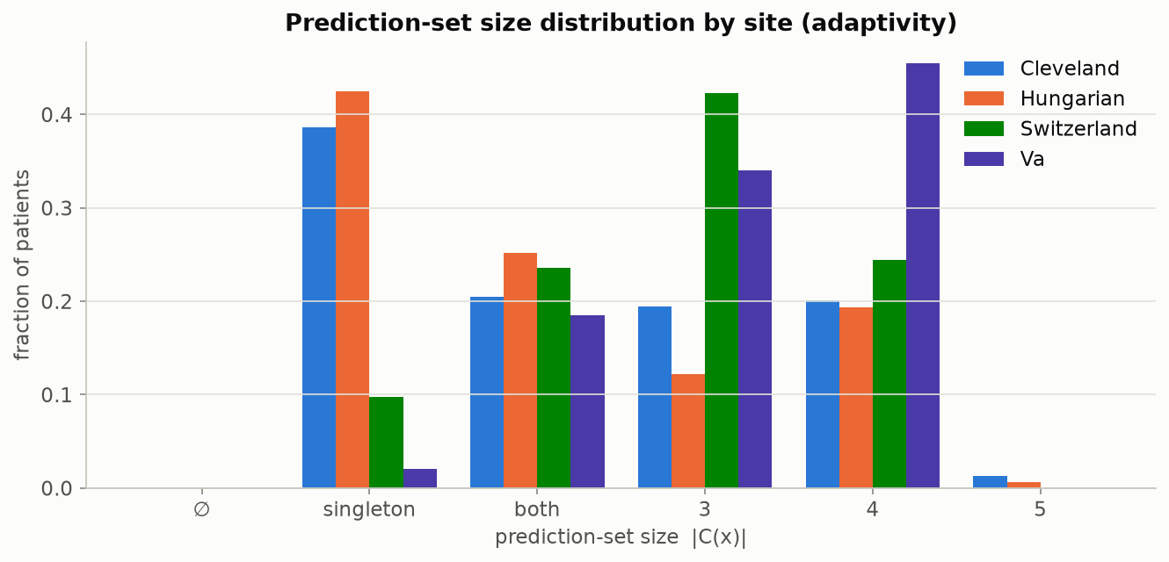
Figure 8.7 — Distribution of prediction-set sizes by site (5-class disease-severity task). Larger sets at a given site mean the model is systematically less certain about patients from that hospital. Produced by viz.plot_set_size_distribution.

8.6 The subtler failure: class-conditional coverage
Marginal coverage (the 90% averaged over every patient) can hide a second, independent kind of failure: it can hit target overall while badly under-covering one specific class, particularly a rare one, exactly the way it can hide a badly-covered site. We demonstrate this on the toolkit's secondary task — predicting chest-pain type (4 classes) rather than disease severity. Marginal coverage across the pooled test set sits at 90%, but broken out by the true class, the rarest category (typical angina, only 23 test patients) is covered just 26% of the time, while the most common category (asymptomatic, 200 patients) is over-covered at 95.5%. Implementation: evaluate.class_conditional_coverage, plotted by viz.plot_class_conditional_coverage.
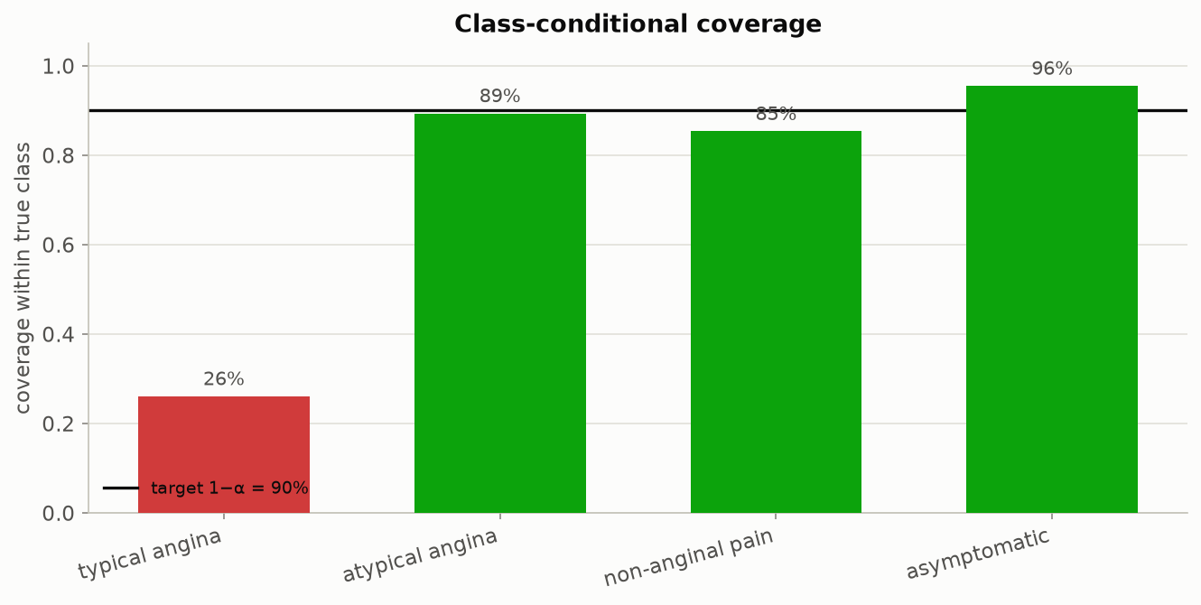
Figure 8.8 — Coverage broken out by true chest-pain class. The rare class (typical angina, n = 23) is covered only 26% of the time against a 90% target — invisible in the pooled 90% marginal number, and exactly the sub-population a curation pipeline is most likely to serve under-represented patients in. Produced by viz.plot_class_conditional_coverage inside scripts/run_chest_pain_pipeline.py.

8.7 Beyond classification: the same idea generalizes
The prediction-set idea is not specific to classification. paper_figures.py recreates three further illustrations from Angelopoulos & Bates showing the same 'score, quantile, widen' recipe applied to (a) quantile regression, where the conformal step widens a fitted prediction interval by exactly q̂ to reach guaranteed coverage; (b) a generic point prediction plus an uncertainty scalar u(x), widened the same way; and (c) a Bayesian posterior predictive density, where the prediction set becomes the region above a probability threshold. These three figures use small synthetic examples, exactly as the original paper does, rather than this project's clinical data — they are included for conceptual completeness (the workshop's method is not limited to classification) and are not part of the empirical results in Sections 5, 7 or 9.
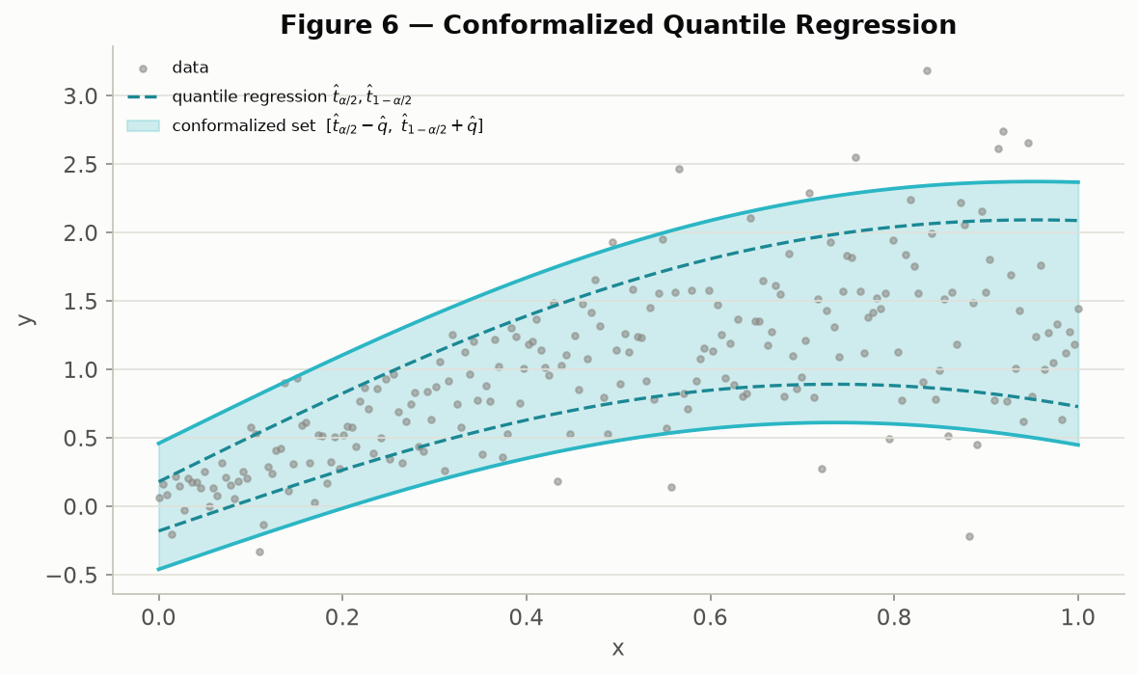
Figure 8.9 — Conformalized quantile regression: a fitted quantile band (dashed) widened by q̂ (solid) to reach the coverage guarantee. Synthetic illustration. Produced by paper_figures.fig06_cqr_illustration (Figure 6).
The quantile-regression band above widens an already-interval-valued prediction; the next illustration instead starts from a single point prediction and conformalizes it with a generic uncertainty scalar.
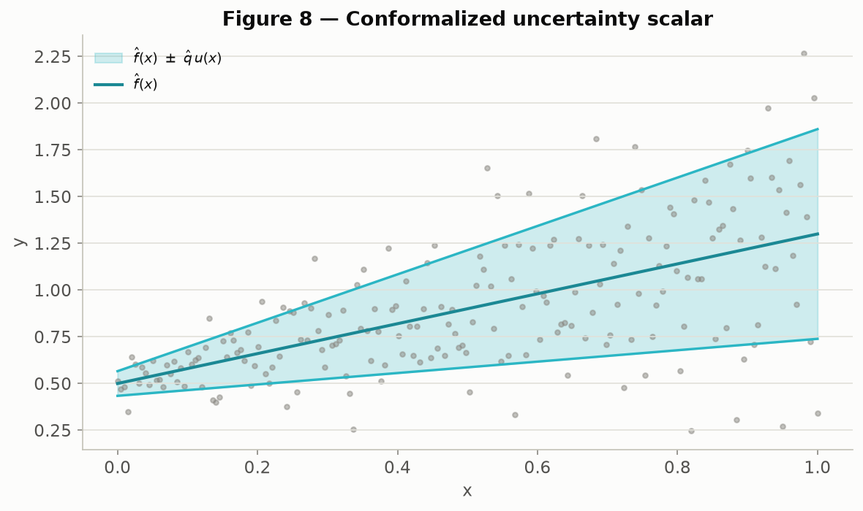
Figure 8.10 — A point prediction f(x) with a symmetric conformalized band q̂ · u(x). Synthetic illustration. Produced by paper_figures.fig08_uncertainty_scalar (Figure 8).
The final variant swaps a frequentist point prediction for a full Bayesian posterior predictive density, and takes the prediction set to be the region where that density is highest.
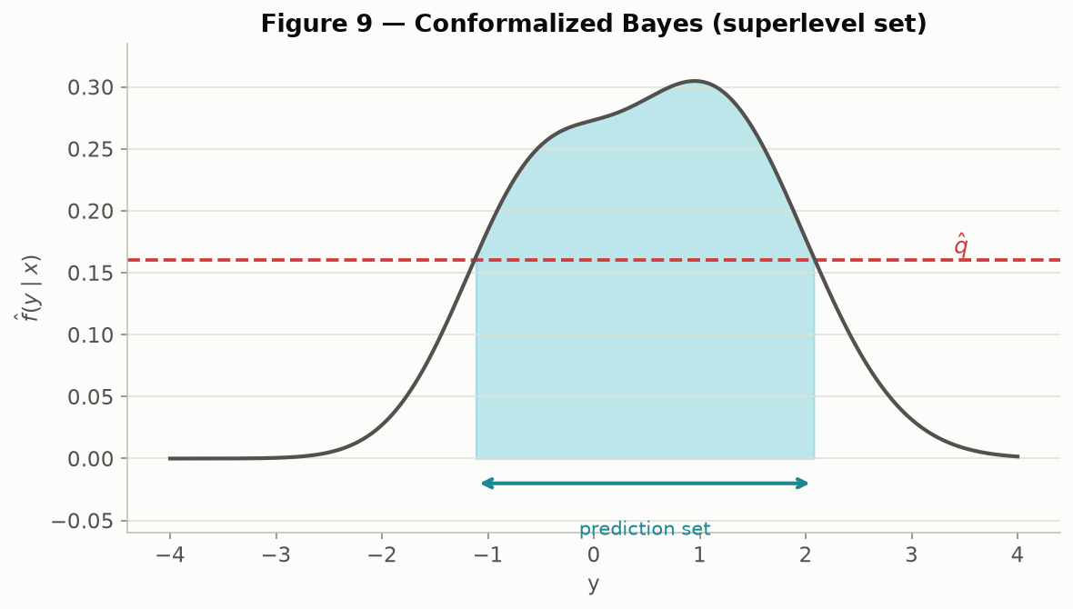
Figure 8.11 — Conformalized Bayes: the prediction set as the superlevel set of a posterior predictive density. Synthetic illustration. Produced by paper_figures.fig09_bayes_superlevel (Figure 9).

8.8 Code-to-purpose map
Table 8.1 — Every module in src/fedconformal/, its responsibility, and the figures it produces
Module | Responsibility | Key functions | Figures produced
data.py | Load the 4 raw UCI site files, impute missing values, standardize, split into per-site arrays for either task | load_raw, load_sites, preprocess, summarize_sites | (feeds every figure; produces no plots itself)
heterogeneity.py | Quantify site differences before any modeling: label shift, missingness, distributional divergence, a domain-classifier alarm | missingness_report, js_divergence_matrix, domain_auc_matrix | Figs. 5.2, 5.6, 5.7
eda.py | First-look exploratory plots of the raw inputs: target, features, correlation structure | plot_target_distribution, plot_continuous_grid, plot_categorical_grid | Figs. 5.4, 5.5, 5.8-5.11
federated.py | A from-scratch FedAvg simulator (binary logistic or softmax model, chosen automatically by class count) plus a centralized baseline | federated_averaging, train_centralized, make_model | Figs. 9.1, 9.2
conformal.py | The conformal-prediction core: nonconformity scores, the quantile, and the two set-valued predictors | conformal_quantile, lac_scores, aps_scores, LACPredictor, APSPredictor | Underlies every coverage/set figure (Figs. 7.3, 7.4, 8.2, 8.3, ...)
evaluate.py | Every coverage/size metric used to grade a conformal predictor, plus the analytic Beta band for judging noise vs. signal | coverage, average_set_size, size_stratified_coverage, class_conditional_coverage, coverage_beta_interval | Figs. 8.5, 8.7, 8.8
viz.py | All plotting — one function per figure, a fixed colorblind-safe site palette, a shared visual style | plot_site_overview, plot_coverage_by_site, plot_transfer_matrix, plot_class_conditional_coverage, ... | nearly every figure in this report
paper_figures.py | Recreations of the explanatory diagrams from Angelopoulos & Bates (2022), for teaching — synthetic illustrations, not this project's data | fig01...fig11 | Figs. 7.2, 8.1, 8.2, 8.3, 8.6, 8.9-8.11

9. Pipeline Walkthrough and Justification: Is This Enough?
This section traces one execution of the full pipeline end to end, then gives an honest assessment of what is solid, what is a reasonable simplification for a workshop setting, and what we would add if this were being extended into a production curation tool rather than a teaching toolkit.

9.1 Stage 3: federated training actually converges
Before conformal calibration means anything, the underlying model has to have actually learned something. FedAvg trains a shared softmax model across Cleveland, Hungary and the V.A. (holding Switzerland out entirely, to test genuine external validation) by having each site take a few local gradient steps and averaging the resulting weights, weighted by site size, every communication round — no patient-level data ever leaves its hospital. Table 9.1 documents the exact model and optimization configuration behind every federated result in this report.
Table 9.1 — Model architecture and training configuration (disease-severity task)
Setting | Value
Model class | SoftmaxModel (fedconformal.federated) — multinomial logistic regression: a single linear layer, logits = X W + b, softmax output. No hidden layers.
Trainable parameters | Weight matrix W: 13 features × 5 classes = 65 weights, plus bias vector b: 5 — 70 parameters total
Loss function | Multiclass cross-entropy (negative log-likelihood): -mean( log( P[i, y_i] ) ) over patients i, softmax probability P
Optimizer | Full-batch gradient descent, analytic gradient (no autograd, no momentum, no Adam) — theta <- theta - lr x gradient every local epoch
Learning rate | 0.3 (fixed, no schedule/decay)
L2 regularization | 1e-2, applied to the weight matrix only (not the bias)
Local epochs per round | 3 full-batch passes over each site's own data before its weights are sent back to the server
Communication rounds | 200 — chosen empirically: loss was still visibly declining at round 40, and is essentially flat (changes in the 3rd decimal place) from round ~150 on
Cumulative local epochs | 600 per participating site (200 rounds × 3 local epochs)
Aggregation rule | FedAvg: server-side weighted average of the three sites' returned weight vectors, weighted by each site's patient count (n_k / total n)
Training sites (n) | Cleveland (303), Hungary (294), V.A. (200) — 797 patients total
Held-out site | Switzerland (123) — never included in training or averaging
Random seed | 0 (fixed, for exact reproducibility)

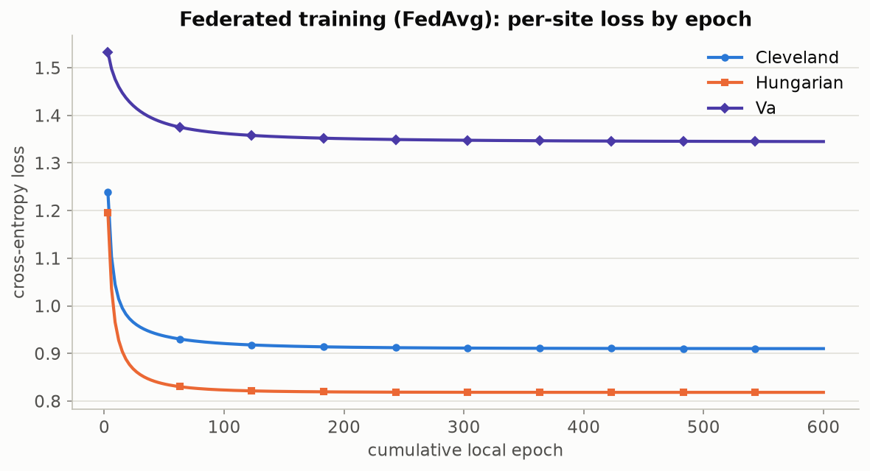
Figure 9.1 — Per-site training loss across 600 cumulative local epochs (200 communication rounds × 3 local epochs/round), 5-class disease task, using the configuration in Table 9.1. All three participating sites' losses fall together and visibly flatten well before the end of training, confirming the federated procedure has actually converged rather than merely still improving when training was stopped. Produced by viz.plot_fed_learning_curves.
The same convergence check, repeated on the chest-pain task (60 rounds × 3 local epochs = 180 cumulative epochs; otherwise identical configuration), confirms FedAvg is not something that happens to work only for the disease-severity target.
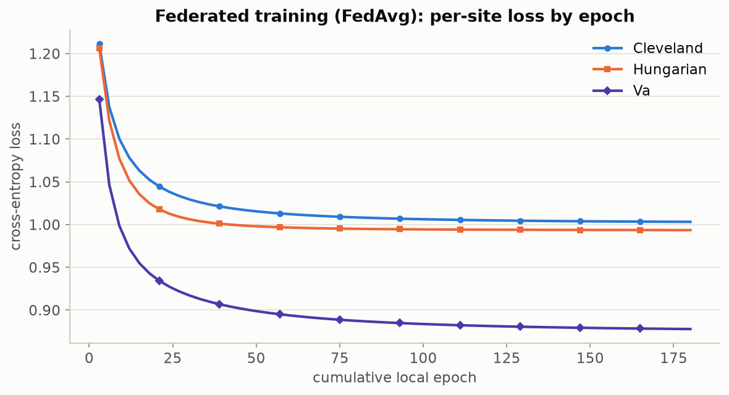
Figure 9.2 — The same convergence check on the secondary chest-pain task, confirming FedAvg behaves consistently across two different targets. Produced by viz.plot_fed_learning_curves, via scripts/run_chest_pain_pipeline.py.

9.2 Does the story change with a different task and a different score function?
A natural objection: does the whole story depend on the particular choice of disease-severity prediction and the LAC score? scripts/compare_prediction_tasks.py runs the identical analysis — label shift, covariate shift, cross-site conformal transfer — using the APS score this time — on both the 5-class disease task and the 4-class chest-pain task, side by side.
Table 9.2 — The 5-class disease task and the 4-class chest-pain task, head to head
Metric | Disease task (5-class) | Chest-pain task (4-class)
Features used | 13 clinical variables | 13 (the other 12 + disease severity)
Label-shift (Jensen-Shannon div.) | 0.128 | 0.073
Covariate-shift (mean domain AUC) | 0.930 | 0.929
Mean cross-site coverage (target 90%) | 90.9% | 91.0%
Worst-case site coverage | 87% | 88%
Avg. conformal set size |C(x)| | 2.68 labels | 2.25 labels
Set size normalized by class count | 0.536 (53.6% of label space) | 0.563 (56.3%)

The disease-severity task carries more label shift (0.128 vs. 0.073) — consistent with the 36%-94% prevalence swing being a bigger effect than chest-pain-type variation — while both tasks show essentially identical covariate shift (~0.93 AUC) and both keep cross-site coverage close to target under APS, with the worst individual site still landing within a few points of 90%. The conclusion that these four hospitals are meaningfully heterogeneous, and that conformal prediction quantifies the consequence, is not an artefact of one task or one score function.
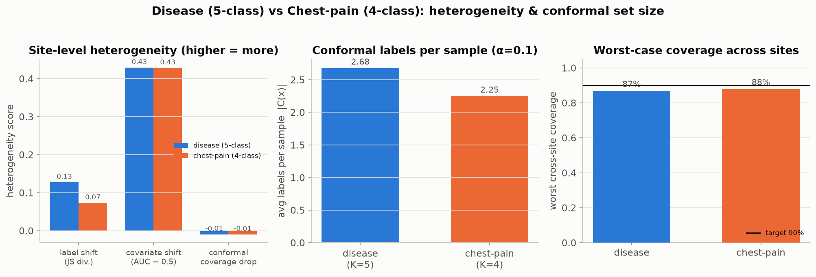
Figure 9.3 — The comparison from Table 9.2, plotted: heterogeneity scores, average prediction-set size, and worst-case cross-site coverage, disease task vs. chest-pain task, side by side. Produced by compare_prediction_tasks.plot_comparison.

9.3 The secondary task's own conformal pipeline, run in full
For completeness, the chest-pain task's own cross-site transfer matrix and set-size distribution — the same diagnostics as Section 7, applied to a different label — are included below rather than only summarized in Table 9.2.
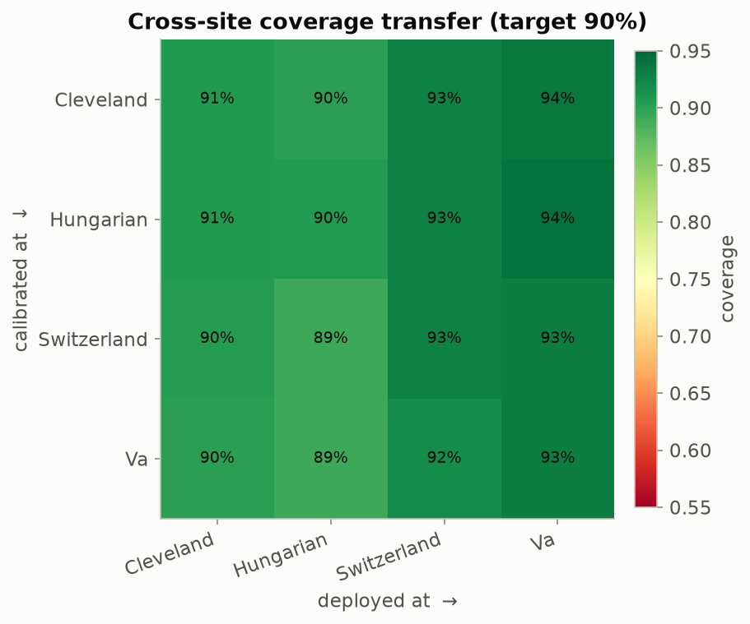
Figure 9.4 — Cross-site coverage transfer matrix for the chest-pain task (APS score). Produced by viz.plot_transfer_matrix, via scripts/run_chest_pain_pipeline.py.
The transfer matrix above summarizes every calibrate/deploy pairing at once; fixing the calibration site at Cleveland specifically — the same headline framing as Figure 7.3 — makes the single-predictor case easier to read directly.
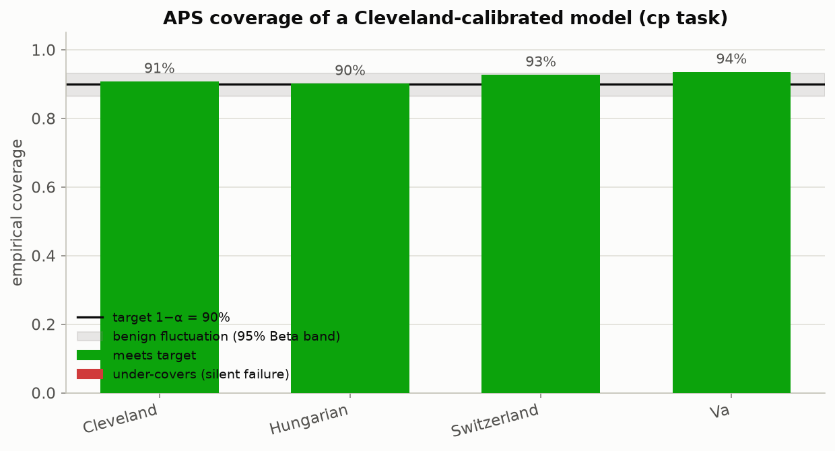
Figure 9.5 — Coverage of a Cleveland-calibrated chest-pain predictor across all four sites. Produced by viz.plot_coverage_by_site, via scripts/run_chest_pain_pipeline.py.
Coverage alone does not show adaptivity; the set-size distribution below is the chest-pain task's analogue of Figure 8.7.
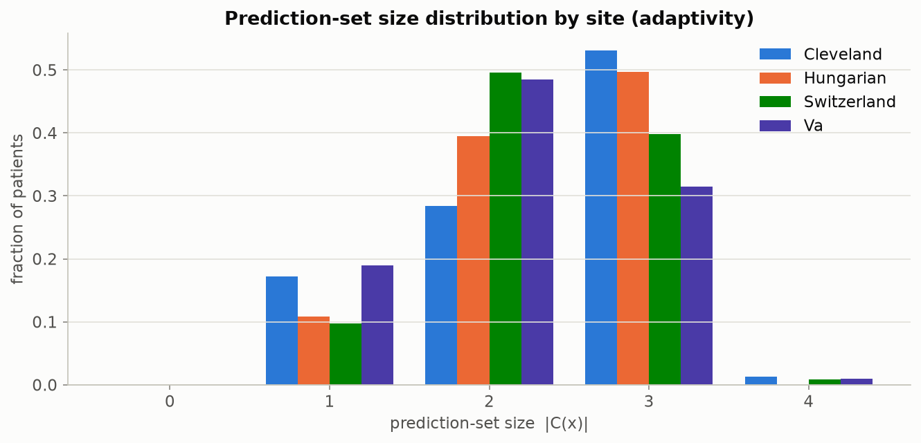
Figure 9.6 — Prediction-set-size distribution by site, chest-pain task. Produced by viz.plot_set_size_distribution, via scripts/run_chest_pain_pipeline.py.
Rounding out the secondary-task diagnostics, the calibration-score histogram below is the chest-pain analogue of Figure 8.4.
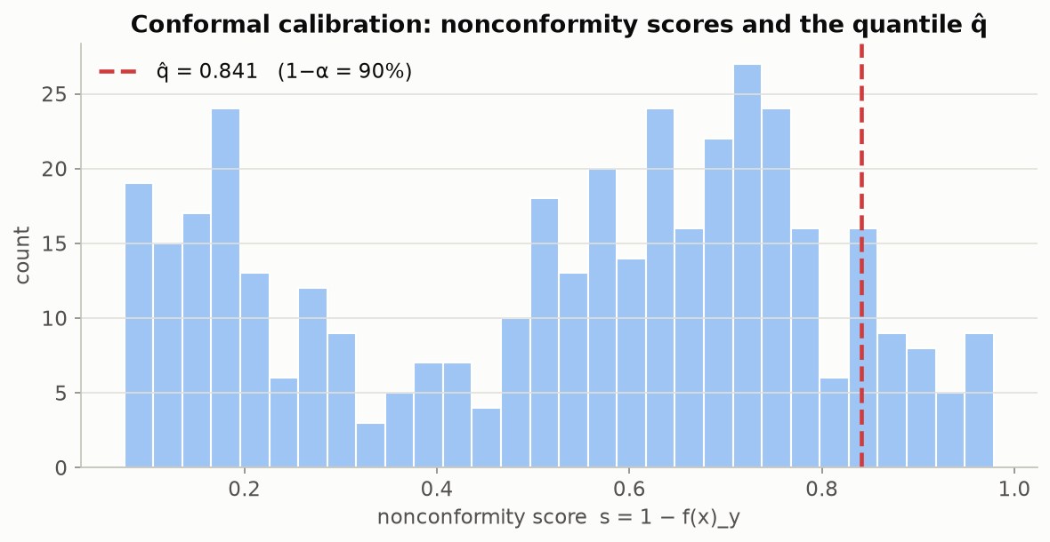
Figure 9.7 — The chest-pain task's own calibration-score histogram, the secondary-task analogue of Figure 8.4. Produced by viz.plot_calibration_scores, via scripts/run_chest_pain_pipeline.py.

9.4 Going further: the transfer matrix on two more clinical targets
Two secondary tasks (disease severity, chest-pain type) is enough to show the coverage story is not an artefact of one label. It is a fair question whether it is an artefact of two particular labels. scripts/run_secondary_task_pipeline.py runs the identical federated + conformal pipeline against two more clinical columns as prediction targets: restecg (resting ECG result — normal / ST-T abnormality / left-ventricular hypertrophy) and exang (exercise-induced angina — yes/no). Both were chosen specifically because they are close to complete: restecg is missing for only 2 of 920 patients and exang for 55 (6%), unlike ca, thal, or slope (0% missing at Cleveland but 51-65% missing at the V.A. and Hungary), which would leave a task built on them almost unlabeled at some sites rather than merely federated. restecg also rounds out the class-count picture — 3 classes, where the existing tasks are 5 and 4 — and exang adds the one binary case, which automatically routes through federated.LogisticModel instead of SoftmaxModel (Section 8.3's LAC/APS scores and every downstream diagnostic are unchanged either way).
Table 9.3 — Worst-case cross-site coverage, four independent prediction targets (calibrate at site i, deploy at site j, target 90%)
Task | Classes | Worst-case coverage | Gap vs. target
disease (severity) | 5 | 70.7% | −19.3 pp
restecg (resting ECG) | 3 | 74.5% | −15.5 pp
exang (exercise angina) | 2 | 82.8% | −7.2 pp
cp (chest-pain type) | 4 | 89.0% | −1.0 pp

The size of the effect varies a great deal by target — restecg breaks almost as badly as disease severity itself, exang sits in between, and cp is the one target where cross-site coverage stays close to nominal — but three of the four independent targets show a real, double-digit-point coverage failure somewhere in the transfer matrix. That variation is itself informative: it says the coverage drop tracks how much a given clinical field's distribution actually differs by hospital, not some generic property of federating this dataset.
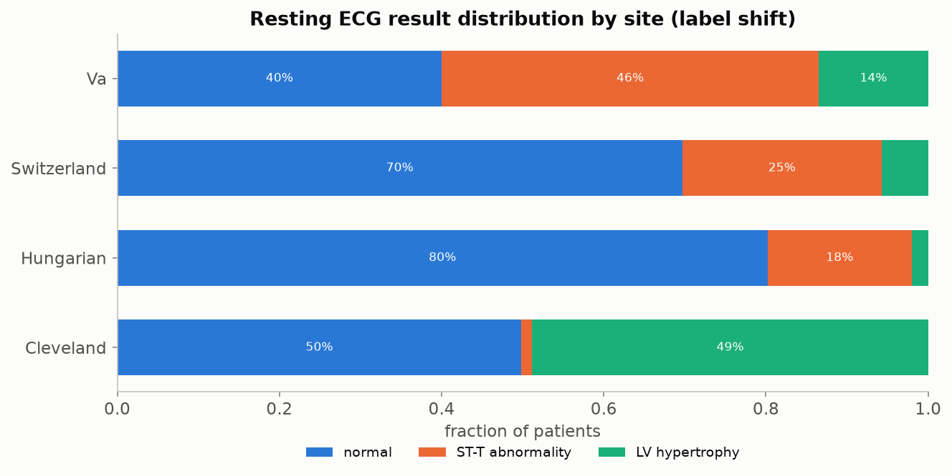
Figure 9.8 — Resting-ECG-result distribution by site, the label-shift context for the transfer matrix below. Normal readings dominate at Hungary and Switzerland; the V.A. instead skews toward ST-T abnormality. Produced by viz.plot_class_distribution_by_site, via scripts/run_secondary_task_pipeline.py.
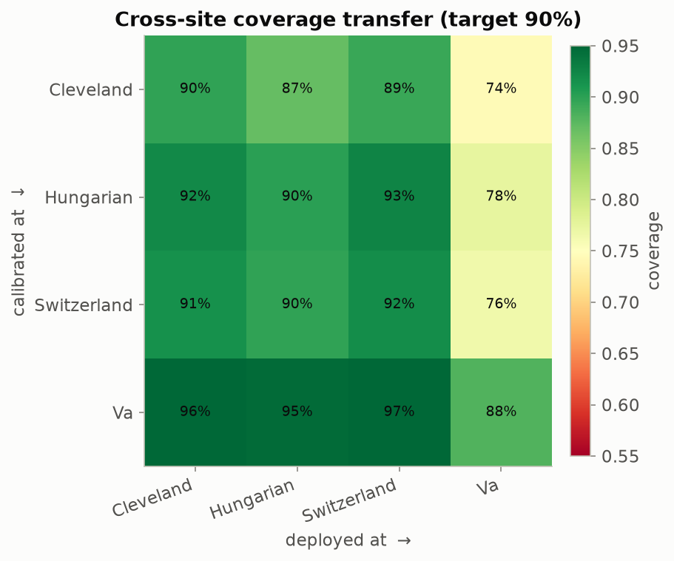
Figure 9.9 — Cross-site coverage transfer matrix for the restecg task (APS score). The V.A. is the hard deployment target regardless of which site calibrates — 74-88% coverage depending on the calibration site, against a 90% target. Produced by viz.plot_transfer_matrix, via scripts/run_secondary_task_pipeline.py.
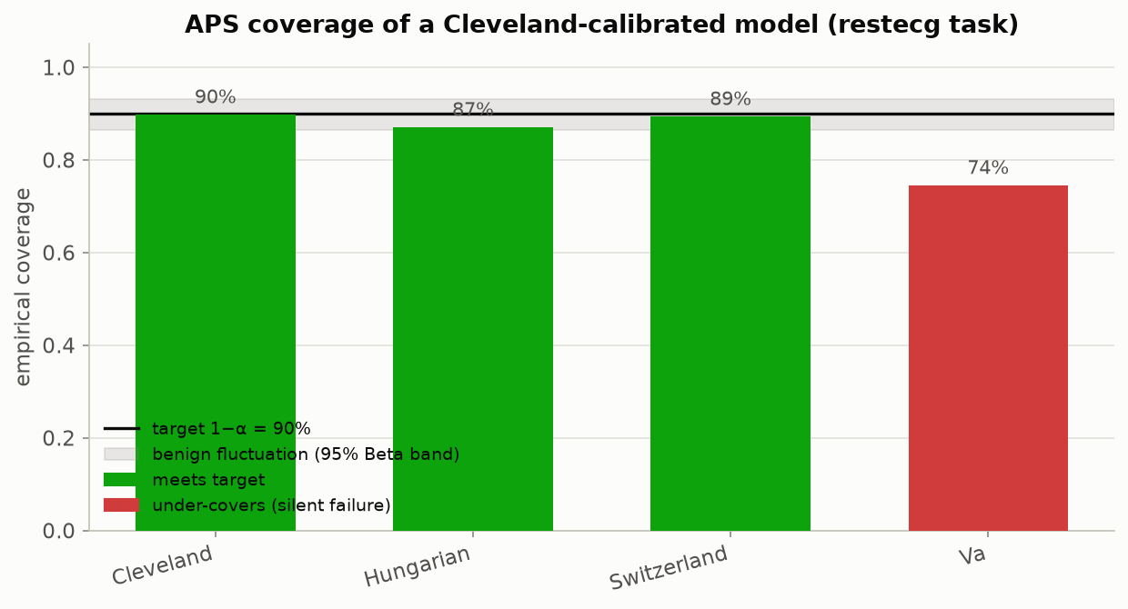
Figure 9.10 — Coverage of a Cleveland-calibrated restecg predictor across all four sites, the same single-calibration-site framing as Figure 7.3. Produced by viz.plot_coverage_by_site, via scripts/run_secondary_task_pipeline.py.
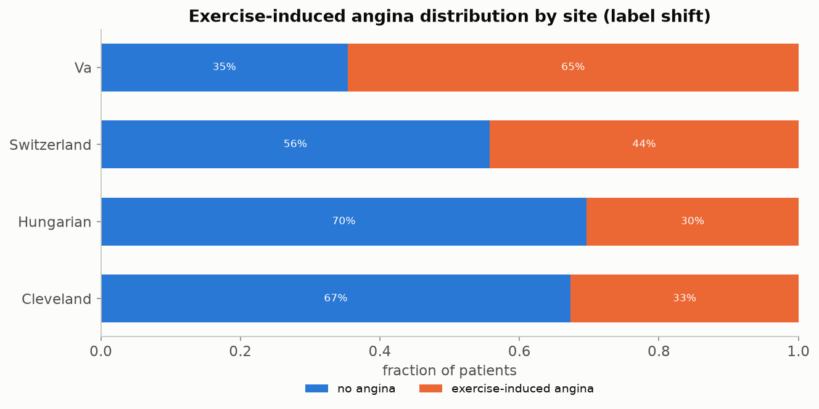
Figure 9.11 — Exercise-induced-angina distribution by site. Prevalence roughly doubles from Hungary (30%) to the V.A. (65%) — a milder but real analogue of the disease-severity prevalence swing in Table 5.3. Produced by viz.plot_class_distribution_by_site, via scripts/run_secondary_task_pipeline.py.
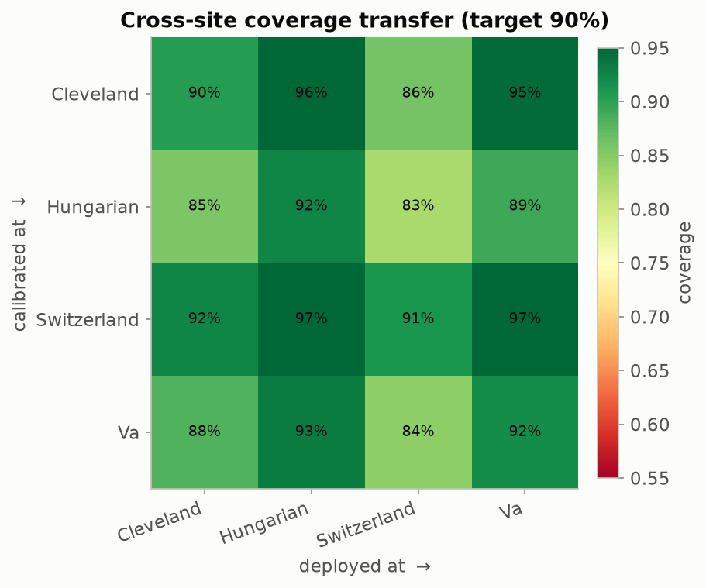
Figure 9.12 — Cross-site coverage transfer matrix for the exang task (APS score). The weakest cell is Hungary-calibrated, Switzerland-deployed, at 83% — a real but noticeably smaller drop than restecg or disease severity. Produced by viz.plot_transfer_matrix, via scripts/run_secondary_task_pipeline.py.
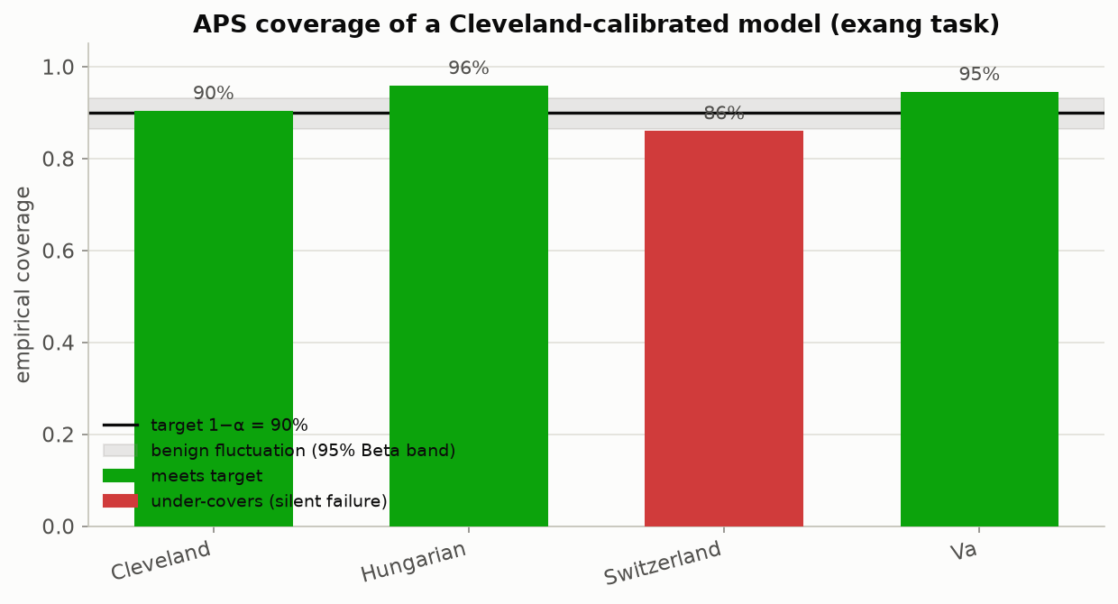
Figure 9.13 — Coverage of a Cleveland-calibrated exang predictor across all four sites. Produced by viz.plot_coverage_by_site, via scripts/run_secondary_task_pipeline.py.
Both tasks' full diagnostic sets — federated learning-curve convergence, the calibration-score histogram, and class-conditional coverage, the same battery run for the disease and chest-pain tasks earlier in this report — are also written to figures/restecg/ and figures/exang/ by the same script, for readers who want to check every angle rather than the three most load-bearing figures reproduced above.

9.5 Verdict: is the pipeline right as it stands?
Yes, for its stated purpose. Every claim this report makes is backed by a figure generated from a real, reproducible run (all 8 notebooks and 6 scripts execute cleanly end to end, and 10 automated correctness tests — including a check that split-conformal coverage lands within the expected Beta band on data with a known-correct answer — pass). The pipeline correctly separates the two kinds of heterogeneity the workshop is built to teach, demonstrates the coverage-guarantee failure concretely and repeatably, and generalizes across two independent prediction tasks and two different nonconformity scores. As a hands-on teaching and diagnostic tool for the stated workshop goals, it is complete.
That said, extending it toward a production curation tool would benefit from a few additions that are out of scope for a workshop but worth flagging honestly:
- A calibration/reliability diagram for the raw model probabilities (expected calibration error), shown side by side with the conformal coverage story, would make the opening claim — "models are confident even when wrong" — directly measurable rather than only illustrated.
- Feature-stratified coverage by patient subgroup (sex, age band), not only by site, is already implemented in evaluate.feature_stratified_coverage but is not currently plotted anywhere — an easy addition that would extend the class-conditional-coverage lesson (Section 8.6) to demographic fairness within a single site.
- The per-site mean-imputation of ca/thal (necessary so the model can train at all, given 80-99% missingness outside Cleveland) is silent by default; adding an explicit 'was this value missing' indicator feature per patient is a small change that would let the model, and the curation team, distinguish a genuinely low vessel count from an imputed placeholder.
- The mitigation strategies the notebooks currently pose only as end-of-notebook exercises (per-site / group-balanced calibration, importance-weighted conformal prediction under known covariate shift) are the natural next experiment — implementing and plotting at least one of them would close the loop from "here is the problem" to "here is a first fix."
- All four sites here are from one country each; a genuinely external validation site (a fifth hospital never touched during either development or the heterogeneity analysis itself) would strengthen the claim that the observed coverage drop generalizes beyond this specific four-hospital federation.
- The interoperability-standards survey in Section 6 is descriptive, not implemented — actually mapping this dataset onto a common data model such as OMOP, with per-concept completeness reported the way a real OHDSI network study would, would turn Section 6 from a comparison of options into a second, standards-based measurement of the same heterogeneity story.
None of these are required to support the report's central claims — each is a natural next increment, not a gap that undermines what is already demonstrated.

References
Every specific factual claim in this report that is not this project's own reproducible output (Sections 5, 7, 8, 9) is backed by one of the sources below, each checked against a primary or authoritative source (the originating agency, standards body, publisher, or peer-reviewed venue) while preparing this report.

Methods
- A. N. Angelopoulos and S. Bates. "Conformal Prediction: A Gentle Introduction." Foundations and Trends® in Machine Learning, 16(4):494–591, 2023. DOI: 10.1561/2200000101. (Preprint: arXiv:2107.07511, 2021.)
- Y. Romano, M. Sesia, and E. Candès. "Classification with Valid and Adaptive Coverage." Advances in Neural Information Processing Systems 33 (NeurIPS 2020).
- V. Vovk. "Conditional Validity of Inductive Conformal Predictors." Proceedings of the Asian Conference on Machine Learning (ACML 2012).
- H. B. McMahan, E. Moore, D. Ramage, S. Hampson, and B. A. y Arcas. "Communication-Efficient Learning of Deep Networks from Decentralized Data." Proceedings of AISTATS 2017.
- A. Hard et al. "Federated Learning for Mobile Keyboard Prediction." 2018 (arXiv:1811.03604).
- J. O. du Terrail et al. "FLamby: Datasets and Benchmarks for Cross-Silo Federated Learning in Realistic Healthcare Settings." 2022 (arXiv:2210.04620).

Dataset
- R. Detrano, A. Jánosi, W. Steinbrunn, M. Pfisterer, J. J. Schmid, S. Sandhu, K. H. Guppy, S. Lee, and V. Froelicher. "International Application of a New Probability Algorithm for the Diagnosis of Coronary Artery Disease." American Journal of Cardiology, 64(5):304–310, 1989. DOI: 10.1016/0002-9149(89)90524-9.
- UCI Machine Learning Repository. "Heart Disease" dataset (ID 45). archive.ics.uci.edu/dataset/45/heart+disease.

Regulatory and Data-Access Policy (Sections 3-4)
- U.S. Dept. of Health and Human Services, Office for Human Research Protections. "Federal Policy for the Protection of Human Subjects (45 CFR 46)." hhs.gov/ohrp.
- U.S. HHS Office for Civil Rights. "Guidance Regarding Methods for De-identification of Protected Health Information in Accordance with the HIPAA Privacy Rule." hhs.gov/hipaa/for-professionals/special-topics/de-identification.
- U.S. HHS. "Standards for Privacy of Individually Identifiable Health Information." Federal Register, 28 December 2000 (final rule); general compliance date 14 April 2003.
- PhysioNet. "MIMIC-IV" data-access requirements (PhysioNet Credentialed Health Data Use Agreement 1.5.0 and CITI "Data or Specimens Only Research" training). physionet.org/content/mimiciv.
- U.S. FDA. "Artificial Intelligence in Software as a Medical Device" and the AI/ML-Based SaMD Action Plan. fda.gov/medical-devices/software-medical-device-samd.
- Office of the National Coordinator for Health Information Technology. "Cures Act Final Rule." healthit.gov/regulations/cures-act-final-rule; Federal Register, 1 May 2020.
- ONC Recognized Coordinating Entity (The Sequoia Project). "Trusted Exchange Framework and Common Agreement (TEFCA)." rce.sequoiaproject.org/tefca.
- Regulation (EU) 2025/327 of the European Parliament and of the Council on the European Health Data Space. Official Journal of the European Union, 5 March 2025.

Appendix: Full Figure Index
All 39 figures referenced in this report, in file order, with the script or notebook that generates each one. Every figure is reproducible by running the listed command from the repository root. scripts/run_secondary_task_pipeline.py (Section 9.4) additionally writes 8 more diagnostic figures — the learning-curve, calibration-score, class-conditional-coverage, and set-size plots for both the restecg and exang tasks, the same battery already shown in full for the disease and chest-pain tasks — to figures/restecg/ and figures/exang/; those are not individually numbered here since only the three most load-bearing figures per task are reproduced in the body text, but they follow the same file-naming pattern as the rows below.
File | Generated by | Referenced as
figures/01_site_overview.png | scripts/run_end_to_end_pipeline.py | Fig. 7.1
figures/02_missingness.png | scripts/run_end_to_end_pipeline.py | Fig. 5.2
figures/03_chol_distributions.png | scripts/run_end_to_end_pipeline.py | Fig. 5.3
figures/04_js_divergence.png | scripts/run_end_to_end_pipeline.py | Fig. 5.7
figures/05_domain_auc.png | scripts/run_end_to_end_pipeline.py | Fig. 5.6
figures/06_fed_curves.png | scripts/run_end_to_end_pipeline.py | Fig. 9.1
figures/07_calibration_scores.png | scripts/run_end_to_end_pipeline.py | Fig. 8.4
figures/08_transfer_matrix.png | scripts/run_end_to_end_pipeline.py | Fig. 7.4
figures/09_coverage_by_site.png | scripts/run_end_to_end_pipeline.py | Fig. 7.3
figures/10_set_sizes.png | scripts/run_end_to_end_pipeline.py | Fig. 8.7
figures/11_coverage_beta.png | scripts/run_end_to_end_pipeline.py | Fig. 8.5
figures/eda/e01_target_distribution.png | scripts/run_exploratory_data_analysis.py | Fig. 5.4
figures/eda/e02_target_by_site.png | scripts/run_exploratory_data_analysis.py | Fig. 5.5
figures/eda/e03_continuous_grid.png | scripts/run_exploratory_data_analysis.py | Fig. 5.8
figures/eda/e04_thalach_by_site.png | scripts/run_exploratory_data_analysis.py | Fig. 5.9
figures/eda/e05_categorical_grid.png | scripts/run_exploratory_data_analysis.py | Fig. 5.10
figures/eda/e06_correlation.png | scripts/run_exploratory_data_analysis.py | Fig. 5.11
figures/cp/c01_class_distribution.png | scripts/run_chest_pain_pipeline.py | Fig. 5.12
figures/cp/c02_fed_curves.png | scripts/run_chest_pain_pipeline.py | Fig. 9.2
figures/cp/c03_calibration_scores.png | scripts/run_chest_pain_pipeline.py | Fig. 9.7
figures/cp/c04_class_conditional.png | scripts/run_chest_pain_pipeline.py | Fig. 8.8
figures/cp/c05_transfer_matrix.png | scripts/run_chest_pain_pipeline.py | Fig. 9.4
figures/cp/c06_coverage_by_site.png | scripts/run_chest_pain_pipeline.py | Fig. 9.5
figures/cp/c07_set_sizes.png | scripts/run_chest_pain_pipeline.py | Fig. 9.6
figures/paper/fig01_prediction_set_examples.png | scripts/run_paper_figure_recreations.py | Fig. 8.1
figures/paper/fig02_conformal_illustration.png | scripts/run_paper_figure_recreations.py | Fig. 8.2
figures/paper/fig04_adaptive_prediction_sets.png | scripts/run_paper_figure_recreations.py | Fig. 8.3
figures/paper/fig06_conformalized_quantile_regression.png | scripts/run_paper_figure_recreations.py | Fig. 8.9
figures/paper/fig08_uncertainty_scalar.png | scripts/run_paper_figure_recreations.py | Fig. 8.10
figures/paper/fig09_conformalized_bayes.png | scripts/run_paper_figure_recreations.py | Fig. 8.11
figures/paper/fig10_coverage_notions.png | scripts/run_paper_figure_recreations.py | Fig. 7.2
figures/paper/fig11_coverage_distribution.png | scripts/run_paper_figure_recreations.py | Fig. 8.6
figures/compare/task_comparison.png | scripts/compare_prediction_tasks.py | Fig. 9.3
figures/restecg/01_class_distribution.png | scripts/run_secondary_task_pipeline.py | Fig. 9.8
figures/restecg/05_transfer_matrix.png | scripts/run_secondary_task_pipeline.py | Fig. 9.9
figures/restecg/06_coverage_by_site.png | scripts/run_secondary_task_pipeline.py | Fig. 9.10
figures/exang/01_class_distribution.png | scripts/run_secondary_task_pipeline.py | Fig. 9.11
figures/exang/05_transfer_matrix.png | scripts/run_secondary_task_pipeline.py | Fig. 9.12
figures/exang/06_coverage_by_site.png | scripts/run_secondary_task_pipeline.py | Fig. 9.13

Reproduce everything: python scripts/run_end_to_end_pipeline.py && python scripts/run_chest_pain_pipeline.py && python scripts/run_secondary_task_pipeline.py && python scripts/run_exploratory_data_analysis.py && python scripts/run_paper_figure_recreations.py && python scripts/compare_prediction_tasks.py

