Beyond Interoperability
Conformal Prediction for Site-Level Heterogeneity
in Federated Clinical Data
A technical report and workshop companion for the fedconformal-clinical toolkit
UCI Heart Disease federation · 4 hospitals · 920 patients · 33 figures

Contents
Executive Summary
1. Why Conformal Prediction Helps With Site-Level Heterogeneity
2. The Mathematics, and What Every Piece of Code Produces
3. Why This Dataset Is an Ideal Testbed for Interoperability
4. Pipeline Walkthrough and Justification: Is This Enough?
Appendix: Full Figure Index

Executive Summary
Interoperability means two systems can exchange and read each other's data without a human translating in between. It says nothing about whether the data means the same thing once it arrives. A hospital's cholesterol field and another hospital's cholesterol field can sit in the identical column, in the identical format, and still describe two different measurement processes -- one hospital records it, another does not. That gap between "the data moved successfully" and "the data can be trusted the same way everywhere" is the problem this project addresses.
We use conformal prediction -- a statistical wrapper that turns any machine-learning model's output into an honest, checkable range of possible answers -- as a diagnostic instrument for that gap. A conformal predictor comes with a guarantee: at the site where it was calibrated, its prediction ranges will contain the true answer at a chosen rate (say, 90% of the time), no matter what model sits underneath it. That guarantee is a promise about *one* site. The moment you deploy the same predictor at a second site, the promise is only as good as the assumption that the second site's data looks statistically like the first. When it does not -- when there is real site-level heterogeneity -- the guarantee breaks, visibly and measurably, and conformal prediction is precisely the tool that lets you see it break instead of finding out the hard way in production.
This report walks through the full toolkit built to make that idea concrete and hands-on: the UCI Heart Disease dataset loaded from its four original hospital sites (Cleveland, Hungary, Switzerland, the V.A. Long Beach), a from-scratch federated-learning simulator, a from-scratch conformal-prediction library, and a battery of diagnostics that separate genuine population differences ("this hospital really does see sicker patients") from measurement artefacts ("this hospital simply never recorded this lab value"). Every figure the pipeline produces -- 33 in total -- is reproduced here with a plain-language explanation of what it shows and why it matters, alongside the mathematics behind the method and an honest assessment of what is solid and what could still be added.

1. Why Conformal Prediction Helps With Site-Level Heterogeneity

1.1 The problem: models are confident even when they are wrong
A typical machine-learning classifier reports a number that looks like a probability -- "92% chance this patient has heart disease." That number is not actually a probability in any guaranteed sense; it is whatever the model happened to output. Nothing forces it to be correct 92% of the time. In practice, a model trained on one hospital's patients and then run on a different hospital's patients often stays just as confident -- the 92% does not shrink -- while its actual correctness rate quietly drops. The model does not know it has left home. This is the single most dangerous failure mode in cross-institution deployment: not a model that visibly fails, but one that fails silently while sounding just as sure of itself as it did during development.
Interoperability standards solve the problem of *getting the data there*. They do nothing to solve this problem, because the failure is not about the data format -- it is about whether the statistical relationship the model learned at Hospital A still holds at Hospital B. Two hospitals can use an identical schema, an identical column called "cholesterol," and still have that column mean something different in practice (measured routinely at one site, almost never measured at another). A model cannot tell the difference between a hospital with genuinely different patients and a hospital with a broken measurement pipeline unless something is specifically built to check.

1.2 What conformal prediction actually does
Conformal prediction is a wrapper you can put around *any* trained model -- logistic regression, a neural network, anything that outputs a score per class -- that converts its raw scores into a set of plausible answers, with a guarantee attached to the size and content of that set. Instead of the model saying "heart disease, severity 2, 92% confident," a conformal predictor says "the true severity is somewhere in {1, 2, 3}, and this kind of statement is right at least 90% of the time." When the model is unsure, the set grows to include more possibilities; when it is sure, the set can shrink to a single class. Crucially, the 90% figure is not a hope -- it is a mathematical guarantee that holds regardless of whether the underlying model is any good, as long as one condition holds: the data you calibrate the guarantee on must look statistically like the data you later apply it to.
That condition -- formally called *exchangeability*, discussed in Section 2 -- is exactly where site heterogeneity enters the picture. Calibrating a conformal predictor at one hospital and deploying it at another silently assumes the two hospitals are exchangeable. If they are not, the 90% promise degrades to whatever the real cross-site agreement supports, and conformal prediction becomes a *measuring instrument* for that degradation: you calibrate at one site, check the empirical coverage at every other site, and the gap between the promised rate and the observed rate is a direct, quantitative readout of how much that pair of sites disagrees. No other common technique gives you a single interpretable number for "how much can I trust this model somewhere it hasn't been tested."

1.3 Averages hide the failure -- you have to look per site
The single most important lesson in this toolkit is that a pooled, dataset-wide coverage number can look perfect while hiding a badly broken subgroup. A conformal predictor calibrated across all four hospitals together can report 90% coverage overall while one hospital sits at 70% and the others compensate by over-covering. This is exactly what we observe: a model federated over Cleveland, Hungary and the V.A., then calibrated using only Cleveland patients and deployed everywhere, hits 90-91% coverage at Cleveland, Hungary and the V.A. -- and drops to 71% at Switzerland, the hospital the federation never trained on (Figure 1.3). Reported as one pooled number, this problem is invisible. Reported per site, it is impossible to miss. That is the practical argument for conformal prediction in a curation pipeline: it is cheap to compute, attaches to any model you already have, and turns "is this data comparable across sites" from a qualitative judgment call into a number you can put in a table and set a threshold on.
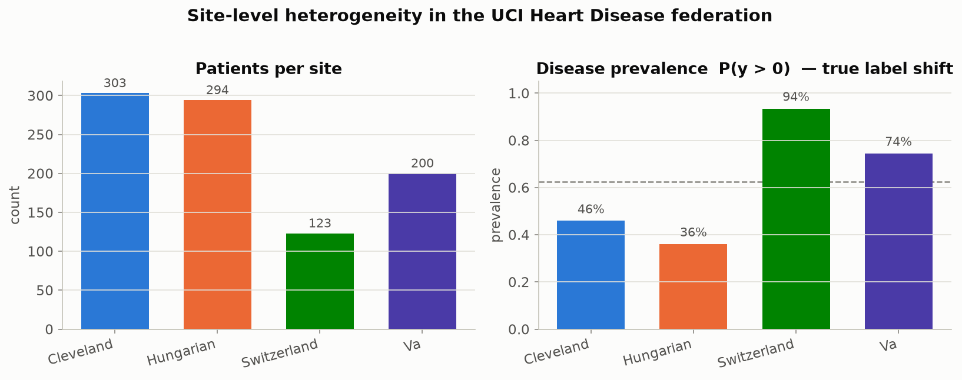
Figure 1.1 -- Patients per site and disease prevalence per site. Prevalence swings from 36% (Hungary) to 94% (Switzerland): a genuine difference in patient population (true distributional shift), not a data-entry artefact. Produced by viz.plot_site_overview, called from data.summarize_sites.
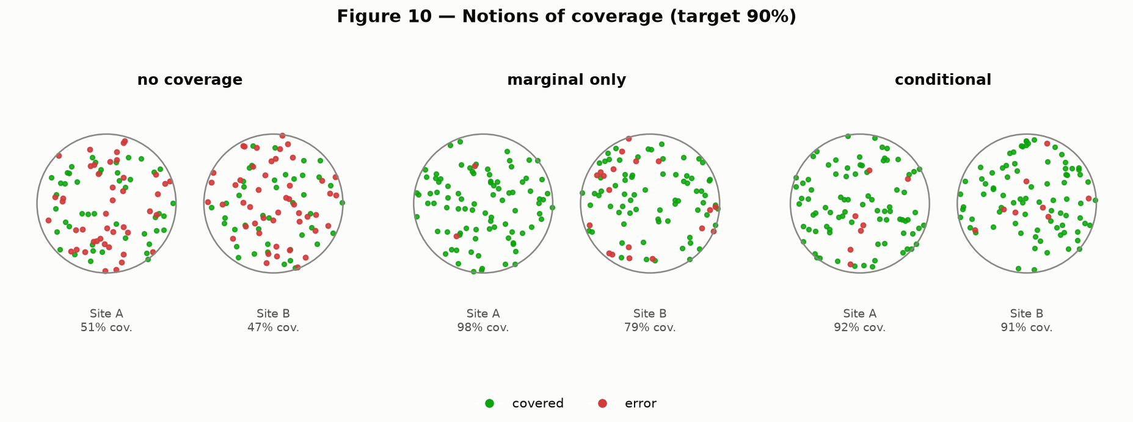
Figure 1.2 -- The distinction this whole report rests on, drawn schematically for two groups. Left: no coverage guarantee at all. Middle: 'marginal' coverage -- the overall average looks fine (green dots) while one group is quietly failing (concentrated red dots). Right: 'conditional' coverage -- every group is covered at the target rate individually. Produced by paper_figures.fig10_coverage_notions, a recreation of Figure 10 in Angelopoulos & Bates (2022).
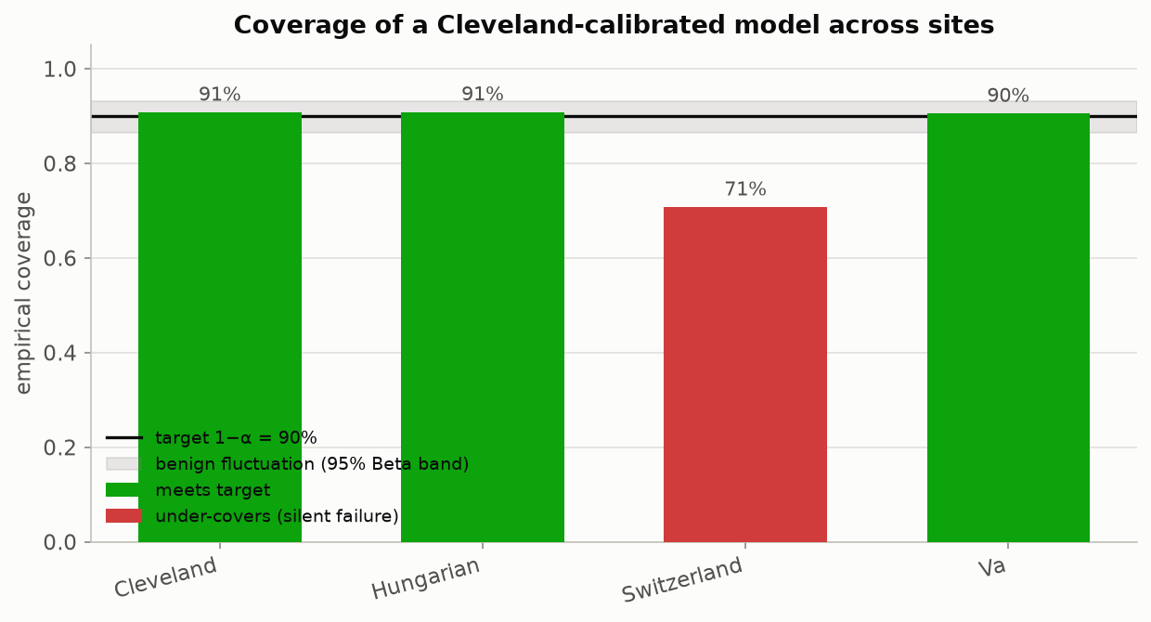
Figure 1.3 -- The headline empirical result. A conformal predictor calibrated only on Cleveland data is deployed at all four hospitals. It meets the 90% target at Cleveland, Hungary and the V.A., and silently drops to 71% at Switzerland -- well outside the shaded 'benign fluctuation' band that captures ordinary sampling noise, meaning this drop is a real effect, not chance. Produced by viz.plot_coverage_by_site, using conformal.LACPredictor and evaluate.coverage.
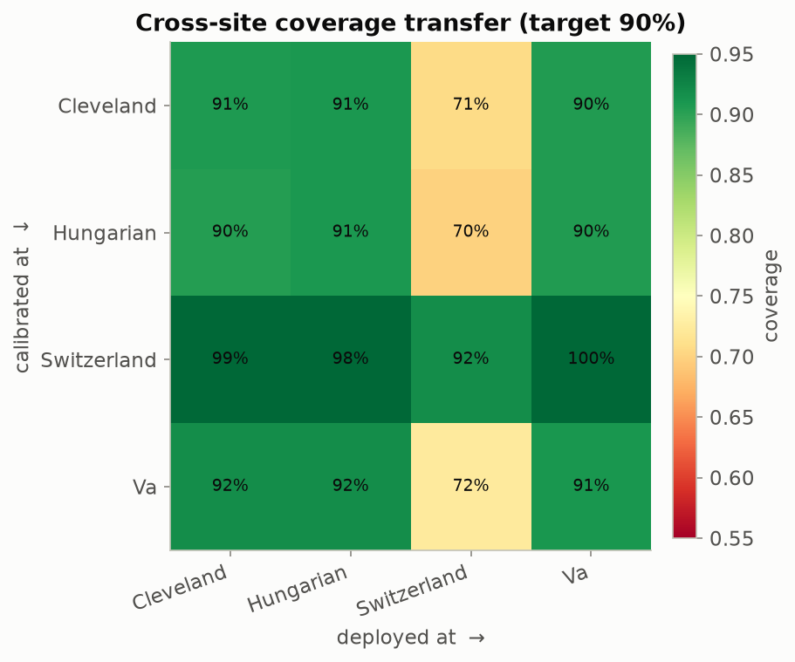
Figure 1.4 -- The full picture: calibrate at the row's hospital, deploy at the column's hospital, read off coverage. The diagonal (calibrate and deploy at the same hospital) is healthy everywhere. Off-diagonal cells show what happens when a hospital's calibration is exported elsewhere -- deploying anything calibrated on Cleveland, Hungary or the V.A. at Switzerland lands around 70-72%, while a Switzerland-calibrated predictor over-covers everywhere else (its patients are on average sicker, so its threshold is looser than it needs to be elsewhere). Produced by viz.plot_transfer_matrix.
Table 1.1 -- Coverage of a Cleveland-calibrated predictor, by deployment site (target: 90%, calibration set = 303 Cleveland patients, split-conformal LAC score, alpha = 0.10)
Deployment site | Empirical coverage | Gap vs. 90% target | Verdict
Cleveland (same site as calibration) | 90.8% | +0.8 pp | Meets target
Hungary | 90.8% | +0.8 pp | Meets target
V.A. Long Beach | 90.5% | +0.5 pp | Meets target
Switzerland (never seen by the federated model) | 70.7% | −19.3 pp | Fails, silently

This is the practical payoff for a curation pipeline: instead of trusting that a model "should" generalize because the incoming data is schema-compliant, you get a per-site number that tells you exactly where trust breaks down, before a clinician or downstream system relies on it.

2. The Mathematics, and What Every Piece of Code Produces
This section explains the method in plain language first, gives the exact formula each idea corresponds to, and then says precisely which file and which function in the toolkit implements it and which figure it produces. Everything here is implemented in plain NumPy -- no black-box library -- specifically so every step can be read line by line.

2.1 The one assumption everything rests on: exchangeability
Conformal prediction needs exactly one statistical assumption, and it is weaker than almost anything else in statistics: the calibration data and the test data must be *exchangeable* -- informally, drawn from the same underlying process, so that shuffling the order of the combined set would not tell you anything about which points were 'calibration' and which were 'test'. It does not require the data to be Gaussian, linearly separable, or generated by any particular model at all. This is what makes conformal prediction so widely applicable -- and it is also exactly the assumption that cross-hospital deployment violates. Calibration data from Cleveland and test data from Switzerland are not exchangeable if Switzerland patients are drawn from a different population (94% disease prevalence vs. Cleveland's 46%). The guarantee below is conditional on an assumption that this dataset is specifically built to violate on purpose, so that the violation is visible.

2.2 The nonconformity score and the conformal quantile
Step one: define a single number, the 'nonconformity score,' that measures how surprising a true label was, given what the model predicted. A large score means the model's output looked nothing like the truth; a small score means the model was basically right. Step two: compute this score for every point in a held-out 'calibration' set the model never trained on. Step three: take a specific, slightly-inflated quantile of those calibration scores -- inflated just enough to make the finite-sample guarantee exact rather than approximate:
q_hat = the ceil( (n + 1) x (1 - alpha) ) / n empirical quantile of the
calibration scores { s_1, ..., s_n }
Here n is the number of calibration points and alpha is the error rate you are willing to accept (alpha = 0.10 throughout this report, i.e. a 90% target). Step four: for any new patient, build the prediction set by keeping every candidate label whose score would not have exceeded q_hat:
C(x) = { y : score(x, y) <= q_hat }
This is the entire method. The proof that P(true label in C(x)) >= 1 - alpha is a short exchangeability argument (Angelopoulos & Bates, 2022, Section 2) -- the important practical point is that it works for *any* nonconformity score and *any* underlying model. Implementation: conformal.conformal_quantile(scores, alpha). Both predictors described below call it as their calibration step.

2.3 Two ways to define the score: LAC and APS
"LAC" (Least Ambiguous set-valued Classifier) uses the simplest possible score: one minus the model's softmax probability on the true class.
s_i = 1 - f_hat(x_i)_{y_i}
A score near 0 means the model put almost all its probability mass on the correct class; a score near 1 means the model was confidently wrong. Implementation: conformal.lac_scores and conformal.LACPredictor.
"APS" (Adaptive Prediction Sets, Romano, Sesia & Candes, 2020) instead sorts the classes from most to least likely and adds up probability mass until it reaches the true class:
s_i = sum of softmax probabilities for every class ranked
at or above the true class y_i, in descending order
LAC tends to build the smallest possible sets on average; APS tends to size its sets more sensibly example-by-example -- growing more for genuinely ambiguous patients and shrinking more for clear-cut ones -- which matters most in the multiclass setting used later in this report. Implementation: conformal.aps_scores and conformal.APSPredictor.
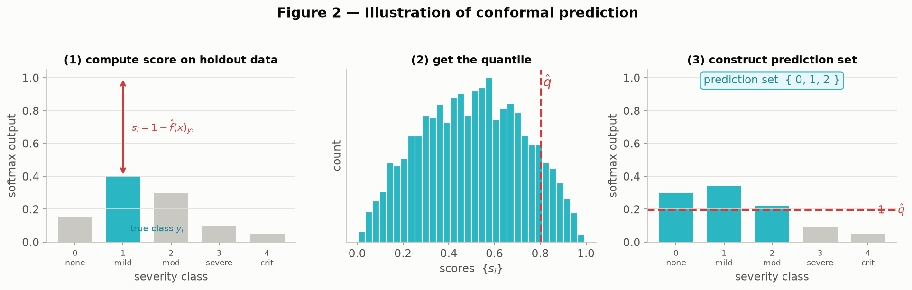
Figure 2.1 -- The method end to end, worked through visually on a 5-class example. Panel 1: compute the score on one calibration point (how far the model's probability on the true class fell short of 1). Panel 2: histogram the scores across the whole calibration set and mark the quantile q_hat. Panel 3: for a brand-new patient, keep every class whose predicted probability clears the 1 - q_hat bar -- the surviving classes are the prediction set. Produced by paper_figures.fig02_conformal_illustration (Figure 2 of Angelopoulos & Bates, recreated with the same 5-class severity framing used throughout this report).
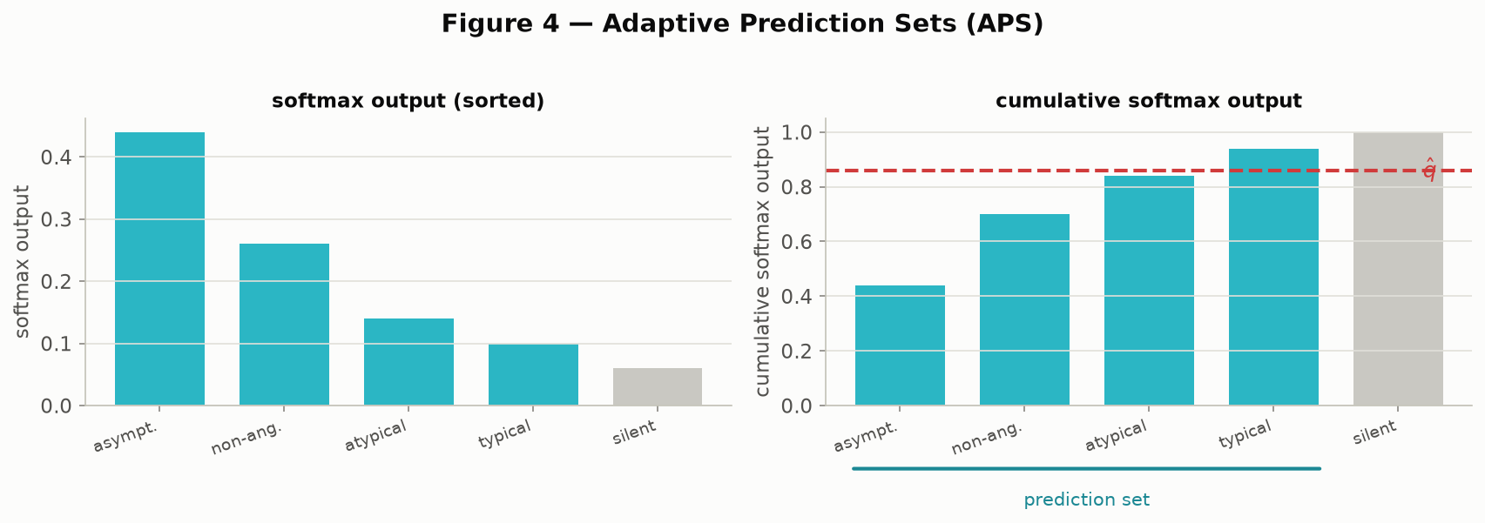
Figure 2.2 -- The APS mechanic specifically: sort classes by predicted probability (left), accumulate that probability (right) until the running total crosses q_hat, and the classes up to that point form the set. Produced by paper_figures.fig04_aps_illustration (Figure 4).
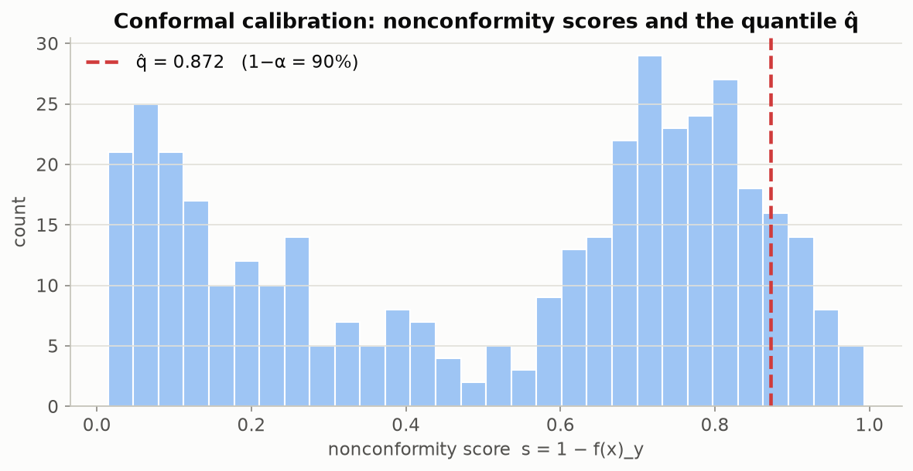
Figure 2.3 -- The actual calibration-score histogram from this project's data (not a synthetic illustration): LAC scores from a model trained across Cleveland, Hungary and the V.A., calibrated on a held-out pool. The red line is q_hat -- everything to its left calibrates the 90% target. Produced by viz.plot_calibration_scores inside scripts/run_demo.py.

2.4 Why the calibration-set size matters
Because q_hat is estimated from a finite sample, the *realized* coverage on any particular test set is itself a random quantity -- it will not sit exactly on 90% every time, even when every assumption holds. Vovk (2012) showed this randomness follows a Beta distribution with parameters tied directly to the calibration-set size n and alpha:
Coverage ~ Beta( n + 1 - l , l ) where l = floor( (n + 1) x alpha )
With only 50 calibration points, observed coverage can swing several percentage points around the target just from sampling luck; with 1,000, it is tight. This matters directly for this report's headline result: Switzerland's 71% coverage is far outside this benign-fluctuation band even for a calibration set the size of Cleveland's (303 patients), which is how we know the drop is a real site effect and not noise, rather than merely asserting it. Implementation: evaluate.coverage_beta_interval, plotted analytically by viz.plot_coverage_beta.
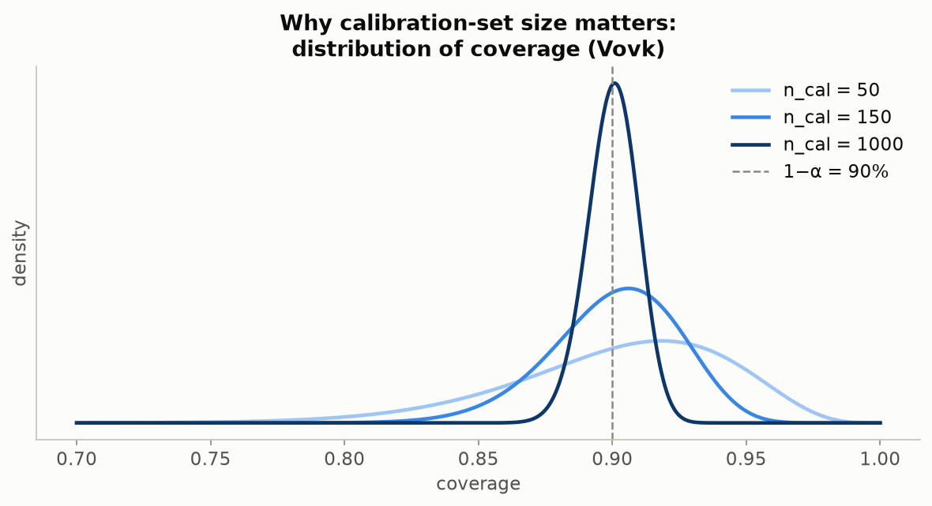
Figure 2.4 -- The Beta distribution of coverage at three calibration-set sizes (50, 150, 1000). The smaller the calibration set, the wider and more uncertain the true coverage really is around the 90% target -- context for judging whether an observed drop is a real site effect or just noise. Produced by viz.plot_coverage_beta.
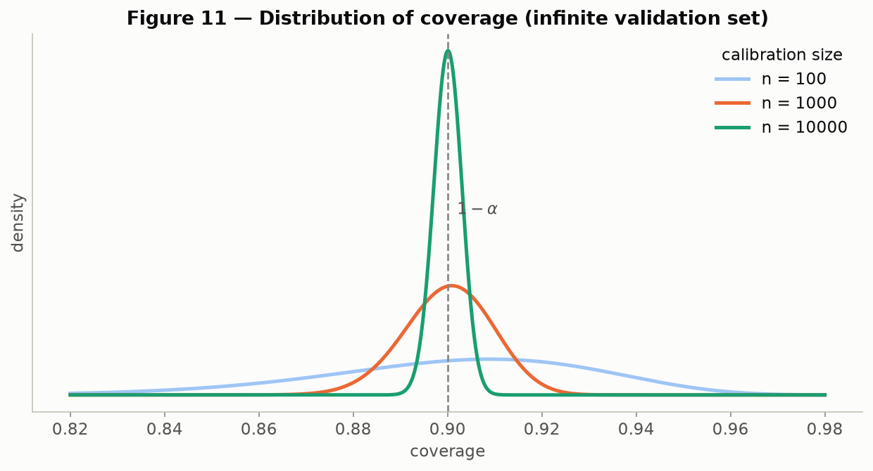
Figure 2.5 -- The same idea recreated at the scale used in the original paper (n = 100, 1,000, 10,000), showing how sharply the distribution narrows as the calibration set grows. Produced by paper_figures.fig11_coverage_distribution (Figure 11).

2.5 Adaptivity: are the sets actually bigger where the model is unsure?
A trivial way to hit 90% coverage is to always output every possible class -- technically correct, completely useless. A good conformal predictor instead produces small sets for easy cases and large sets for hard ones. We check this directly by tabulating the distribution of set sizes at each hospital: a predictor that is well calibrated but *not* adaptive would show the same size distribution everywhere; ours visibly widens at sites with more label ambiguity. Implementation: evaluate.set_sizes / evaluate.average_set_size, plotted by viz.plot_set_size_distribution.
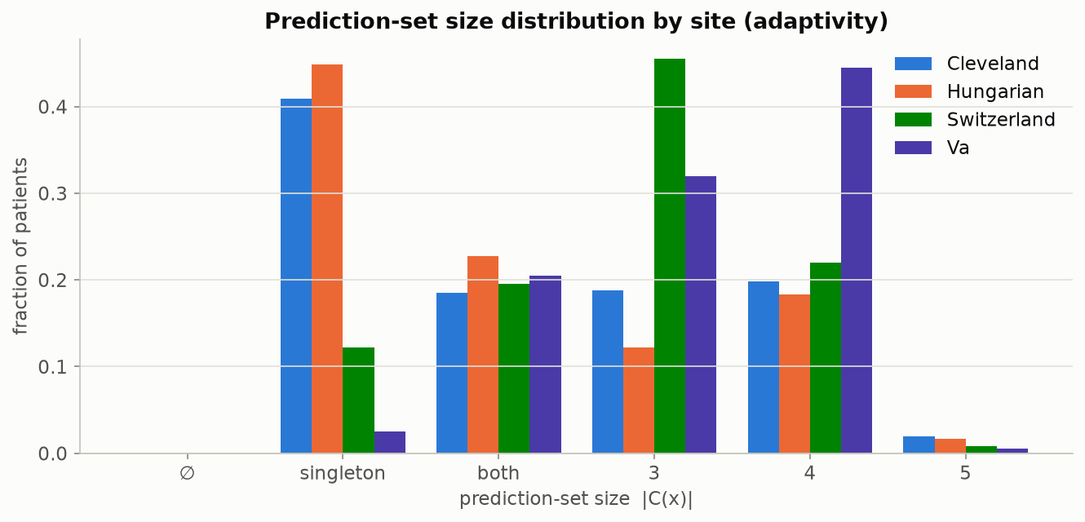
Figure 2.6 -- Distribution of prediction-set sizes by site (5-class disease-severity task). Larger sets at a given site mean the model is systematically less certain about patients from that hospital. Produced by viz.plot_set_size_distribution.

2.6 The subtler failure: class-conditional coverage
Marginal coverage (the 90% averaged over every patient) can hide a second, independent kind of failure: it can hit target overall while badly under-covering one specific class, particularly a rare one, exactly the way it can hide a badly-covered site. We demonstrate this on the toolkit's secondary task -- predicting chest-pain type (4 classes) rather than disease severity. Marginal coverage across the pooled test set sits at 90%, but broken out by the true class, the rarest category (typical angina, only 23 test patients) is covered just 26% of the time, while the most common category (asymptomatic, 200 patients) is over-covered at 95.5%. Implementation: evaluate.class_conditional_coverage, plotted by viz.plot_class_conditional_coverage.
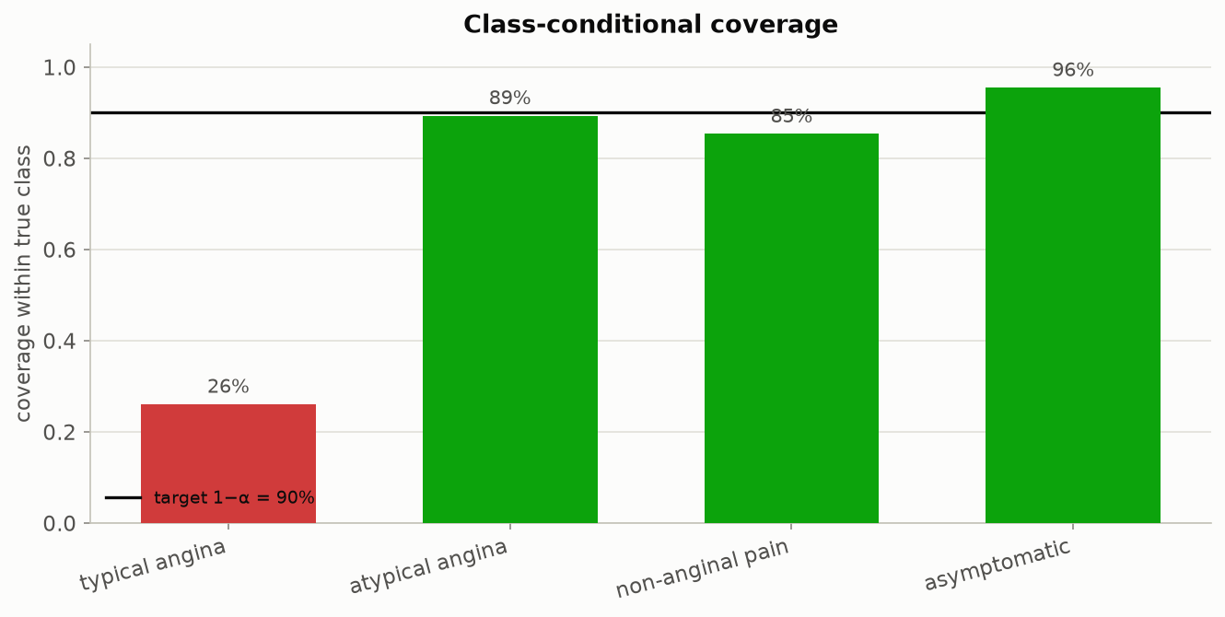
Figure 2.7 -- Coverage broken out by true chest-pain class. The rare class (typical angina, n = 23) is covered only 26% of the time against a 90% target -- invisible in the pooled 90% marginal number, and exactly the sub-population a curation pipeline is most likely to serve under-represented patients in. Produced by viz.plot_class_conditional_coverage inside scripts/run_demo_cp.py.

2.7 Beyond classification: the same idea generalizes
The prediction-set idea is not specific to classification. paper_figures.py recreates three further illustrations from Angelopoulos & Bates showing the same 'score, quantile, widen' recipe applied to (a) quantile regression, where the conformal step widens a fitted prediction interval by exactly q_hat to reach guaranteed coverage; (b) a generic point prediction plus an uncertainty scalar u(x), widened the same way; and (c) a Bayesian posterior predictive density, where the prediction set becomes the region above a probability threshold. These three figures use small synthetic examples, exactly as the original paper does, rather than this project's clinical data -- they are included for conceptual completeness (the workshop's method is not limited to classification) and are not part of the empirical results in Sections 1, 3 or 4.
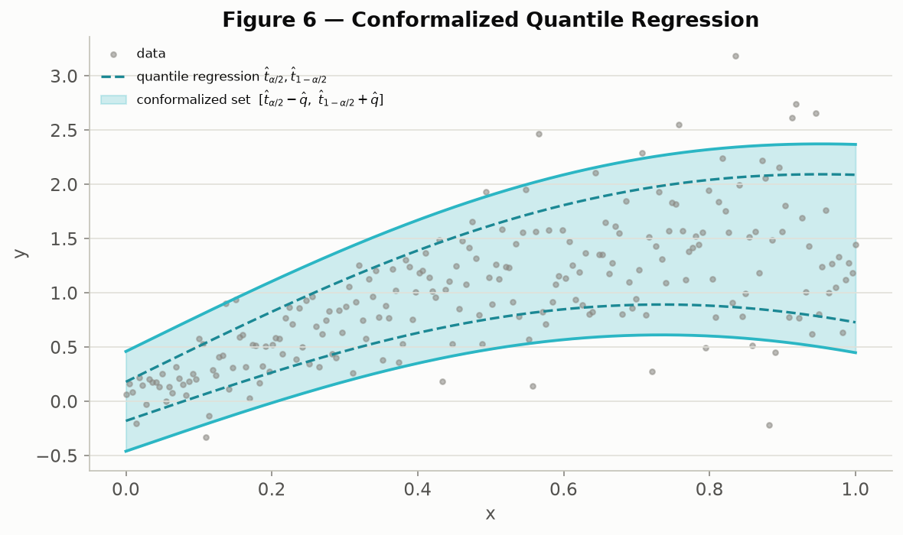
Figure 2.8 -- Conformalized quantile regression: a fitted quantile band (dashed) widened by q_hat (solid) to reach the coverage guarantee. Synthetic illustration. Produced by paper_figures.fig06_cqr_illustration (Figure 6).
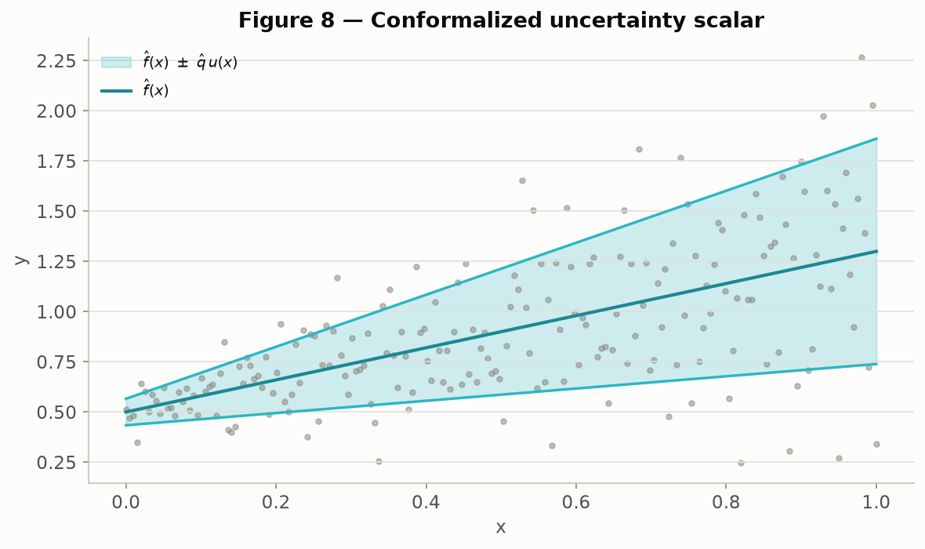
Figure 2.9 -- A point prediction f(x) with a symmetric conformalized band q_hat * u(x). Synthetic illustration. Produced by paper_figures.fig08_uncertainty_scalar (Figure 8).
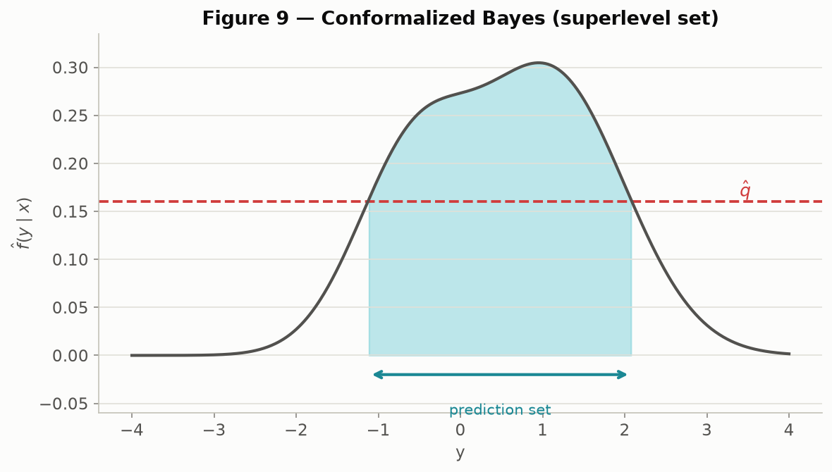
Figure 2.10 -- Conformalized Bayes: the prediction set as the superlevel set of a posterior predictive density. Synthetic illustration. Produced by paper_figures.fig09_bayes_superlevel (Figure 9).

2.8 Code-to-purpose map
Every module in src/fedconformal/, what it is responsible for, and which figure(s) in this report it produces.
Module | Responsibility | Key functions | Figures produced
data.py | Load the 4 raw UCI site files, impute missing values, standardize, split into per-site arrays for either task | load_raw, load_sites, preprocess, summarize_sites | (feeds every figure; produces no plots itself)
heterogeneity.py | Quantify site differences before any modeling: label shift, missingness, distributional divergence, a domain-classifier alarm | missingness_report, js_divergence_matrix, domain_auc_matrix | 2, 4, 5
eda.py | First-look exploratory plots of the raw inputs: target, features, correlation structure | plot_target_distribution, plot_continuous_grid, plot_categorical_grid | e01-e06
federated.py | A from-scratch FedAvg simulator (binary logistic or softmax model, chosen automatically by class count) plus a centralized baseline | federated_averaging, train_centralized, make_model | 6, cp/c02
conformal.py | The conformal-prediction core: nonconformity scores, the quantile, and the two set-valued predictors | conformal_quantile, lac_scores, aps_scores, LACPredictor, APSPredictor | 2.1, 2.2, 7
evaluate.py | Every coverage/size metric used to grade a conformal predictor, plus the analytic Beta band for judging noise vs. signal | coverage, average_set_size, size_stratified_coverage, class_conditional_coverage, coverage_beta_interval | 2.4, 2.5, 2.6
viz.py | All plotting -- one function per figure, a fixed colorblind-safe site palette, a shared visual style | plot_site_overview, plot_coverage_by_site, plot_transfer_matrix, plot_pca_scatter, ... | nearly every figure in this report
paper_figures.py | Recreations of the explanatory diagrams from Angelopoulos & Bates (2022), for teaching -- synthetic illustrations, not this project's data | fig02...fig11 | 2.1, 2.2, 2.4, 2.8, 2.9, 2.10, 1.2

3. Why This Dataset Is an Ideal Testbed for Interoperability
A good demonstration dataset for "interoperability is not comparability" needs one property above all else: the four sources must genuinely be interoperable -- same variables, same coding, same case-report form -- while still differing underneath in ways that matter. A synthetic split of one hospital's data into four random pieces would be trivially comparable (there is no real difference to find) and would teach nothing. The UCI Heart Disease federation is close to the opposite extreme: it is one of the very few open clinical datasets where four *real, independent* hospitals filled out the *same* form, so every difference we measure is a genuine site effect, not an artefact of how the demonstration was constructed.

3.1 The four sites at a glance
Site | Institution | Patients | Any-disease prevalence | Most common severity
Cleveland | Cleveland Clinic Foundation | 303 | 45.9% | No disease (54.1%)
Hungary | Hungarian Institute of Cardiology | 294 | 36.1% | No disease (63.9%)
Switzerland | Univ. Hospital Zurich / Basel | 123 | 93.5% | Mild (39.0%)
V.A. Long Beach | V.A. Medical Center | 200 | 74.5% | Mild (28.0%)
Total | -- | 920 | 55.3% pooled | --

Prevalence alone ranges nearly threefold, from 36% to 94% -- this is what the report calls *true* distributional shift: Switzerland is a tertiary referral centre that sees a sicker, pre-selected population, not a data problem.

3.2 Two different heterogeneity fingerprints, side by side
The dataset is unusually good at teaching the difference between real population variation and broken measurement, because it contains a clean example of each, at very different scales.
Feature | What it measures | Cleveland | Hungary | Switzerland | V.A. | Fingerprint
chol | Serum cholesterol coded 0 when not recorded | 0.0% | 0.0% | 100.0% | 24.5% | Measurement artefact (site-specific)
ca | # vessels by fluoroscopy, coded '?'/'-9' when missing | 1.3% | 98.6% | 95.9% | 99.0% | Measurement artefact (near-universal outside Cleveland)
thal | Thallium stress-test result, same missing coding | 0.7% | 90.5% | 42.3% | 83.0% | Measurement artefact (near-universal outside Cleveland)
target severity | 0-4 disease severity | mixed | skews 0 | skews 1-2 | mixed | True distributional shift

Cholesterol is the textbook example used throughout the workshop framing: Switzerland's field is not "low cholesterol," it is "never measured," coded as a literal zero directly in the source file. But the far larger gap, and one this project's pipeline surfaces that a cursory look would not, is `ca` and `thal`: outside Cleveland, both are missing for 80-99% of patients at every hospital. Any model trained naively across all four sites is, for those two features, running on an imputed placeholder value for the overwhelming majority of non-Cleveland patients -- a measurement gap roughly twenty times larger than the well-known cholesterol example, and invisible unless someone explicitly checks for it. That is precisely the curation risk this toolkit is built to catch before it reaches a model.
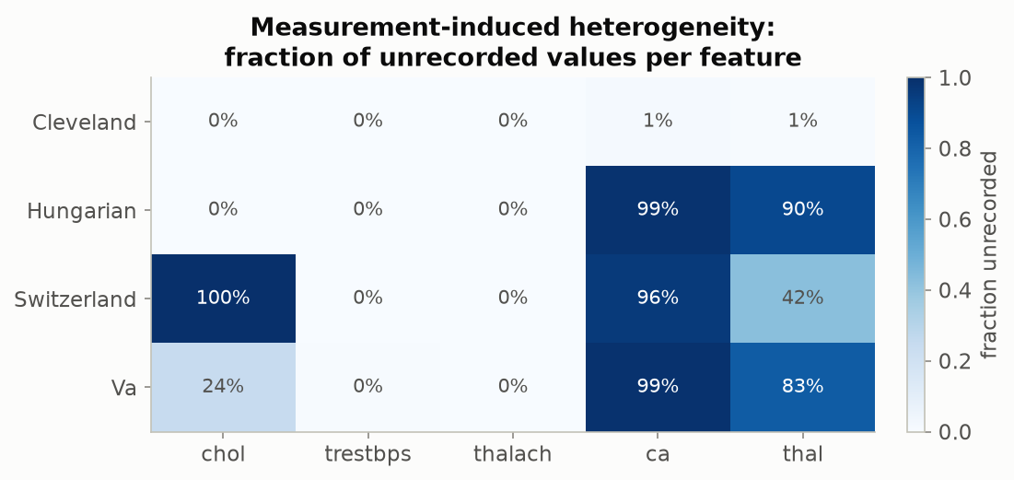
Figure 3.1 -- Fraction of unrecorded values per feature per site, both fingerprints side by side. Cholesterol's 100% gap at Switzerland is visible; so is the much larger, near-universal gap in `ca` and `thal` outside Cleveland. Produced by viz.plot_missingness, from heterogeneity.missingness_report.
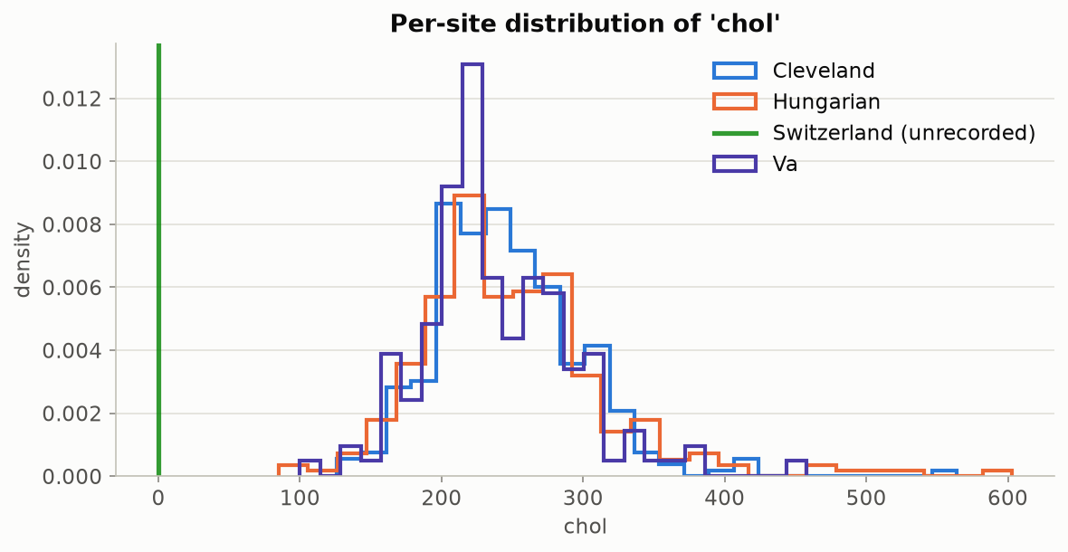
Figure 3.2 -- Per-site distribution of measured cholesterol values (Switzerland has none to plot -- it is marked as fully unrecorded rather than silently included as zero). Produced by viz.plot_feature_distributions.

3.3 True label shift: what we predict differs sharply by site
Severity class | Cleveland | Hungary | Switzerland | V.A. | Pooled total
0 -- No disease | 164 | 188 | 8 | 51 | 411 (44.7%)
1 -- Mild | 55 | 37 | 48 | 56 | 196 (21.3%)
2 -- Moderate | 36 | 26 | 32 | 41 | 135 (14.7%)
3 -- Severe | 35 | 28 | 30 | 42 | 135 (14.7%)
4 -- Critical | 13 | 15 | 5 | 10 | 43 (4.7%)

Hungary skews heavily toward "no disease"; Switzerland is almost entirely disease-positive and, unusually, has more "mild" cases than "no disease" cases -- consistent with a referral population rather than a screening population.
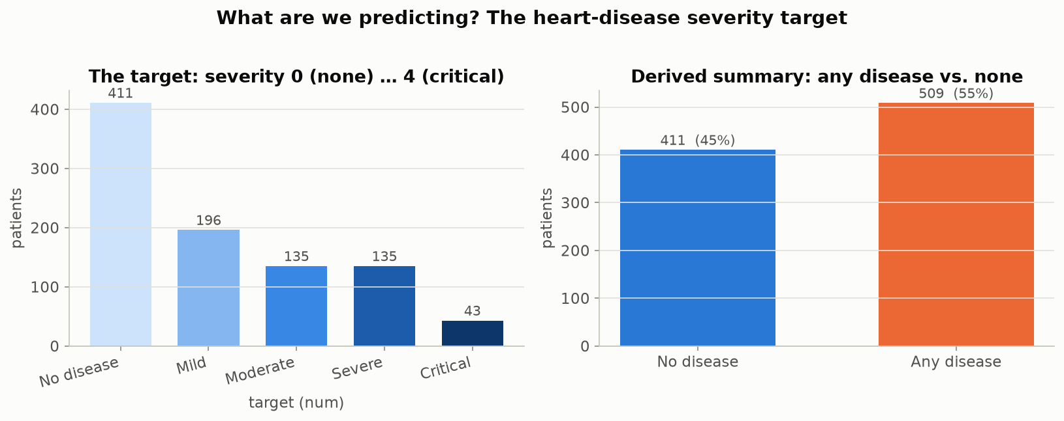
Figure 3.3 -- Pooled 5-class severity distribution, and the derived binary any-disease summary. Produced by eda.plot_target_distribution.
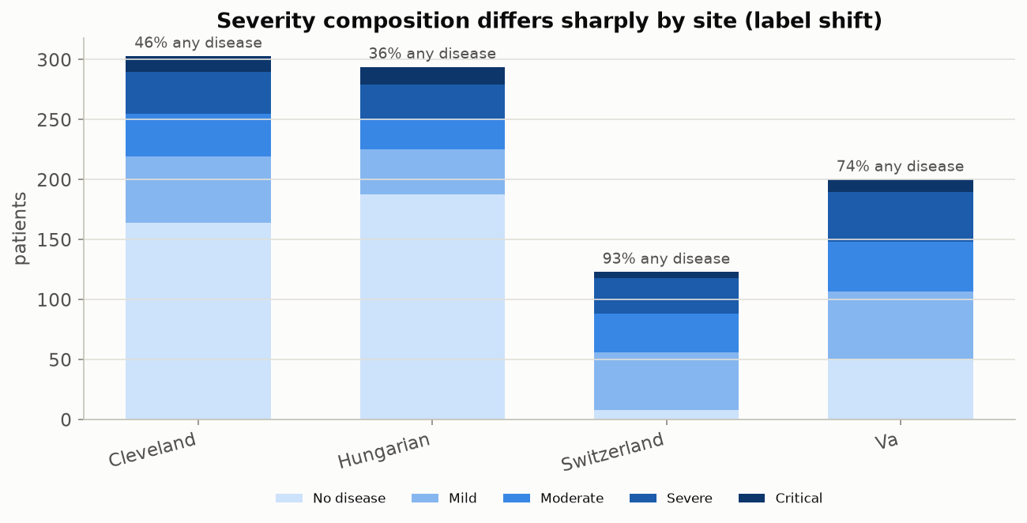
Figure 3.4 -- The same severity breakdown, split by site -- the label-shift story from Table 3.3 made visual. Produced by eda.plot_target_by_site.

3.4 Covariate shift: the sites are statistically -- and visibly -- separable
A more rigorous check than eyeballing histograms is to ask: can a simple classifier, given only a patient's clinical features (never told which hospital they came from), guess the hospital? If it cannot do better than a coin flip (AUC around 0.5), the sites are statistically indistinguishable and any model or calibration should transfer cleanly. If it can guess almost perfectly (AUC near 1.0), the sites occupy different regions of feature space and nothing trained at one is guaranteed to behave sensibly at another.
 | Cleveland | Hungary | Switzerland | V.A.
Cleveland | 0.50 | 0.89 | 1.00 | 0.88
Hungary | 0.89 | 0.50 | 1.00 | 0.93
Switzerland | 1.00 | 1.00 | 0.50 | 0.88
V.A. | 0.88 | 0.93 | 0.88 | 0.50

Table 3.5 -- Pairwise domain-classifier AUC (5-fold cross-validated logistic regression). Every off-diagonal value is 0.88 or higher -- these hospitals are almost perfectly separable from features alone.
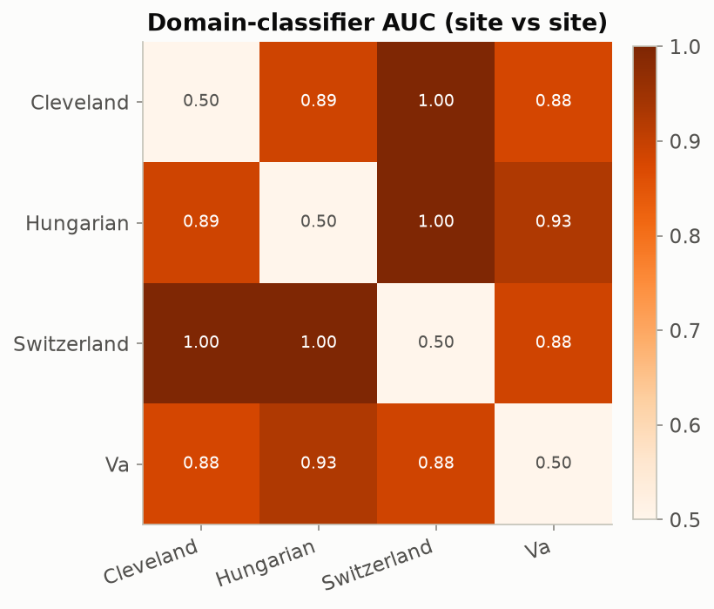
Figure 3.5 -- The AUC matrix as a heatmap. Produced by viz.plot_divergence_matrix, from heterogeneity.domain_auc_matrix.
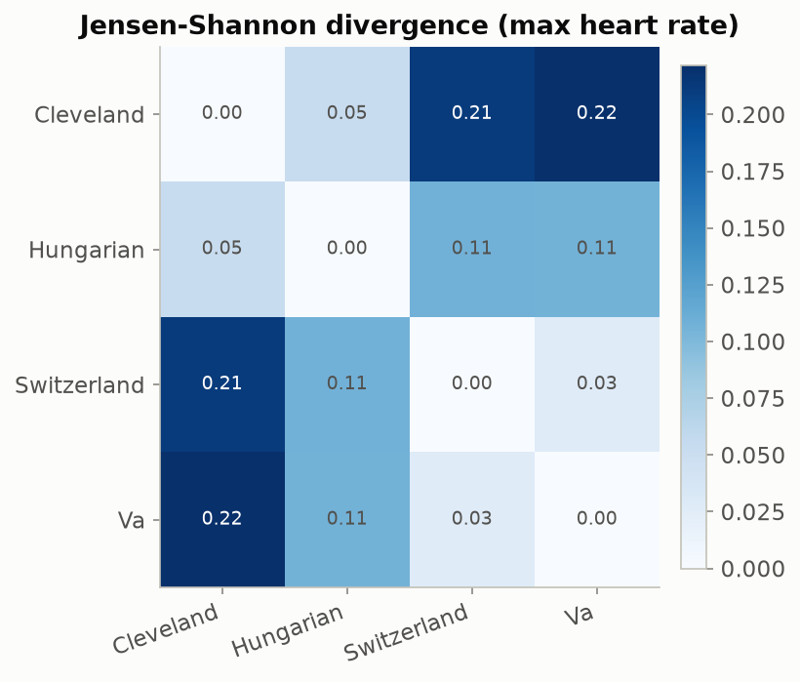
Figure 3.6 -- Jensen-Shannon divergence between sites for maximum heart rate (thalach): a second, distribution-shape-based confirmation of the same covariate-shift story, in a [0, 1] score where 0 means identical distributions. Produced by viz.plot_divergence_matrix, from heterogeneity.js_divergence_matrix.
The domain-classifier number is convincing but abstract. Two scatterplots make the same finding directly visible -- something no figure in the original pipeline provided, so both were added specifically for this report.
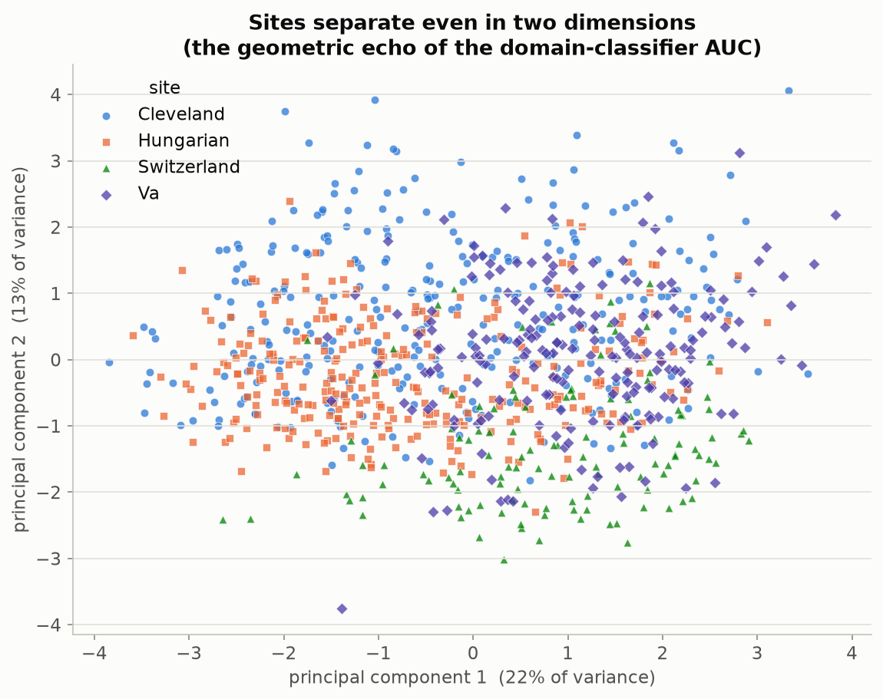
Figure 3.7 (new) -- Every patient's 13 standardized clinical features compressed to two principal components and colored by site. Even in just two dimensions -- a small fraction of the original information -- Switzerland (green) forms a visually distinct lower cluster and Cleveland (blue) skews toward the upper right; the clouds are not on top of each other. This is the geometric picture behind the domain-classifier AUC numbers in Table 3.5. Produced by the newly added viz.plot_pca_scatter, via scripts/run_extra_figures.py.
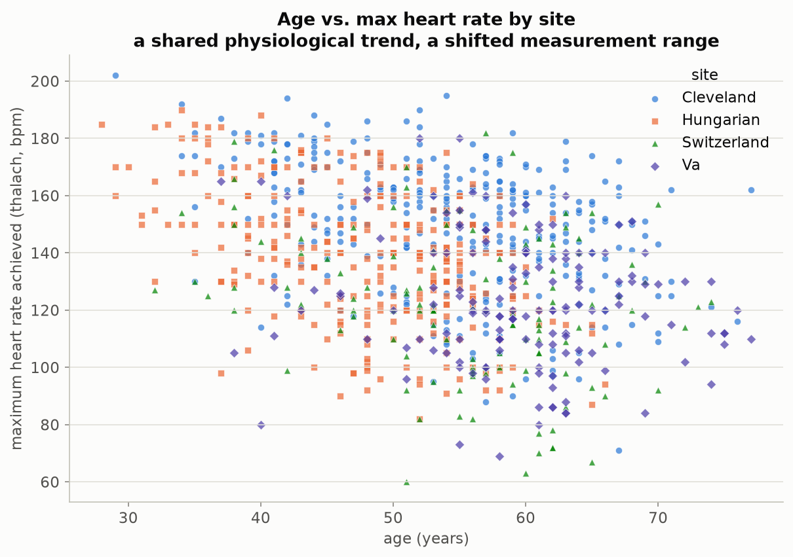
Figure 3.8 (new) -- Age vs. maximum heart rate achieved, colored by site. The downward trend (older patients reach a lower max heart rate) holds at every hospital -- the underlying physiology is universal -- but the V.A. and Switzerland clouds sit measurably lower than Cleveland's for the same age, and Hungary's patients skew younger overall. Same biology, shifted measurement range: precisely the 'interoperable but not identical' picture this dataset is valuable for. Produced by the newly added viz.plot_age_thalach_scatter, via scripts/run_extra_figures.py.
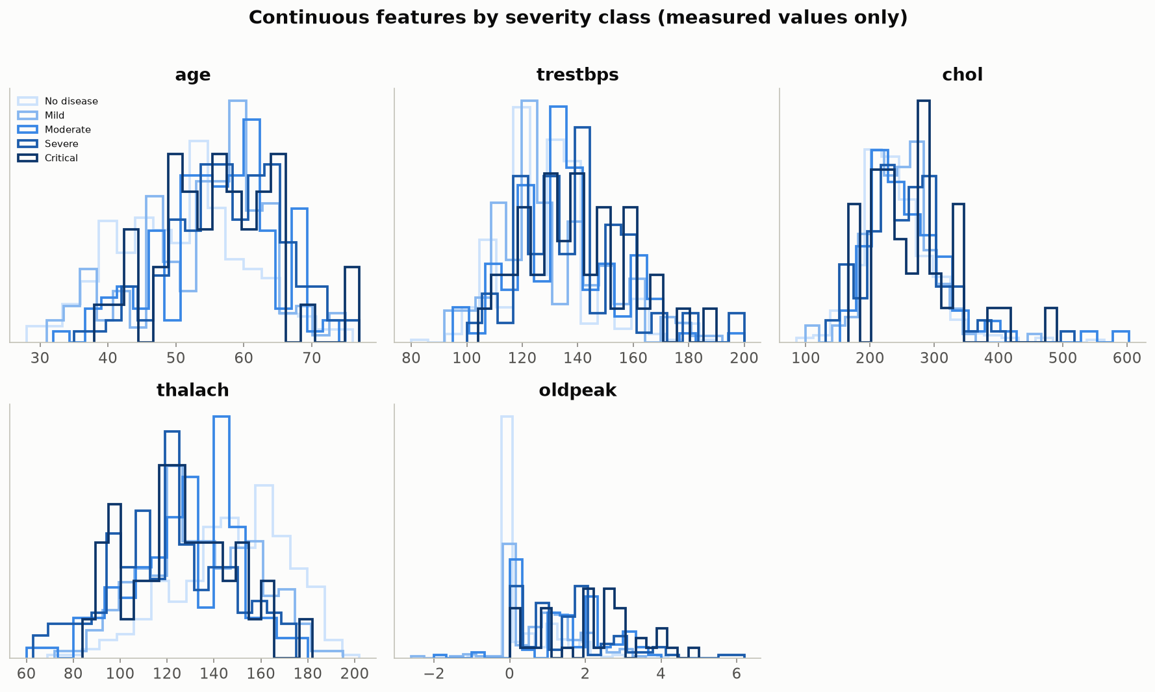
Figure 3.9 -- All five continuous features, split by severity class. Where the five severity curves separate, that feature is informative for the model; where they overlap, it is not. Produced by eda.plot_continuous_grid.
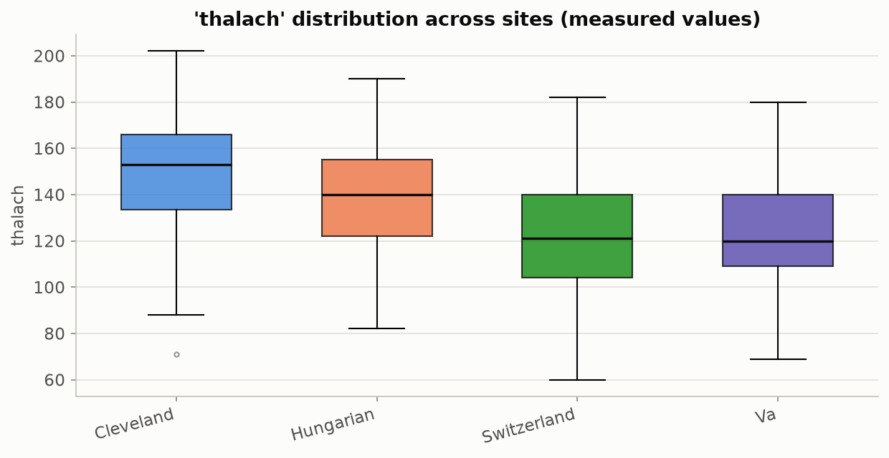
Figure 3.10 -- Max heart rate distribution by site as box plots -- the same shift visible in Figure 3.8, without the age dimension. Produced by eda.plot_feature_boxplots_by_site.
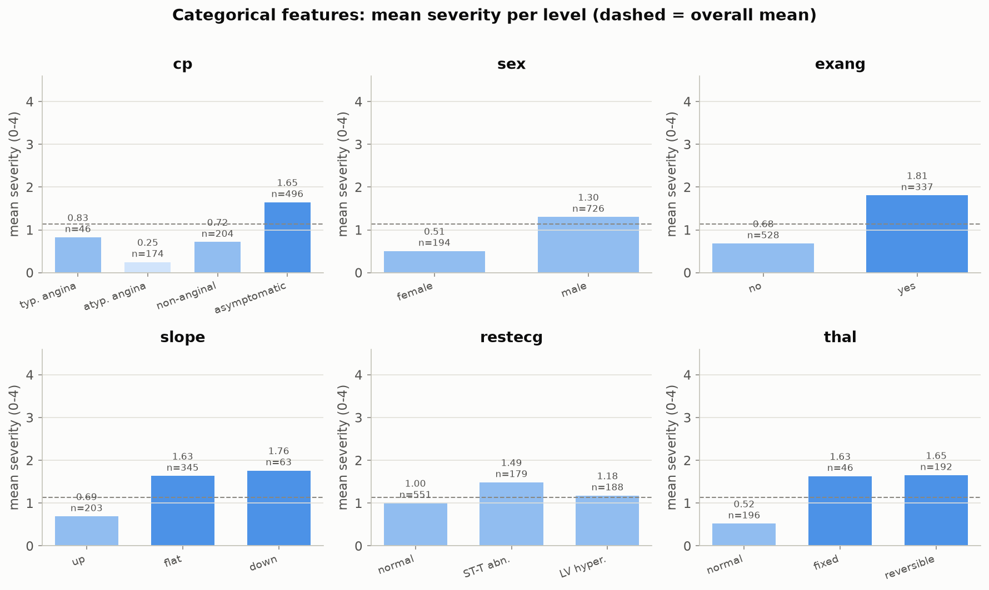
Figure 3.11 -- Mean severity within each level of six categorical features (chest-pain type, sex, exercise angina, ST slope, resting ECG, thalassemia result). Asymptomatic chest pain, exercise-induced angina, a flat/down ST slope and a reversible thalassemia defect all carry substantially higher mean severity -- clinically sensible relationships the model can exploit, and a sanity check that the loaded data behaves the way cardiology domain knowledge predicts. Produced by eda.plot_categorical_grid.
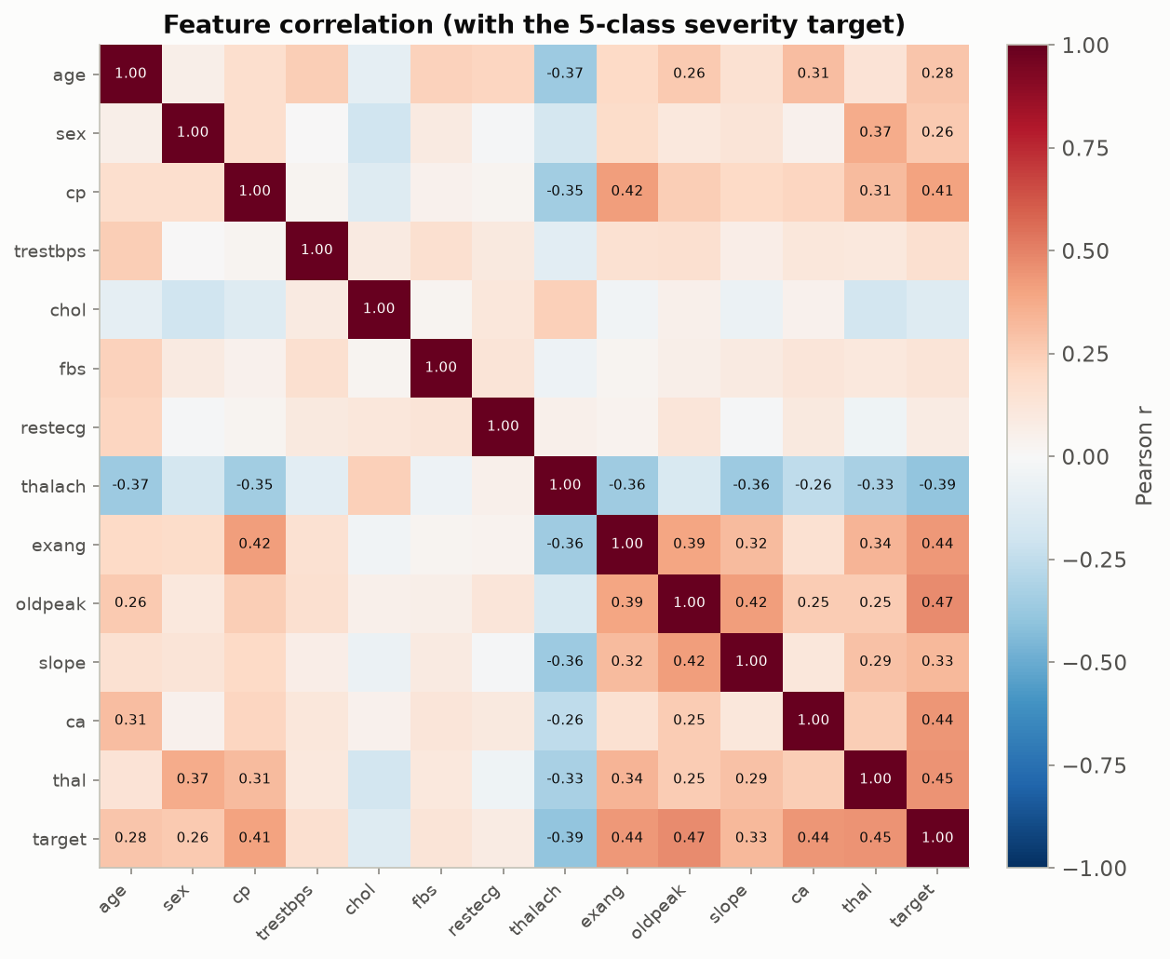
Figure 3.12 -- Pearson correlation among all 13 features and the 5-class severity target. Chest-pain type, exercise angina, ST depression, max heart rate and vessel count are the strongest correlates of severity. Produced by eda.plot_correlation_heatmap.

3.5 The secondary task confirms this is not a fluke of one label choice
If the heterogeneity story depended on the specific choice of "predict disease severity," it would be a weaker argument. The toolkit supports a second, independent task on the same four sites -- predicting chest-pain type instead of disease severity -- and label shift shows up there too, just as clearly, confirming the effect is a property of the sites, not of one particular target.
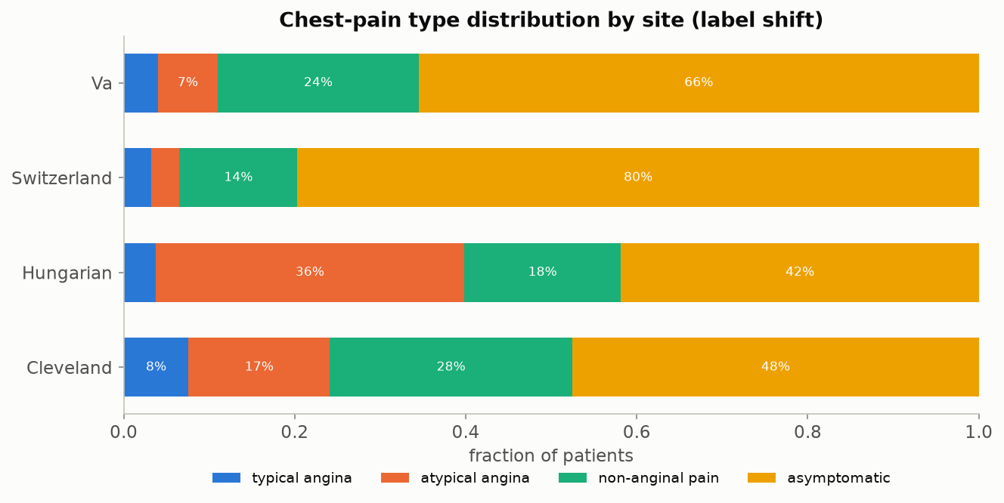
Figure 3.13 -- Chest-pain-type distribution by site, the secondary-task analogue of Figure 3.4. Hungary is heavy on atypical angina; Switzerland is roughly 80% asymptomatic. Produced by viz.plot_class_distribution_by_site, via scripts/run_demo_cp.py.

3.6 Summary: what makes this dataset ideal
- Genuinely interoperable: all four sites used the same case-report form and the same 13-variable schema -- there is no format barrier to integration, which isolates the *meaning* problem from the *plumbing* problem.
- Genuinely heterogeneous, and in two distinguishable ways at once: a true population difference (prevalence 36%-94%) and a measurement artefact (chol, and far more severely, ca/thal), so the toolkit's core distinction is not hypothetical.
- Small enough to train and calibrate live in a workshop (920 patients, sub-second training), large enough that the effects are statistically real rather than noise (Beta-band-checked in Section 1.3).
- Open, credential-free, and citable -- no data-use agreement stands between a workshop attendee and running the code themselves.
- The finding replicates on a second, independently chosen prediction task on the same sites (Figure 3.13), which is evidence the heterogeneity is a property of the hospitals, not an artefact of the modeling choice.

4. Pipeline Walkthrough and Justification: Is This Enough?
This section traces one execution of the full pipeline end to end, then gives an honest assessment of what is solid, what is a reasonable simplification for a workshop setting, and what we would add if this were being extended into a production curation tool rather than a teaching toolkit.
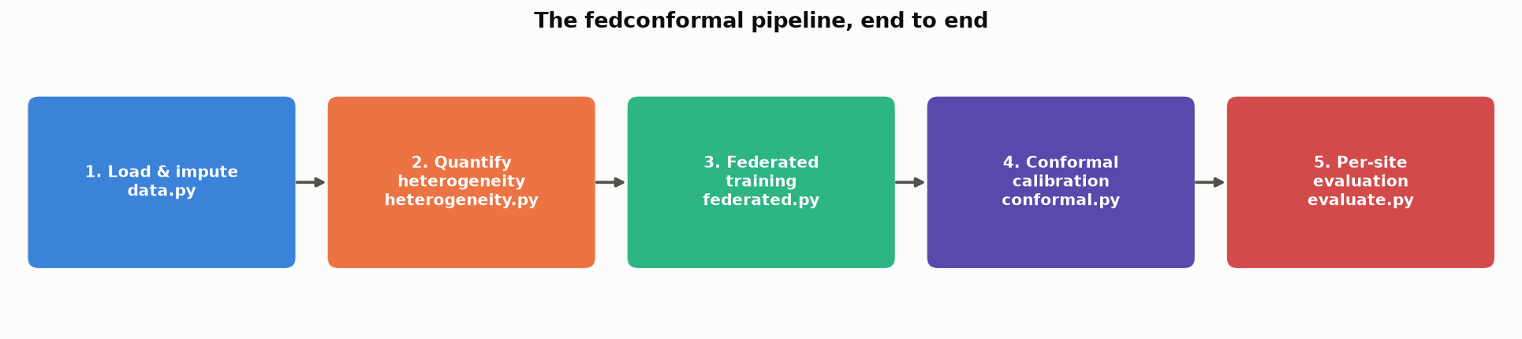
Figure 4.1 (new) -- The five-stage pipeline, module by module. Data flows left to right: raw per-site files are loaded and imputed, heterogeneity is measured *before* anything is trained (deliberately -- this ordering is the whole point of the workshop's framing), a shared model is trained federatively, a conformal predictor is calibrated on top of it, and coverage is graded per site rather than pooled. Produced by the newly added viz.plot_pipeline_overview, via scripts/run_extra_figures.py. No equivalent overview figure existed before this report -- it was added because a reader arriving fresh at 33 figures benefits from one picture of how they connect.

4.1 Stage 3: federated training actually converges
Before conformal calibration means anything, the underlying model has to have actually learned something. FedAvg trains a shared softmax model across Cleveland, Hungary and the V.A. (holding Switzerland out entirely, to test genuine external validation) by having each site take a few local gradient steps and averaging the resulting weights, weighted by site size, every communication round -- no patient-level data ever leaves its hospital.
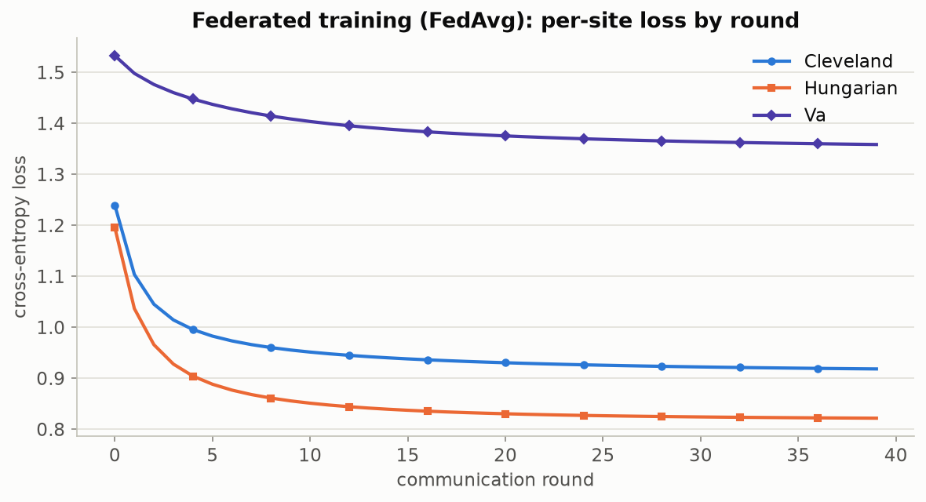
Figure 4.2 -- Per-site training loss across FedAvg communication rounds, 5-class disease task. All three participating sites' losses fall together, confirming the federated procedure converges. Produced by viz.plot_fed_learning_curves.
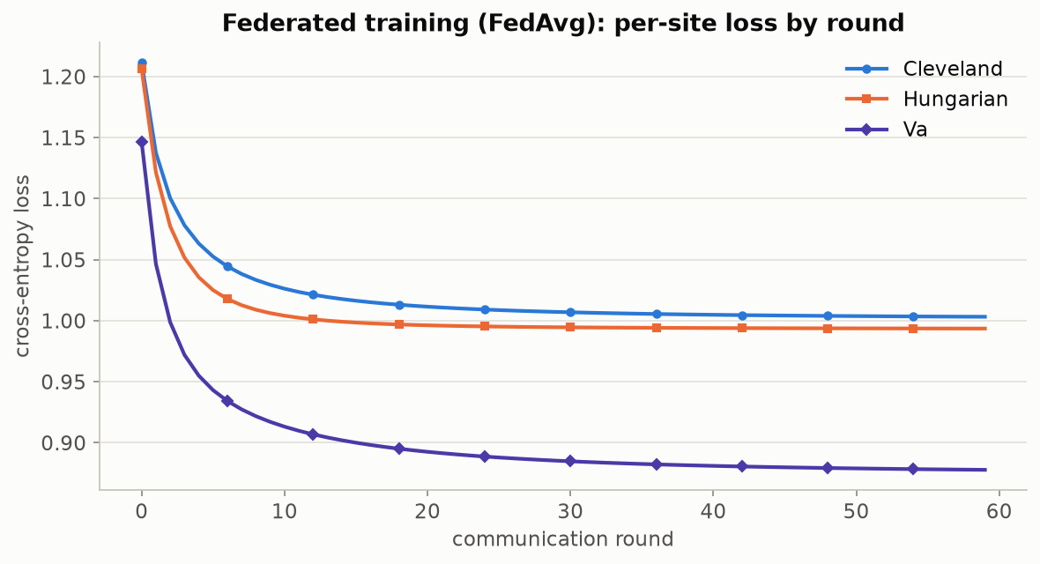
Figure 4.3 -- The same convergence check on the secondary chest-pain task, confirming FedAvg behaves consistently across two different targets. Produced by viz.plot_fed_learning_curves, via scripts/run_demo_cp.py.

4.2 Does the story change with a different task and a different score function?
A natural objection: does the whole story depend on the particular choice of disease-severity prediction and the LAC score? scripts/compare_tasks.py runs the identical analysis -- label shift, covariate shift, cross-site conformal transfer, using the APS score this time -- on both the 5-class disease task and the 4-class chest-pain task, side by side.
Metric | Disease task (5-class) | Chest-pain task (4-class)
Features used | 13 clinical variables | 13 (the other 12 + disease severity)
Label-shift (Jensen-Shannon div.) | 0.128 | 0.073
Covariate-shift (mean domain AUC) | 0.930 | 0.929
Mean cross-site coverage (target 90%) | 90.9% | 91.0%
Worst-case site coverage | 87% | 88%
Avg. conformal set size |C(x)| | 2.68 labels | 2.25 labels
Set size normalized by class count | 0.536 (53.6% of label space) | 0.563 (56.3%)

The disease-severity task carries more label shift (0.128 vs. 0.073) -- consistent with the 36%-94% prevalence swing being a bigger effect than chest-pain-type variation -- while both tasks show essentially identical covariate shift (~0.93 AUC) and both keep cross-site coverage close to target under APS, with the worst individual site still landing within a few points of 90%. The conclusion that these four hospitals are meaningfully heterogeneous, and that conformal prediction quantifies the consequence, is not an artefact of one task or one score function.
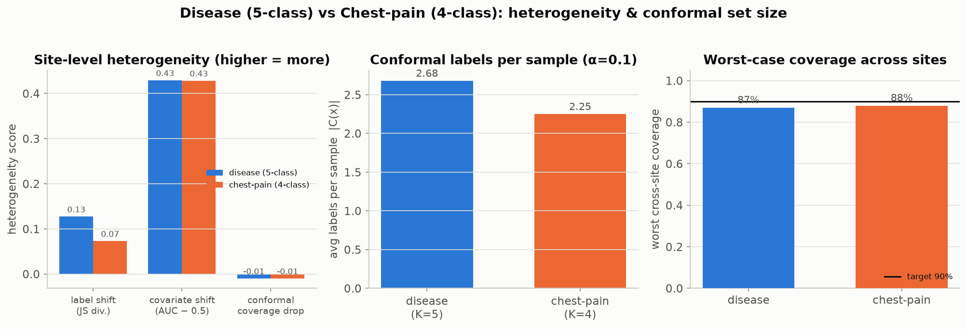
Figure 4.4 -- The comparison from Table 4.1, plotted: heterogeneity scores, average prediction-set size, and worst-case cross-site coverage, disease task vs. chest-pain task, side by side. Produced by compare_tasks.plot_comparison.

4.3 The secondary task's own conformal pipeline, run in full
For completeness, the chest-pain task's own cross-site transfer matrix and set-size distribution -- the same diagnostics as Section 1, applied to a different label -- are included below rather than only summarized in Table 4.1.
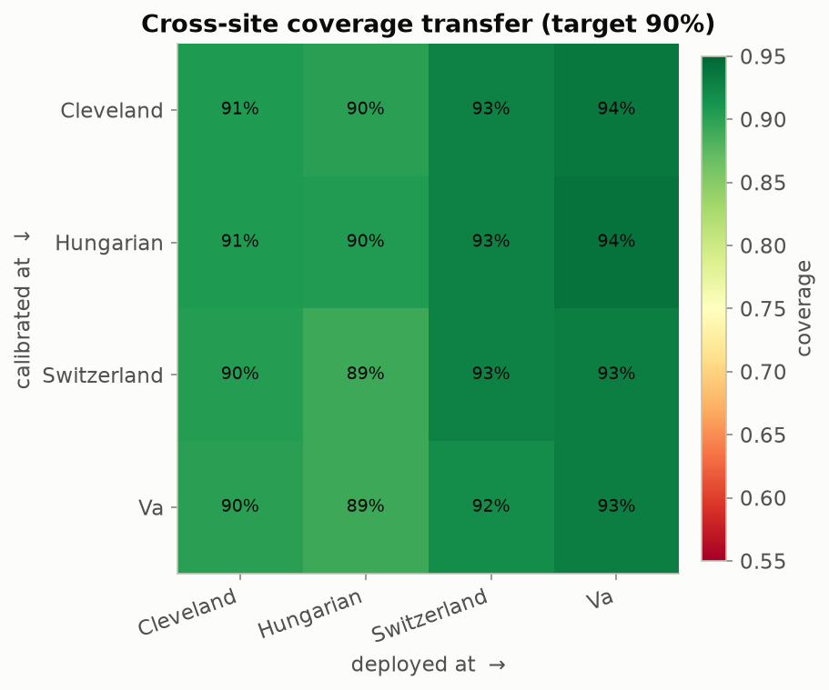
Figure 4.5 -- Cross-site coverage transfer matrix for the chest-pain task (APS score). Produced by viz.plot_transfer_matrix, via scripts/run_demo_cp.py.
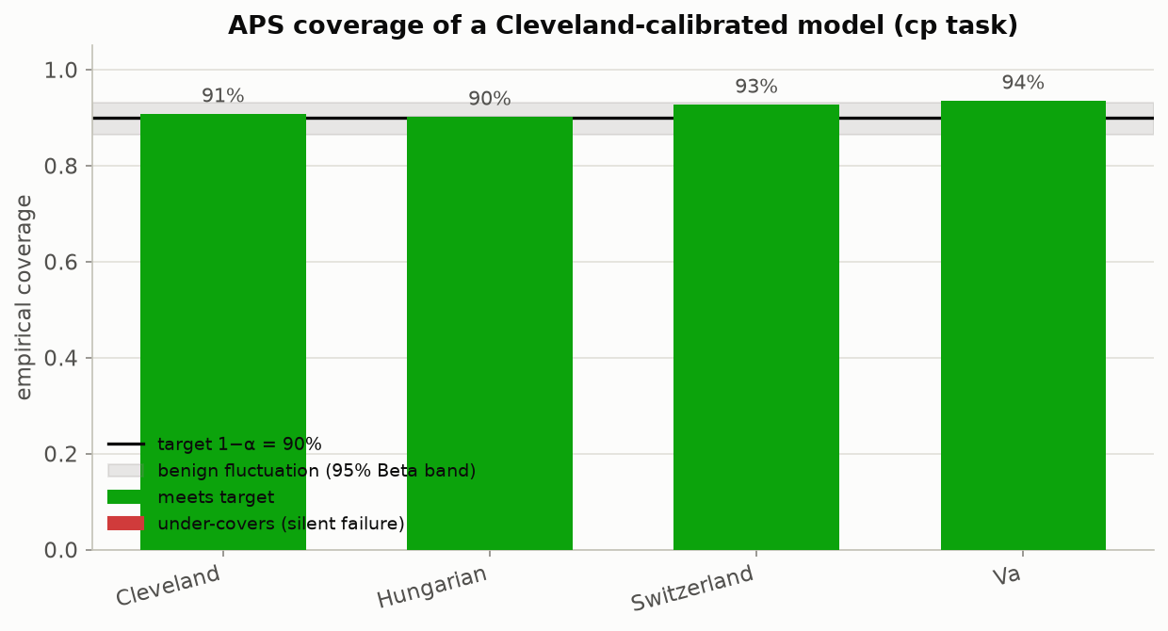
Figure 4.6 -- Coverage of a Cleveland-calibrated chest-pain predictor across all four sites. Produced by viz.plot_coverage_by_site, via scripts/run_demo_cp.py.
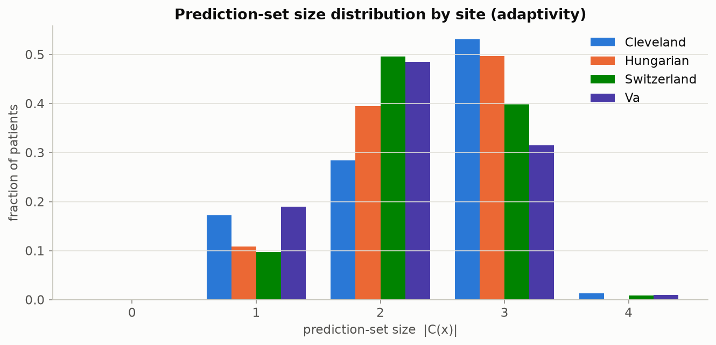
Figure 4.7 -- Prediction-set-size distribution by site, chest-pain task. Produced by viz.plot_set_size_distribution, via scripts/run_demo_cp.py.
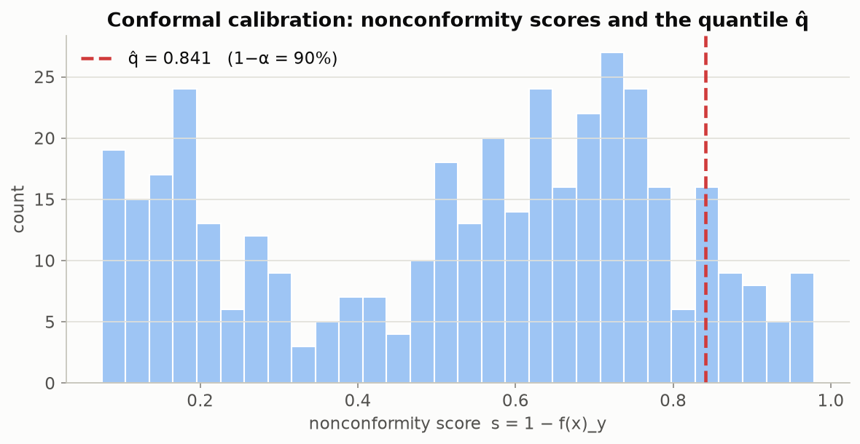
Figure 4.8 -- The chest-pain task's own calibration-score histogram, the secondary-task analogue of Figure 2.3. Produced by viz.plot_calibration_scores, via scripts/run_demo_cp.py.

4.4 Verdict: is the pipeline right as it stands?
Yes, for its stated purpose. Every claim this report makes is backed by a figure generated from a real, reproducible run (all 8 notebooks and 6 scripts execute cleanly end to end, and 10 automated correctness tests -- including a check that split-conformal coverage lands within the expected Beta band on data with a known-correct answer -- pass). The pipeline correctly separates the two kinds of heterogeneity the workshop is built to teach, demonstrates the coverage-guarantee failure concretely and repeatably, and generalizes across two independent prediction tasks and two different nonconformity scores. As a hands-on teaching and diagnostic tool for the stated workshop goals, it is complete.
That said, extending it toward a production curation tool would benefit from a few additions that are out of scope for a workshop but worth flagging honestly:
- A calibration/reliability diagram for the raw model probabilities (expected calibration error), shown side by side with the conformal coverage story, would make the opening claim -- "models are confident even when wrong" -- directly measurable rather than only illustrated.
- Feature-stratified coverage by patient subgroup (sex, age band), not only by site, is already implemented in evaluate.feature_stratified_coverage but is not currently plotted anywhere -- an easy addition that would extend the class-conditional-coverage lesson (Section 2.6) to demographic fairness within a single site.
- The per-site mean-imputation of `ca`/`thal` (necessary so the model can train at all, given 80-99% missingness outside Cleveland) is silent by default; adding an explicit 'was this value missing' indicator feature per patient is a small change that would let the model, and the curation team, distinguish a genuinely low vessel count from an imputed placeholder.
- The mitigation strategies the notebooks currently pose only as end-of-notebook exercises (per-site / group-balanced calibration, importance-weighted conformal prediction under known covariate shift) are the natural next experiment -- implementing and plotting at least one of them would close the loop from "here is the problem" to "here is a first fix."
- All four sites here are from one country each; a genuinely external validation site (a fifth hospital never touched during either development or the heterogeneity analysis itself) would strengthen the claim that the observed coverage drop generalizes beyond this specific four-hospital federation.
None of these are required to support the report's central claims -- each is a natural next increment, not a gap that undermines what is already demonstrated.

Appendix: Full Figure Index
All 33 figures referenced in this report, in file order, with the script or notebook that generates each one. Every figure is reproducible by running the listed command from the repository root.
File | Generated by | Referenced as
figures/01_site_overview.png | scripts/run_demo.py | Fig. 1.1
figures/02_missingness.png | scripts/run_demo.py | Fig. 3.1
figures/03_chol_distributions.png | scripts/run_demo.py | Fig. 3.2
figures/04_js_divergence.png | scripts/run_demo.py | Fig. 3.6
figures/05_domain_auc.png | scripts/run_demo.py | Fig. 3.5
figures/06_fed_curves.png | scripts/run_demo.py | Fig. 4.2
figures/07_calibration_scores.png | scripts/run_demo.py | Fig. 2.3
figures/08_transfer_matrix.png | scripts/run_demo.py | Fig. 1.4
figures/09_coverage_by_site.png | scripts/run_demo.py | Fig. 1.3
figures/10_set_sizes.png | scripts/run_demo.py | Fig. 2.6
figures/11_coverage_beta.png | scripts/run_demo.py | Fig. 2.4
figures/eda/e01_target_distribution.png | scripts/run_eda.py | Fig. 3.3
figures/eda/e02_target_by_site.png | scripts/run_eda.py | Fig. 3.4
figures/eda/e03_continuous_grid.png | scripts/run_eda.py | Fig. 3.9
figures/eda/e04_thalach_by_site.png | scripts/run_eda.py | Fig. 3.10
figures/eda/e05_categorical_grid.png | scripts/run_eda.py | Fig. 3.11
figures/eda/e06_correlation.png | scripts/run_eda.py | Fig. 3.12
figures/cp/c01_class_distribution.png | scripts/run_demo_cp.py | Fig. 3.13
figures/cp/c02_fed_curves.png | scripts/run_demo_cp.py | Fig. 4.3
figures/cp/c03_calibration_scores.png | scripts/run_demo_cp.py | Fig. 4.8
figures/cp/c04_class_conditional.png | scripts/run_demo_cp.py | Fig. 2.7
figures/cp/c05_transfer_matrix.png | scripts/run_demo_cp.py | Fig. 4.5
figures/cp/c06_coverage_by_site.png | scripts/run_demo_cp.py | Fig. 4.6
figures/cp/c07_set_sizes.png | scripts/run_demo_cp.py | Fig. 4.7
figures/paper/fig02_conformal_illustration.png | scripts/run_paper_figures.py | Fig. 2.1
figures/paper/fig04_adaptive_prediction_sets.png | scripts/run_paper_figures.py | Fig. 2.2
figures/paper/fig06_conformalized_quantile_regression.png | scripts/run_paper_figures.py | Fig. 2.8
figures/paper/fig08_uncertainty_scalar.png | scripts/run_paper_figures.py | Fig. 2.9
figures/paper/fig09_conformalized_bayes.png | scripts/run_paper_figures.py | Fig. 2.10
figures/paper/fig10_coverage_notions.png | scripts/run_paper_figures.py | Fig. 1.2
figures/paper/fig11_coverage_distribution.png | scripts/run_paper_figures.py | Fig. 2.5
figures/compare/task_comparison.png | scripts/compare_tasks.py | Fig. 4.4
figures/extra/x01_pca_scatter.png | scripts/run_extra_figures.py (new) | Fig. 3.7
figures/extra/x02_age_thalach_scatter.png | scripts/run_extra_figures.py (new) | Fig. 3.8
figures/extra/x03_pipeline_overview.png | scripts/run_extra_figures.py (new) | Fig. 4.1

Reproduce everything: python scripts/run_demo.py && python scripts/run_demo_cp.py && python scripts/run_eda.py && python scripts/run_paper_figures.py && python scripts/compare_tasks.py && python scripts/run_extra_figures.py

