QUANT CLUB

**IIT KHARAGPUR**

SUMMER OF QUANT

C E R T I F I C A T E O F C O M P L E T I O N

**THIS CERTIFICATE IS AWARDED TO**

**ARNAB NANDI**

for successfully completing 6 weeks Summer of Quant Program conducted by Quant Club, Indian Institute of Technology Kharagpur, demonstrating exceptional dedication and a profound understanding of quantitative finance.

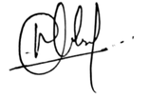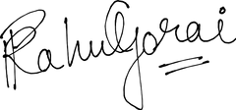

**SHREEKRISHNA CHATE GOVERNOR**



**RAHUL GORAI ADVISOR**