**1. What are the two values of the Boolean data type? How do you write them?**

**Answer:** True and False

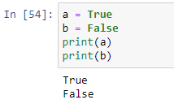

**2. What are the three different types of Boolean operators?**

**Answer:** and, or, not

**3. Make a list of each Boolean operator's truth tables (i.e. every possible combination of Boolean values for the operator and what it evaluate ).**

**Answer:**

|  |  |  |  |  |
| --- | --- | --- | --- | --- |
| **AND TRUTH TABLE** | | | | |
| **IN-1** | | **IN-2** | **OUTPUT** | |
| 0 | | 0 | 0 | |
| 0 | | 1 | 0 | |
| 1 | | 0 | 0 | |
| 1 | | 1 | 1 | |
|  | | | | |
| **OR TRUTH TABLE** | | | | |
| **IN-1** | | **IN-2** | **OUTPUT** | |
| 0 | | 0 | 0 | |
| 0 | | 1 | 1 | |
| 1 | | 0 | 1 | |
| 1 | | 1 | 1 | |
|  | | | | |
| **NOT TRUTH TABLE** | | | |
| **IN** | **OUTPUT** | | |
| 0 | 1 | | |
| 1 | 0 | | |

**4. What are the values of the following expressions?**

**(5 > 4) and (3 == 5) - False**

**not (5 > 4) - False**

**(5 > 4) or (3 == 5) - True**

**not ((5 > 4) or (3 == 5)) - False**

**(True and True) and (True == False) - False**

**(not False) or (not True) - True**

**5. What are the six comparison operators?**

**Answer:**

1. > is greater than
2. >= is greater than or equal to
3. < is less than
4. <= is less than or equal to
5. == is equal to
6. != is not equal to

**6. How do you tell the difference between the equal to and assignment operators?Describe a condition and when you would use one.**

**Answer:**

Assignment is used to assign a value to a variable (example: a=100 assigns 100 to variable a)

Equal to operator == checks whether the value of a variable is equal to a certain value or not and provides True or False based on condition.

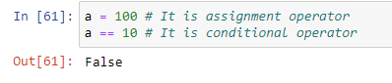

**7. Identify the three blocks in this code:**

**spam = 0 # Block – 1 - assignment**

**if spam == 10: # Block -2 – single if**

**print('eggs')**

**if spam > 5: # Block – 3 – if else**

**print('bacon')**

**else:**

**print('ham')**

**print('spam')**

**print('spam')**

**8. Write code that prints Hello if 1 is stored in spam, prints Howdy if 2 is stored in spam, and prints Greetings! if anything else is stored in spam.**

**Answer:**

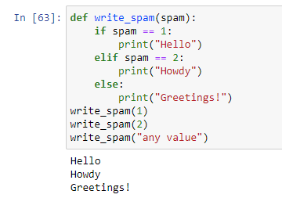

**9. If your programme is stuck in an endless loop, what keys you’ll press?**

**Answer:**

In jupyter notebook I will interrupt the kernel. In command prompt I will press CTRL + C

**10. How can you tell the difference between break and continue?**

**Answer:**

‘break’ is used to break a loop. ‘continue’ is used to skip the code written after it and go to next iteration.

Example: A while loop which print the value from 1 to 10 but skip a particular value

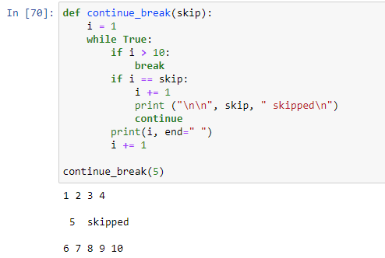

**11. In a for loop, what is the difference between range(10), range(0, 10), and range(0, 10, 1)?**

**Answer:**

The result will be same in all three cases.

**12. Write a short program that prints the numbers 1 to 10 using a for loop. Then write an equivalent program that prints the numbers 1 to 10 using a while loop.**

**Answer:**

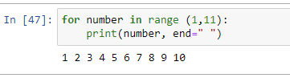

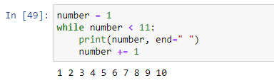

**13. If you had a function named bacon() inside a module named spam, how would you call it after importing spam?**

**Answer:**

