**Product:** AllPayC Assessment

**Goal:** Development of “Lights out” game in using Microsoft .Net suite, Visual Studio 2017 and C#.

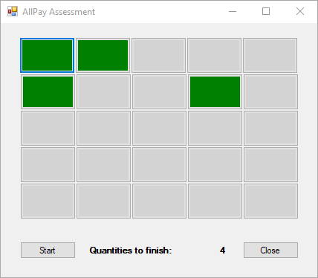

**Scenario:** I added 25 buttons (5x5) in the process and I will manage each action based in what button was pressed.

Steps:

1. Screen Initial Load

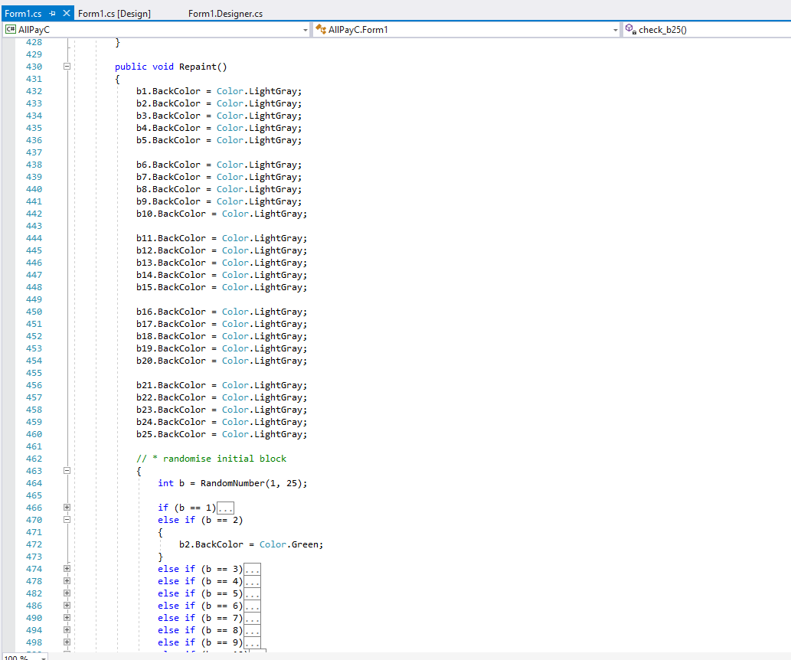

This process will paint all buttons with lightgray colour and will turn on (green) one using randomize feature.

1. Action when pressed a button

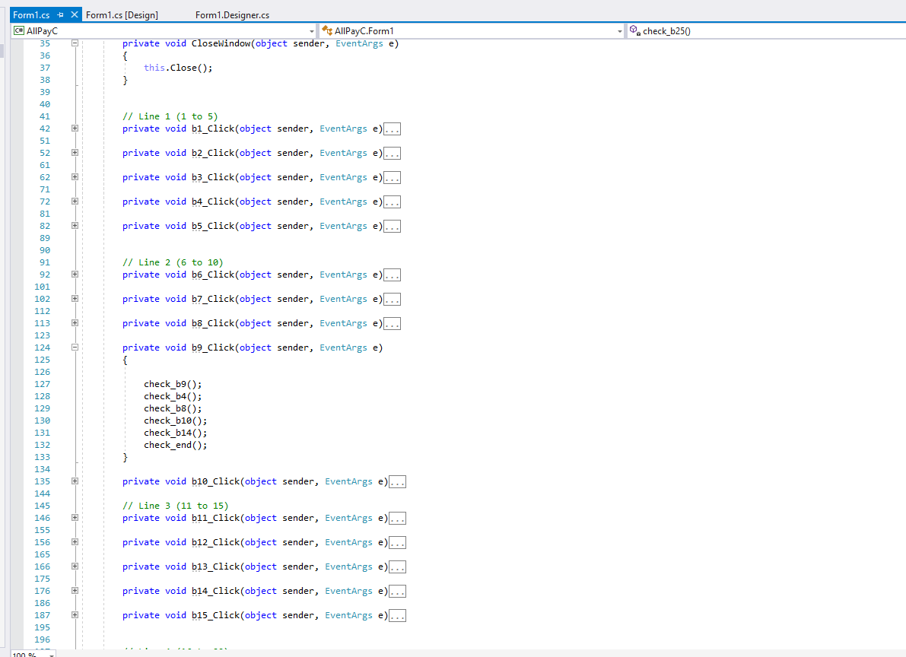

According the pressed button the process will run the buttons around the pressed button.

Like:

- Pressing button 9:

- will process the button 9 itself

- will process the button 4 above

- will process the button 8 left

- will process the button 10 right

- will process the button 14 bellow

- then, will check if the board is clear.

1. Check if ended

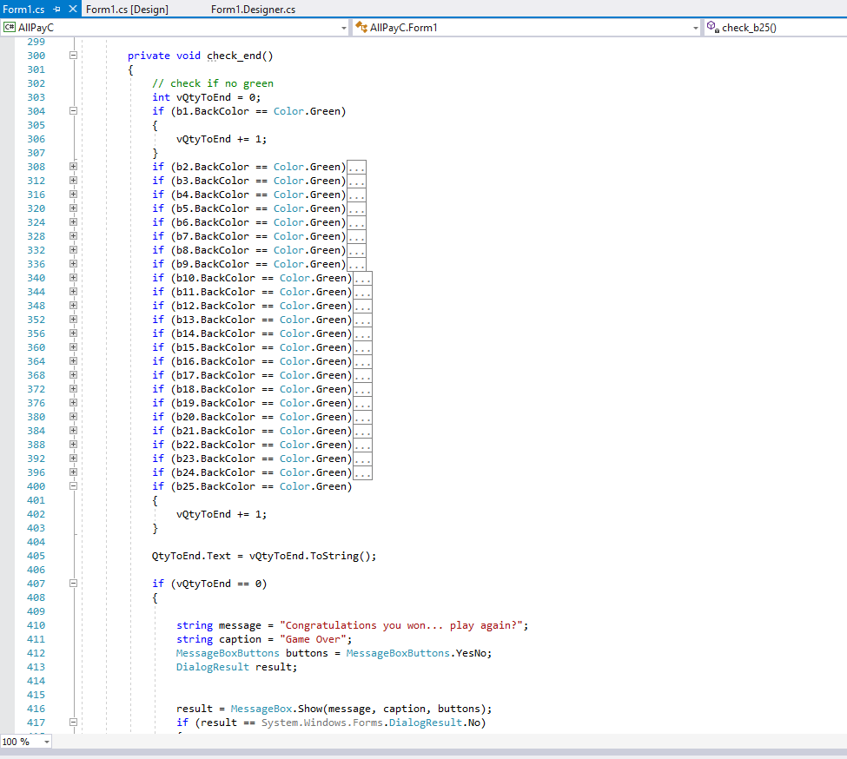

Using a counter that will be displayed in the screen, the process will check if all buttons are not green.

If there is no button green, return a congratulation message, where the user can select if start a new round or leave the game.

1. Start / Restart button

Pressing the button will clear out all buttons and a new game will be released.

1. Close Button

Pressing the button will leave the game.