
La Bamba / Twist and shout
(152 à la noire, 4/4 pulsation binaire, Ré majeur) – Strum : B-B-Bh-H-h-hB-Bh ( A7 en avance d’une croche)

Intro La Bamba (uku seul)
D / G A7*

Para bailar la bamba
Para bailar la bamba
Se necesita una poca de gracia
Una poca de gracia pa mi pa ti
Y arriba y arriba
Ay arriba y arriba
Por ti sere, por ti sere, por ti sere
-----------------[STOP] -----------------
Well, shake it up, baby, now
(shake it up, baby)
Twist and shout (twist and shout)
Come on, come on, come on, come on, baby, now (come on, baby)
Come on and work it all out
(work it all out hoooooooo)
Well, you twist,you little girl
(twist, little girl)
You know, you twist so fine
(twist so fine)
Come on and twist a little closer, now (twist a little closer)
And let me know that you're mine
(let me know you're mine hoooooo)

A / A
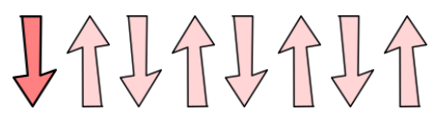
AAAAHHH AAAAHHH
A / A7
AAAAHHH AAAAHHH

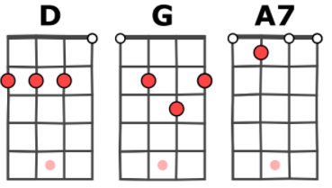
Yo no soy marinero
Yo no soy marinero, soy capitan
Soy capitan, soy capitan
Bamba, bamba
Bamba, bamba
Bamba, bamba
Bamba, bamba
D D G G A7



1 et 2 et 3 et 4 et 5 et 6 et 7 et 8 et
Riff Twist and shout
D / G A7*

(Bamba, bamba)
Well, shake it up, baby, now
Twist and shout (Bamba, bamba)
Come on, come on, come on, come on, baby, now (poca de gracia)
Come on and work it all out
(por ti sere oooooh)
Well, you twist, you little girl (marinero)
You know, you twist so fine (capitan)
Come on and twist a little closer, now (Bamba, bamba)
And let me know that you're mine
(por ti sere oooooh)
A / A
AAAAHHH AAAAHHH
A / A7
AAAAHHH AAAAHHH

Para bailar la bamba (shake it up, baby)
Para bailar la bamba
Se necesita una poca de gracia
(twist and shout)
Una poca de gracia pa mi pa ti
Y arriba y arriba (come on, baby)
Ay arriba y arriba
Por ti sere, por ti sere, por ti sere (oooooh)
Bamba, bamba (shake it up, baby)
Bamba, bamba (twist and shout)
Bamba, bamba (come on, baby)
Bamba bamba (oooooh)

A / A
AAAAHHH AAAAHHH
A / A7
AAAAHHH AAAAHHH
V2

A A# B C C# D7…
