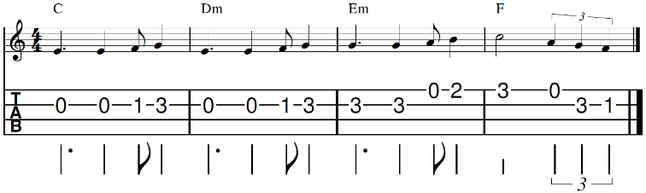
Boys don’t cry – The Cure (1979)
Riff sur Intro / refrains / outro

Intro :

C… Dm… Em F / F
C Dm Em F / F (2x avec riff)
C Dm Em F / F ( sans riff)

C Dm
I would say I'm sorry
Em F
If I thought that it would change your mind
C Dm
But I know that this time
Em F
I have said too much, been too unkind

Em Dm Em Dm
I try to laugh about it cover it all up with lies
Em Dm Em Dm
I try to laugh about it hiding the tears in my eyes

C Dm Em F
'Cause boys don't cry
C Dm Em F / F
Boys don't cry

C Dm
I would break down at your feet
Em F
And beg forgiveness plead with you
C Dm
But I know that it's too late
Em F
And now there's nothing I can do

Em Dm Em Dm
I try to laugh about it cover it all up with lies
Em Dm Em Dm
I try to laugh about it hiding the tears in my eyes

C Dm Em F / F
'Cause boys don't cry
C Dm Em F / F
Boys don't cry

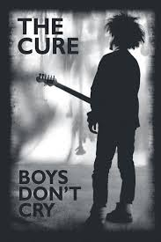

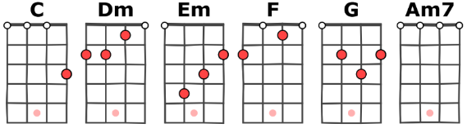

C Dm
I would tell you that I loved you
Tempo 169 bpm
-
Strum :
B Bh hB
Em F
If I thought that you would stay
C Dm
But I know that it's no use
Em F
That you've already gone away

G Am7
Misjudged your limits
G Am7
Pushed you too far
G Am7
Took you for granted
F G
I thought that you needed me more

C Dm
Now I would do most anything
Em F
To get you back by my side
C Dm
But I just keep on laughing
Em F
Hiding the tears in my eyes

C Dm Em F / F
'Cause boys don't cry
C Dm Em F / F
Boys don't cry

Outro:
C Dm Em F

C… Dm… Em … F… F / Em / Dm / C
A - V7

