Dirty old town – The Pogues
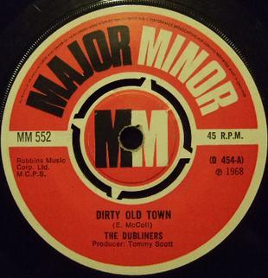
Paroles et musique : Ewan MacColl (1949)
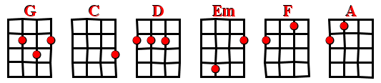
Strum : B BhB B 2x – 125 BPM
INTRO: G % C G D Em / block  G %  I met my love by the gas works wall  C G  Dreamed a dream by the old canal  % %  I Kissed my girl by the factory wall  D Em / block  Dirty old town, dirty old town  G %  Clouds are drifting across the moon  C G  Cats are prowling on their beat  % %  Spring's a girl from the streets at night  D Em / block  Dirty old town, dirty old town    Pont : C % F C % % G Am/ block | G %  I Heard a siren from the docks  C G  Saw a train set the night on fire  % %  I Smelled the spring on the smoky wind  D Em / block  Dirty old town, dirty old town  G %  I'm going to make me a big sharp axe  C G  Shining steel tempered in the fire  % %  I'll chop you down like an old dead tree  D Em / block  Dirty old town, dirty old town  G %  I met my love by the gas works wall  C G  Dreamed a dream by the old canal  % %  I Kissed my girl by the factory wall  D Em / block  Dirty old town, dirty old town  D Em  Dirty old town, dirty old town

PHILIPPE V4

