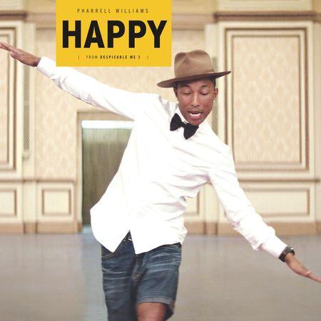
Happy – Pharrell Williams

160 bpm – Tonalité originale F - 2013

Couplet
E7 - - - ( 4x)
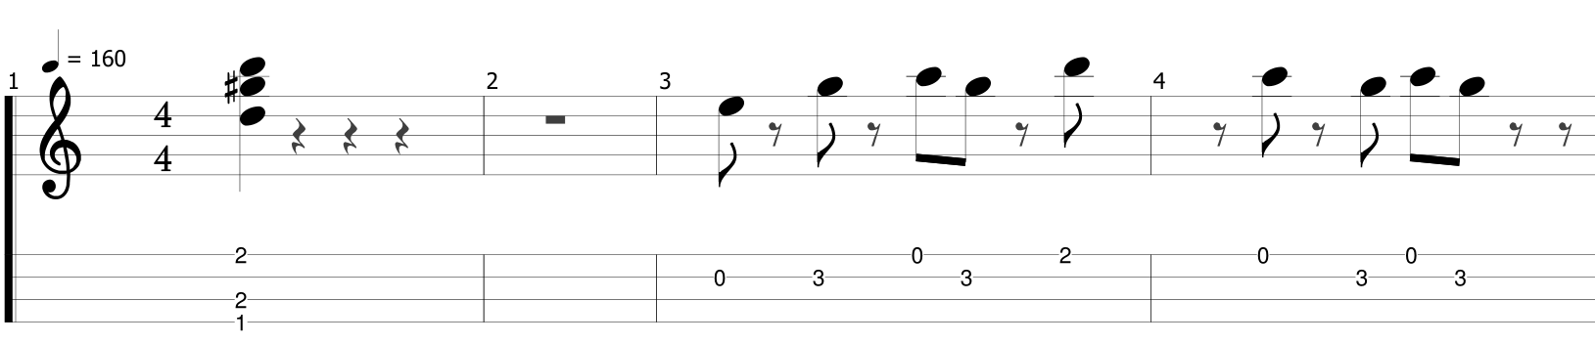
It might seem crazy what I'm about to say
Sunshine she's here, you can take a break
I'm a hot air balloon that could go to space
With the air, like I don't care baby by the way

Refrain
C Bm Bm7 E7 (4x)
Because I'm happy / Clap along if you feel like a room without a roof
Because I'm happy / Clap along if you feel like happiness is the truth
Because I'm happy / Clap along if you know what happiness is to you
Because I'm happy / Clap along if you feel like that's what you wanna do

Couplet 2
Here come bad news talking this and that, yeah,
Well, give me all you got, and don't hold it back, yeah,
Well, I should probably warn you I'll be just fine, yeah,
No offense to you, don't waste your time (Here's why)

Refrain

Pont

Bring me down / Can't nothing / Bring me down / My level's too high
Bring me down / Can't nothing / Bring me down /I said (let me tell you now)
Bring me down / Can't nothing / Bring me down / My level's too high
Bring me down / Can't nothing / Bring me down /I said (let me tell you now)

Refrain 2X

