Happy – Pharrell Williams
160 bpm – Tonalité originale F - 2013
F Bb C Bb
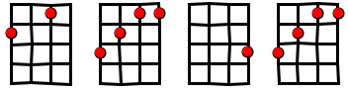

Intro
F - - - ( 5x)

Couplet
F (block) NC F / Bb C / Bb
It might seem crazy what I'm about to say
Sunshine she's here, you can take a break I'm a
hot air balloon that could go to space With the
air, like I don't care baby by the way
DbM7 Cm7 Eb F
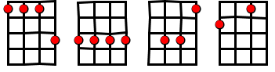

Refrain
DbM7 Cm7 Eb F
Because I'm happy / Clap along if you feel like a room without a roof
Because I'm happy / Clap along if you feel like happiness is the truth
Because I'm happy / Clap along if you know what happiness is to you
Because I'm happy / Clap along if you feel like that's what you wanna do

Couplet 2
F (block) NC F / Bb C / Bb
Here come bad news talking this and that, yeah,
Well, give me all you got, and don't hold it back, yeah, Well, I
should probably warn you I'll be just fine, yeah,
No offense to you, don't waste your time (Here's why)

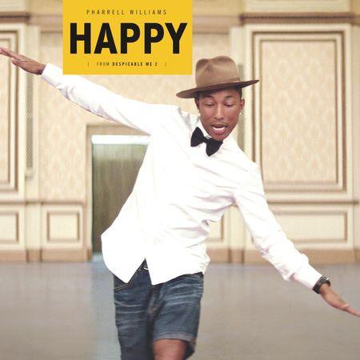
Refrain

Pont (pas d’accord)

Bring me down / Can't nothing / Bring me down / My level's too high
Bring me down / Can't nothing / Bring me down /I said (let me tell you now)
Bring me down / Can't nothing / Bring me down / My level's too high
Bring me down / Can't nothing / Bring me down /I said (let me tell you now)

Refrain 2X

