
Mamma mia (ABBA, 1975) 137 BPM

INTRO D D+ x4 Ajouter sur les 2 derniers D D+ x2
C -----2-----2-----2-----2-----2-----2-----2-----2------ A------------5---9---(9)---9---7---9---7---5
G --------2-----2-----2-----3-----3-----3-----3-----2--- E----5—7--------------------------------------
D / A/D D / A/D G G
I've been cheated by you, since I don't know when
D / A/D D / A/D G G
So I made up my mind, it must come to an end
D D+
Look at me now…… will I ever learn?
D D+. G G A
I don't know how…… but I suddenly lose control… There's a fire within… my soul
1 2 3 4
↓ ↓↑↓↑↓↑
A / G↓ D↓ A A / G↓ D↓ A A
Just one look and I can hear a bell ring… One more look and I forget everything, wohoho
.
D D G↓ C↓ / G G
Mamma mia… here I go again… My my, how can I resist you ?
D D G↓ C↓ / G G
Mamma mia… does it show again ?... My my, just how much I've missed you

REFRAIN
D A Bm F#m
Yes, I've been bro – kenhearted… Blue since the day we parted
G↓ C↓ / G↓(↓) Em* ↑ / A
Em* : anticipé 1 /2 temps avant la mesure
Why, why did I ever let you go ?
D Bm G↓ C↓ / G↓(↓) Em* ↑ / A
Mamma mia… now I really know…… My my, I could never let you go

.
PONT : D D+ D D+ Idem 2ème partie intro
.
.
D / A/D D / A/D G G
I've been angry and sad about the things that you do
D / A/D D / A/D G G
I can't count all the times that I've told you we're through
D D+
And when you go….. when you slam the door
D D+. G G A
I think you know…… that you won't be away too long…. You know that I'm not that strong.
A / G↓ D↓ A A / G↓ D↓ A A
Just one look and I can hear a bell ring… One more look and I forget everything, wohoho
Les 2 premières lignes de chaque refrain : cordes pincées et étouffées 8 fois par accord
Sur les 2 couplets, à la place des 2 G :
G G
2—5-5-7-5-5-5—(5)—10-10-9
3---7-7-7-7-7-7---(7)---10-10-10-10-10-10
2---7-7-7-7-7-7----------11-11-11-11-11-11
0---0-0-0-0-0-0---(0)-----0--0—0--0—0---0
REFRAIN

D D G↓ C↓ / G G
Mamma mia… even if I say….. Bye bye, leave me now or never
D D G↓ C↓ / G G
Mamma mia… it's a game we play…… Bye bye does - n't mean forever
.
REFRAIN

D Bm G↓ C↓ / G↓(↓) Em* ↑ / A
Mamma mia… now I really know……My my, I could never let you go.
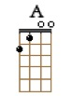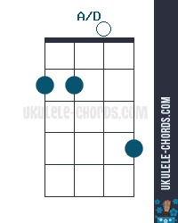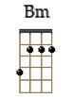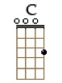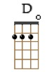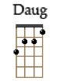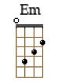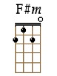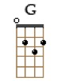

FIN : D D+…. idem intro
M-A / V1

