
Mamma mia – ABBA – 1975 - 137 bpm
I
N
T
R
O

D D+ D D+ D D+ D D+
C 2--2--2--2--2--2--2--2--2--2--2--2--2--2--2--2--2--2--2--2--2--2--2--2--2--2--2--2--2--2--2--2--
G --2--2--2--3--3--3--3--2--2--2--2--3--3--3--3--2--2--2--2--3--3--3--3--2--2--2--2--3--3--3--3--2
RIFF
A---------5---9-----9-7-9-7-5-----5--9-------9-7-9-7-5
E---5--7-------------------------5-7-----------------------
D / D²7M D / D²7M G G
I've been cheated by you, since I don't know when
D / D²7M D / D²7M G G
So I made up my mind, it must come to an end
D D+
Look at me now…… will I ever learn?
D D+. G G A
I don't know how…… but I suddenly lose control… There's a fire within… my soul
Sur les 2 couplets, sur les 2 G : SOLO
G G
A-(2)----5-5-7-5-5-5--(5)--10-10-9---------------
E-(3)---------------------------------------10-10-10-
A / G↓ D↓ A A / G↓ D↓ A A
Just one look and I can hear a bell ring… One more look and I forget everything, wohoho
.
D D G↓ C↓ / G G
Mamma mia… here I go again… My my, how can I resist you ?
D D G↓ C↓ / G G
Mamma mia… does it show again ?... My my, just how much I've missed you
REFRAIN
Cordes pincées et étouffées
8 x par mesure
D A Bm F#m
Yes, I've been bro – kenhearted… Blue since the day we parted
G↓ C↓ / G↓(↓) Em* ↑ / A
Em* : anticipé 1 /2 temps avant la mesure
Why, why did I ever let you go ?
D Bm G↓ C↓ / G↓(↓) Em* ↑ / A
Mamma mia… now I really know…… My my, I could never let you go

.
PONT : D D+… IDEM INTRO
.
.
D / D²7M D / D²7M G G
I've been angry and sad about the things that you do
D / D²7M D / D²7M G G
I can't count all the times that I've told you we're through
D D+
And when you go….. when you slam the door
D D+. G G A
I think you know…… that you won't be away too long…. You know that I'm not that strong.
A / G↓ D↓ A A / G↓ D↓ A A
Just one look and I can hear a bell ring… One more look and I forget everything, wohoho
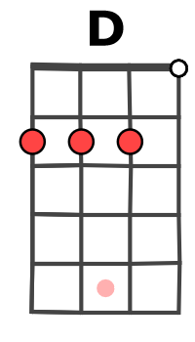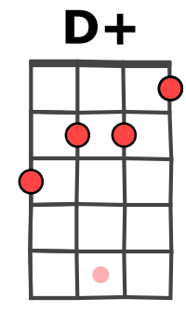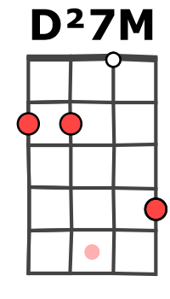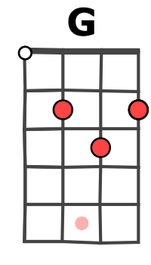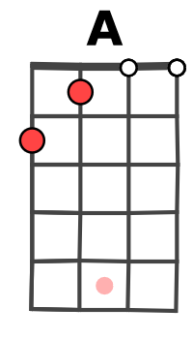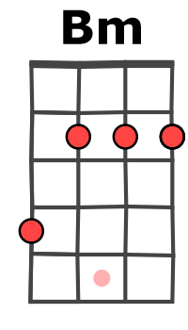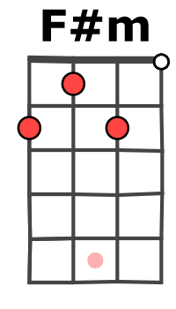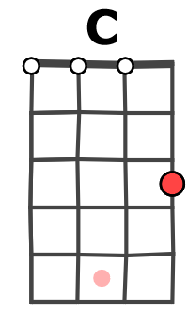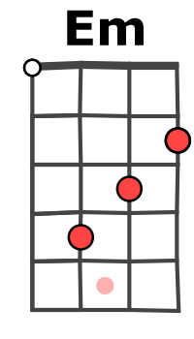

D D G↓ C↓ / G G
puis Mamma mia… even if I say….. Bye bye, leave me now or never
D D G↓ C↓ / G G
Mamma mia… it's a game we play…… Bye bye does - n't mean forever
.
REFRAIN
REFRAIN

puis D Bm G↓ C↓ / G↓(↓) Em* ↑ / A
Mamma mia… now I really know……My my, I could never let you go
1 2 3 4
↓ ↓↑↓↑↓↑

FIN : D D+…. IDEM INTRO
G / V5

