All about that bass – Meghan Trainor -2014 – 135 bpm – tonalite originale
Intro : A A Bm Bm E7 E7 A A (un tour basse seule, puis un tour basse + percus)
Refrain A A
(1,2) Because you know I'm all about that bass, 'bout that bass no treble
Bm Bm
Strum couplets et refrains
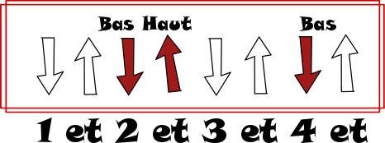I'm all ‘bout that bass, 'bout that bass no treble
E7 E7
I'm all ‘bout that bass, 'bout that bass no treble
A A (2,3,4)
I'm all ‘bout that bass, 'bout that bass

Couplet 1 A A
(choeurs)
voix + choeurs
Yeah it's pretty clear, I ain't no size two
Bm Bm
But I can shake it, shake it like I'm supposed to do
E7 E7
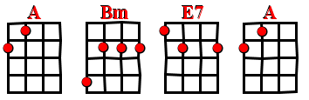 C’se I got that boom boom that all the boys chase
A ( block) A ( block)
All the right junk in all the right places

A A
I see the magazines (ha haaa !) working that Photoshop
 Bm Bm
(ha haa !) We know that shit ain't real come on now, make it stop !
E7 E7
If you got beauty beauty (ah aah ) just raise 'em up cause every
A ( block) A ( block)
inch of you is perfect from the bottom to the top

Pré- refrain A A Bm Bm
Yeah, my momma she told me don't worry about your si_ze (shoo wap wap sha ooo wap wap)
E7 E7 A A
She says, boys like a little more booty to hold at ni_ight (that booty booty x2)
A A Bm Bm
You know I won't be no stick figure silicone Barbie doll, (shoo wap wap sha ooo wap wap )
E7 E7 A A Block
So, if that's what's you're into then go ahead and move alo - ong!

Refrain
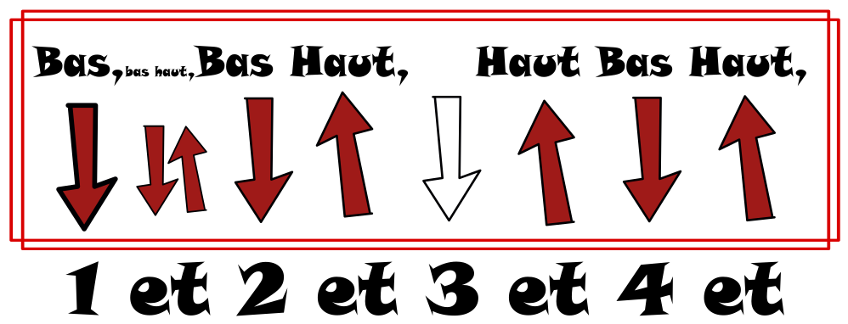
Couplet 2 A (block) Α
« calypso romantique »
I'm bringing booty ba-a-ack Go ahead and tell them skinny
Bm Bm
ladies He-ey ! … No, I'm just playing I know you
E7 E7
think you're fa-at, But I'm here to tell you
A block A block
Every inch of you is perfect from the bottom to the top!

Pré- refrain
Refrain X3 (la dernière fois, basse + percu seuls) -- V6 --

