
Back to black
124 BPM, Em, tonalité originale Dm
Intro : ½ couplet
He left no time to regret
Kept his dick wet
With his same old safe bet
Me and my head high
And my tears dry
Get on without my guy
You went back to what you knew
So far removed from all
that we went through
And I tread a troubled track
My odds are stacked
I'll go back to black
We only said goodbye with words
I died a hundred times
You go back to her
And I go back to...
[ 2 mesures de blanc]
I go back to
us
I love you much
It's not enough
You love blow and I love puff
And life / is like a pipe
And I'm a tiny penny rolling up the walls inside
We only said goodbye with words
I died a hundred times
You go back to her
And I go back to...
We only said goodbye with words
I died a hundred times
You go back to her
And I go back to...
[ 2 mesures de “blanc”
(percu seule) en ralentissant]
Rythmique uku : à la noire, 8 noires par case
Couplet / refrain
Em | Am | C | B
Em | Am | C | B

Pont
Em | C | G | B
Em | C | G | B | B7
Black, black, black, black, black, black, black,
I go back to...
I go back to...
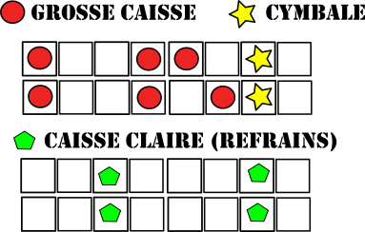
We only said goodbye with words
I died a hundred times
You go back to her
And I go back to...
We only said goodbye with words
I died a hundred times
You go back to her
And I go back to…
black

