
Get Lucky
Intro / pont / couplet / refrain
Bm | D | F#m | E
2013, 116 BPM, Bm, une case = une mesures de quatre temps
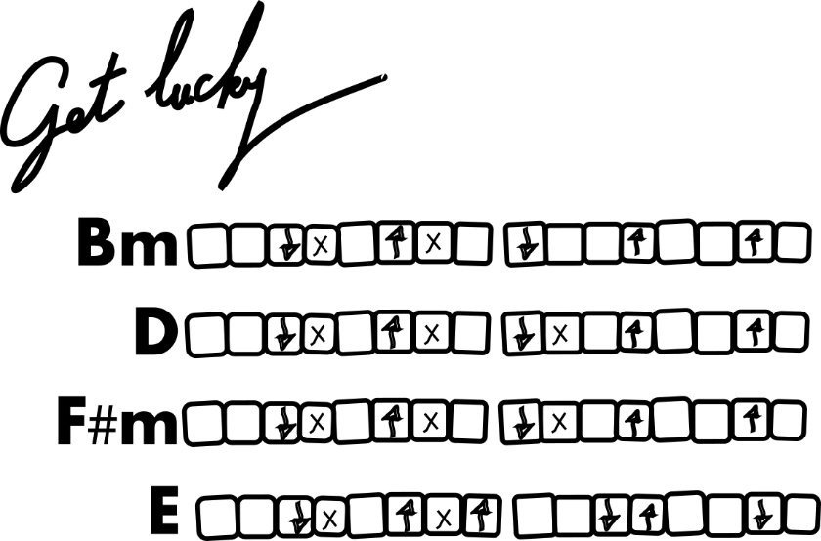
She's up all night 'til the sun
I'm up all night to get some
She's up all night for good fun
I'm up all night to get lucky
We're up all night 'til the sun
We're up all night to get some
We're up all night for good fun
We're up all night to get lucky
We're up all night to get lucky (x4)

We're up all night to get lucky (8x)

We've come too far to give up who we are
So let's raise the bar and our cups to the stars
She's up all night 'til the sun
I'm up all night to get some
She's up all night for good fun
I'm up all night to get lucky
We're up all night 'til the sun
We're up all night to get some
We're up all night for good fun
We're up all night to get lucky
We're up all night to get lucky (x4)
Like the legend of the phoenix
All ends with beginnings
What keeps the planet spinning
The force from the beginning
We've come too far to give up who we are
So let's raise the bar and our cups to the stars
She's up all night 'til the sun
I'm up all night to get some
She's up all night for good fun
I'm up all night to get lucky
We're up all night 'til the sun
We're up all night to get some
We're up all night for good fun
We're up all night to get lucky
We're up all night to get lucky (x4)

The present has no ribbon
Your gift keeps on giving
What is this I'm feeling?
If you wanna leave I'm ready (ahh)

We've come too far to give up who we are
So let's raise the bar and our cups to the stars


.

