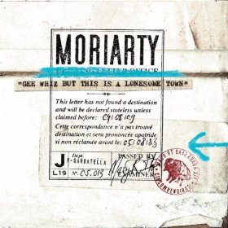
Jimmy, 2007
Intro / pont / couplet / refrain
Am | C | G | F
124 BPM, Am, une case = une mesures de quatre temps

Couplet 3
Harmonica [fausse sortie]
Refrain [guitar basse puis batterie]
Outtro
Guitare seule
Guitare + Harmonica 2x
Couplet 1 [Guitare]
Guitare + Harmonica
Couplet 2 [guitare basse batterie]
Harmonica [fausse sortie]
Refrain [chœurs sur 2ème moitié]
Banjo / Harmonica 4x


.

Hey!
you've gotta have a wash but you can't clean your name
You're now called Jimmy you'll be Jimmy just the same
The keys are in a bag in a chest by the door
One of Jimmy's friends has taken the floor
Jimmy won't you please come home where the grass is green and the buffaloes roam
Dear old Jimmy you've forgotten you're young but you can't ignore the buffalo song
Buffaloes used to say be proud of your name
Buffaloes used to say be what you are
Buffaloes used to say roam where you roam
Buffaloes used to say do what you do
If you remember you're unknown
Buffaloland will be your home... [4x]
Jimmy won't you please come home where the grass is green and the buffaloes roam
Come see Jimmy your uncle Jim your auntie Jimmie and your cousin Jim
Come home Jimmy because you need a bath
And your grandpa Jimmy is still gone daft
Now there's buffalo Jim and buffalo Jim
And Jim buffalo now didn't you know
Jim' Jim' Jimmy it's your last cigarette
But there's buffalo piss and it's all kind of wet
Jambo Jimmy you'd better hold your nose
All roads lead to roam with the buffaloes
Buffaloes used to say be proud of your name
Buffaloes used to say be what you are
Buffaloes used to say roam where you roam
Buffaloes used to say do what you do

