Jimmy (Moriarty, 2007) 126 BPM en Am (originale en Bb).

INTRO : uku seul = Am C G F + harmonica = Am C Em Em Am C G F

Am C G F
Jimmy won't you please come home where the grass is green and the buffaloes roam
Am C G F
Come see Jimmy your uncle Jim and your auntie Jim and your cousin Jim
Am C G F
Come home Jimmy 'cause you need a bath and your grandpa Jimmy is still gone daft

Am C G Em Emi… E7 E7i… + harmonica

Am C G F
Now there's buffalo Jim and buffalo Jim, there's Jim buffalo now didn't you know
Am C G F
Jim Jimmy Jimmy it’s your last cigarette but there's buffalo piss, it's all kind of wet
Am C G F
Jambo Jimmy you'd better hold your nose, all roads lead to roam with the buffaloes

Am C G Em E7 + harmonica
1.&2.&3.&4.&
B B hb hB h
B B i P i B h
i : index P : pouce
Am F G Am
REFRAIN
And the Buffaloes used to say-ay be proud of your name
Am F G Am
The Buffaloes used to say-ay be what you are
Am F G Am
The Buffaloes used to say-ay roam where you roam
Am F G Am
Am F G Am x 2
+ harmonica
The Buffaloes used to say-ay do what you do``

Am C
Hey you've gotta have a wash but you can't clean your name
G F
You're now called Jimmy you'll be Jimmy just the same
Am C
The keys are in the bag in the chest by the door
G F
One of Jimmy's friends has taken the floor
Am C G F
Jimmy won't you please come home where the grass is green and the buffaloes roam
Am C G F
Dear old Jimmy you've forgotten you're young but you can't ignore the buffalo song

Am C G Em E7 + harmonica REFRAIN (… sur les 2 1ères lignes)

Am F G Am
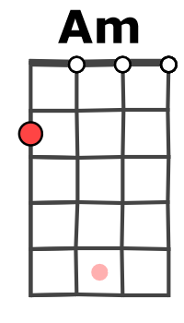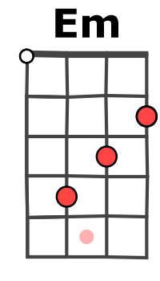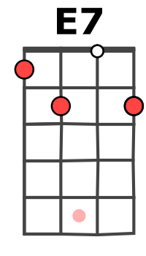
If you remember you're unknown Buffaloland will be your home
Am F G… Am…
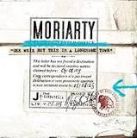
If you remember you're unknown Buffaloland will be your home

Am C G F
A……0…….0………..3……..3…………..2……….2…………0………0……
E……………..0………………...0…………………….3…………………..1….
C..0…….0………..0……..0…………2……….2………….0….…..0…………
G………………..2…………………0…………………….0………………….2.
M-A V0
Merci à benauukulele

