Imagine - John Lennon 1971
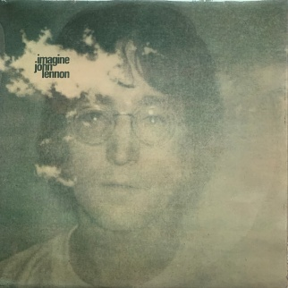

INTRO
*
Riff 2x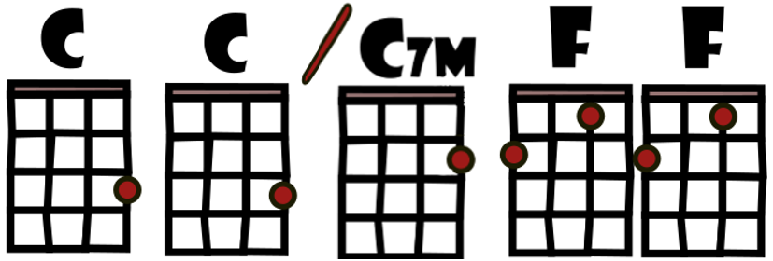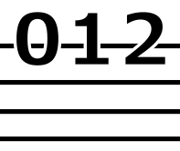

Couplet 1
C C / Cmaj7 F F*
Imagine there's no heaven
C C / Cmaj7 F F*
It's easy if you try
C C / Cmaj7 F F*
No hell below us
C C /Cmaj7 F F
Above us only sky

Refrain 1
F Am Dm Dm7
Imagine all the people
G G G7 NC
Living for to - day a-hah

Couplet 2
C C / Cmaj7 F F*
Imagine there's no countries
C C / Cmaj7 F F*
It isn't hard to do
C C / Cmaj7 F F*
Nothing to kill or die for
C C / Cmaj7 F F
And no religion too

Refrain 2
F Am Dm Dm7
Imagine all the people
G G G7 G…
Living life in peace hou-hou-ou

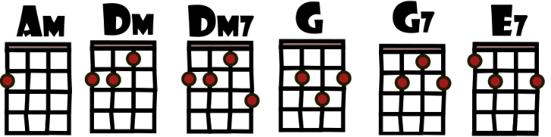
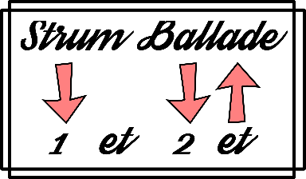

2 temps par mesure 78 Imagine bpm

Pont 1
F G C E7
You may say I'm a dreamer
F G C E7
But I'm not the only one
F G C E7
I hope some day you'll join us
F G C C
And the world will be as one

Couplet3
C C/Cmaj7 F F*
Imagine no pos - sessions
C C/Cmaj7 F F*
I wonder if you can
C C / Cmaj7 F F*
No need for greed or hunger
C C / Cmaj7 F F
A brotherhood of man

Refrain 3
F Am Dm Dm7
Imagine all the people
G G G7 G…
Sharing all the world hou-hou-ou

Pont 2
F G C E7
You may say I'm a dreamer
F G C E7
But I'm not the only one
F G C E7
I hope some day you'll join us
F… G… C…
And the world will live as one
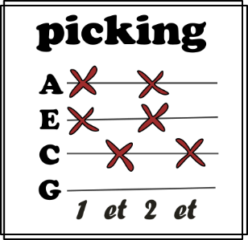
V4

