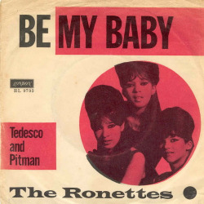
BE MY BABY THE RONETTES 1963
Tempo 130 BPM – Strum Couplet : B . . H B . . .
C C

C C Dm G7
The night we met I knew I needed you so
C C Dm G7
And if I had the chance I 'd never let you go.
E7 E7
(oooh) So won't you say you love me
A7 A7
(oooh) I'll make you so proud of me
D7 D7 G7 / F G7
(oooh) We'll make 'em turn their heads every place we go.

Refrain (strum B . B H . H B H)
C C
So won't you, please (Be my, be my baby)
Am Am
Be my little baby (My one and only baby)
F F
Say you'll be my darlin'(Be my, be my baby)
G7 G7
Be my baby now (My one and only baby) Wha-oh-oh-oh.

C C Dm G7
(oooh) I'll make you happy, baby (ooh ooh) just wait and see (ooh ooh ooh)
C C Dm G7
(oooh) For every kiss you give me (ooh ooh) , I'll give you three (ooh ooh ooh)
E7 E7
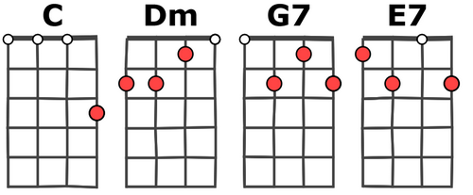
(haaa) Oh, since the day I saw you
A7 A7
(haaaa) I have been waiting for you.
D7 D7 G7 / F G7
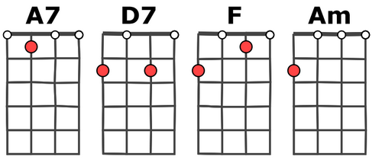
You know I will adore you ' til e---ter--ni---ty.

Refrain

Instrumental ou tempo mains

Coda :
C Am
(Be my, be my baby) Be my little baby
C Dm
(My one and only baby) Oh

G
(Be my, be my baby) Oh
V2

