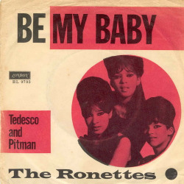
BE MY BABY THE RONETTES 1963
Tempo 130 BPM – Strum Couplet : B . . H B . . . , strum refrain B . B H . H . B . H.

Intro percu: (Zchord) B . . H B . . . 2x
Puis sur accord : D D

D D Em A7
The night we met I knew I needed you so
D D Em A7
And if I had the chance I 'd never let you go.
F#7 F#7
(oooh) So won't you say you love me
B7 B7
(oooh) I'll make you so proud of me
E7 E7 A7 / G A7
(oooh) We'll make 'em turn their heads every place we go.

Refrain (strum B . B H . H B H)
D D
So won't you, please (Be my, be my baby)
Bm Bm
Be my little baby (My one and only baby)
G G
Say you'll be my darlin'(Be my, be my baby)
A7 A7
Be my baby now (My one and only baby) Wha-oh-oh-oh.

D D Em A7
(oooh) I'll make you happy, baby (ooh ooh) just wait and see (ooh ooh ooh)
D D Em A7
(oooh) For every kiss you give me (ooh ooh) , I'll give you three (ooh ooh ooh)
F#7 F#7
(haaa) Oh, since the day I saw you
B7 B7
(haaaa) I have been waiting for you.
E7 E7 A7 / G A7
You know I will adore you ' til e---ter--ni---ty.

Refrain

D D Em A7 x 2
(oooh) (ooh ooh) (ooh ooh ooh)

Refrain (So come on and please)

Refrain x 2 :
D D
……………………….. (Be my, be my baby)
Bm Bm

Be my little baby (My one and only baby)
G G
Oooohhhhhh (Be my, be my baby)
A7 A7
Oooohhhhhh (My one and only baby) Wha-oh-oh-oh.

percu: (Zchord) B . . H B . . . 2x
V4

