Space oddity, Bowie 1972

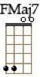 | 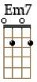 | 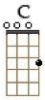 | 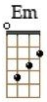 | 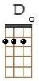 | 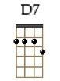 | 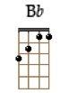 |  | 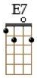 | 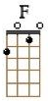 | 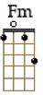 |  | 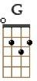 | 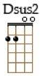 | 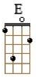

Song : C  Intro : Intro (1 3 4) 2 sur chaque note  Fmaj7 Em7 Fmaj7 Em7  C Em  Ground Control to Major Tom  C Em  Ground Control to Major Tom  Am / Am7  Take your protein pills and  D7  Put your helmet on  C Em  Ground Control to Major Tom  C Em  Commencing countdown, engines on  Am Am7 D7  Check ignition and may God's love be with you  Lift off sequence…  C E7  This is Ground Control to Major Tom  F  You've really made the grade  Fm / C F  And the papers want to know whose shirts you wear  Fm / C F  Now it's time to leave the capsule if you dare  C E7  This is Major Tom to Ground Control  F  I'm stepping through the door  Fm / C F  And I'm floating in a most peculiar way  Fm / C F  And the stars look very different today  Fmaj7 Em7  For here am I sitting in a tin can  Fmaj7 Em7  Far above the world  Bb / Am  Planet Earth is blue  G / F  And there's nothing I can do | Acoustic Solo : C F G A A (babaho sur chaque accord sauf A)  C F G A A  Lead Break :  Fmaj7 Em7 A C Dsus2 E  C E7  Though I'm past one hundred thousand miles  F  I'm feeling very still  Fm C F  And I think my spaceship knows which way to go  Fm C F  Tell my wife I love her very much she knows  G E7  Ground Control to Major Tom  Am Am  Your circuit's dead, there's something wrong  D  Can you hear me, Major Tom?  C  Can you hear me, Major Tom?  G  Can you hear me, Major Tom?  Fmaj7 Em7  Can you hear, am I floating round my tin can?  Fmaj7 Em7  Far above the Moon  Bb Am  Planet Earth is blue  G F  And there's nothing I can do  Acoustic Solo  Outro :  Fmaj7 Em7 A C Dsus2 E

