Mrs Robinson Simon and Garfunkel 1968
tonalité originale en F# Bpm : 92 Rythme B Bh hBh

E7 E7 E7 E7 E7 A A A A D G C / G Am Am E7 E7 D D
De De De… Do Do Do… De De De…

G Em G Em C C Am Am
And here's to you Mrs. Robinson Jesus loves you more than you will know wo wo wo
G Em G Em C C
God bless you please Mrs. Robinson Heaven holds a place for those who pray
Am Am E E
Hey hey hey hey hey hey

E7 E7 E7 E7 E7
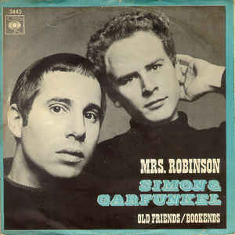
We'd like to know a little bit about you for our files
A A A A
We'd like to help you learn to help yourself
D G C / G Am Am
Look around you all you see are sympathetic eyes
E7 E7 D D
Stroll around the grounds until you feel at home

Refrain

E7 E7 E7 E7 E7
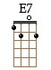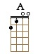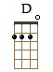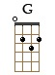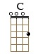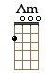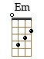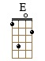
Hide it in a hiding place where no one ever goes
A A A A
Put it in your pantry with your cupcakes
D G C / G Am Am
It's a little secret just the Robinsons'affair
E7 E7 D D
Most of all you've got to hide it from the kids

G Em G Em C C Am Am
Koo-koo-ka-choo, Mrs. Robinson Jesus loves you more than you will know wo wo wo
G Em G Em C C
God bless you please Mrs. Robinson Heaven holds a place for those who pray
Am Am E E
Hey hey hey hey hey hey

E7 E7 E7 E7 E7 A A A A
Sitting on a sofa on a Sunday afternoon Going to the can-didates debate
D G C / G Am Am E7 E7 D D
Laugh about it shout about it when you've got to choose Every way you look at it you lose

G Em G Em C C Am Am
Where have you gone Joe DiMaggio Our nation turns it’s lonely eyes to you woo woo woo
G Em G Em C C
What's that you say Mrs Robinson Joltin'Joe has left and gone away
Am Am E7 E7 E7 E7…
Hey hey hey hey hey hey
G / V1 TOP5

