Lemon Tree - Fool's Garden - 1995 - Tonalité originale en Fm - Rythme : B Bh hBh - Bpm : 143

Intro : Bm F#m Bm F#m Em F#m Bm / F#m Bm

Bm F#m Bm F#m
I'm sitting here in a boring room It's just another rainy sunday afternoon
Bm F#m Bm F#m
I'm wasting my time I got nothing to do I'm hanging around I'm waiting for you
Em F#m Bm / F#m Bm
But nothing ever happens and I wonder
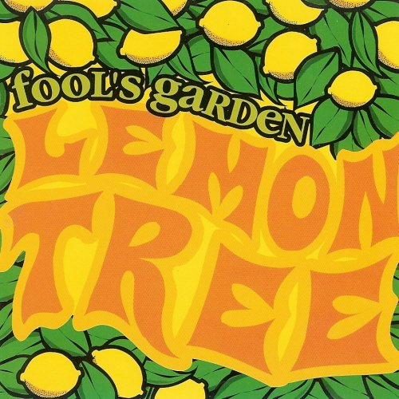

Bm F#m Bm F#m
I'm driving around in my car I'm driving too fast I'm driving too far
Bm F#m Bm F#m
I'd like to change my point of view I feel so lonely I'm waiting for you
Em F#m Bm / F#m Bm
But nothing ever happens and I wonder

D A Bm F#m
I wonder how I wonder why Yesterday you told me 'bout the blue blue sky
G A D A
And all that I can see is just a yellow lemon-tree
D A Bm F#m
I'm turning my head up and down I'm turning turning turning turning turning around
G E A A
And all that I can see is just a yellow lemon-tree

Bm F#m Bm F#m Em F#m Bm / F#m Bm
Sing Da Dadada-dam Deedada Dadada-dam Deedada Dab-deedeeda
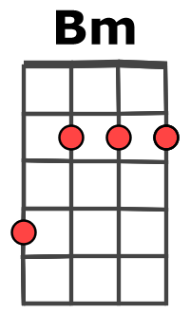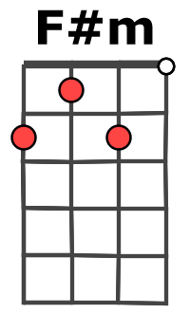
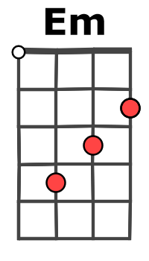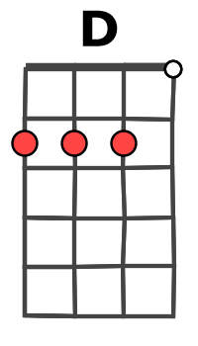
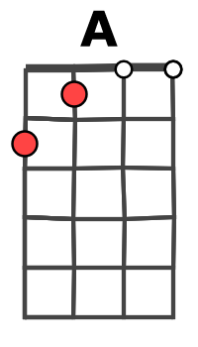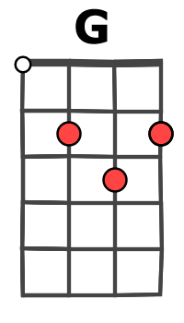
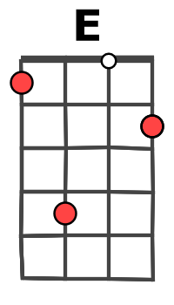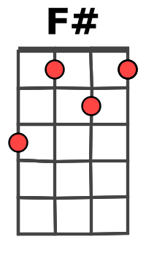

Bm F#m Bm F#m
I'm sitting here I miss the power I'd like to go out taking a shower
Bm F#m Bm F#m
But there's a heavy cloud inside my head I feel so tired put myself into bed
Em F#m Bm / F#m Bm
Well nothing ever happens and I wonder

F# F# Bm Bm A A D F#
I-so-la-tion is not good for me I-so-la-tion I don't want to sit on a lemon-tree

Bm F#m Bm F#m
I'm steppin' around in the desert of Joy Baby anyhow I'll get another toy
Em F#m Bm / F#m Bm
And everything will happen and you'll wonder

Refrain + and I wonder wonder

D A Bm F#m
I wonder how I wonder why Yesterday you told me 'bout the blue blue sky
G A G A G A
And all that I can see And all that I can see And all that I can see
D…
Is just a yellow lemon-tree. G / V2

