Home Edward Sharpe & The Magnetic Zeros (2009)
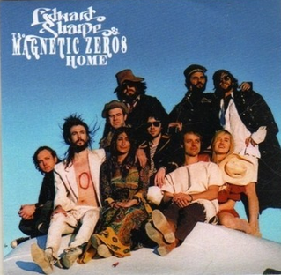
(Tonalité originale) BPM : 112 Rythme :

Intro : Bm D D G (x2)
Bm D D G
(Elle) Alabama, Arkansas, I do love my ma and pa Not the way that I do love you
Bm D D G
(Lui) Well, Holy, Moley me, oh my, you're the apple of my eye Girl I've never loved one like you
Bm D D G
Man oh man you're my best friend, I scream it to the nothingness There ain't nothing that I need
Bm D D G
Well, hot and heavy, pumpkin pie, Choc’late candy, Jesus Christ There ain't nothing please me more than you

Bm D D G
Ohh Home, let me come home Home is wherever I'm with you
Bm D D G
Ohh Home, let me come ho-o-ome Home is wherever I'm with you

Em D(1/2) A Em D / A Em D(1/2) G
xA|--10--9-7--------------------------10-9-7-----------------------------------------------------(---9-----------------------------10-9-----10-9-----)
xE|-------------7--10-10-12-9----------------7--10-10-12---------10-10-12-9—10-------(---- 10-9-----------------------------10-------10--)
xC|-----------------------------------------------------------------9--7-----------------------------(--------------9-11-9-6-7----------------------------)

Bm / A D / G G / A…
La, la, la, la, take me-e home (1) Mother, I'm coming home xA|--0-2-4--|
Bm D D G (x2)

Bm D D G
I'll follow you into the park, through the jungle through the dark, Girl I never loved one like you
Bm D D G
Moats and boats and waterfalls, Alley-ways and pay phone calls, I've been everywhere with you
Bm D
(That's true) We laugh until we think we’ll die Barefoot on a summer night
D G
Nothing new is sweeter than with you
Bm D D G
And in the streets you run afree, Like it's only you and me Geeze, you're something to see

Refrain (2) Father, I’m coming home xA|--0-2-4--|
Bm D D G (x2)

Bm D D G
Ohh Home, let me come home Home is wherever I'm with you
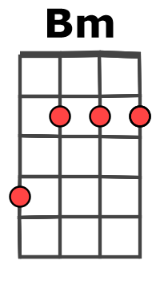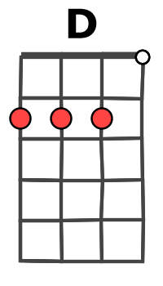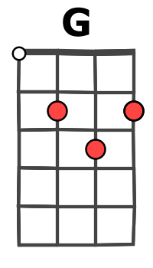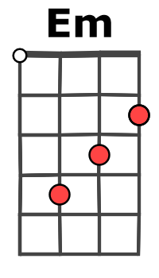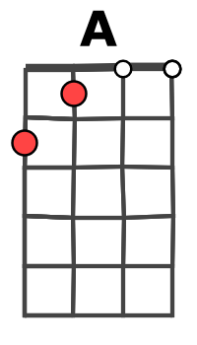
Bm D D G
Ohh Home, let me come ho-o-ome Home is when I'm alone with you
Bm… D… D… G…
Home, let me come home Home is wherever I'm with you
Bm… D… D… G…
Ohh Home, yes I’am ho-o-ome Home is when I'm alone with you
Bm D D G
Alabama, Arkansas… I do love my ma and pa…
Bm D D G
Moats and boats and waterfalls… Alley-ways and pay phone calls…
Bm D D G
Ho-oh-oh-ome Ho-oh-oh-ome Home is when I'm alone with you (x2)

