Help ! The Beatles 1965
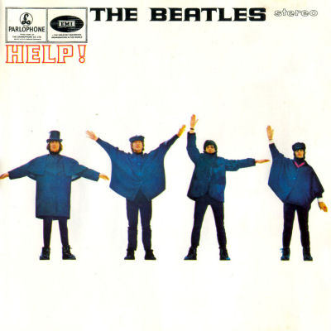
Tonalité originale : A Bpm : 190 Rythme : B Bh hB (couplets)

Gm… Eb…
Help! I need somebody Help! Not just anybody
C… F…
Help! You know I need someone, Help !


F F Am Am
When I was younger, so much younger than today,
Dm Dm Bb / Eb F
I never needed anybody's help in any way.
F F Am Am
But now these days are gone I'm not so self-assured,
Dm Dm Bb / Eb F
Refrain
Rythme : B Bh hBh

Now I find I've changed my mind, I've opened up the door.

Gm Gm Gm Gm / F Eb Eb Eb Eb/D
Help me if you can I'm feeling down, and I do appreciate you being 'round.
C C C C F… (F…) F F
Help me get my feet back on the ground, won't you please please help me.

F F Am Am
And now my life has changed in oh so many ways,
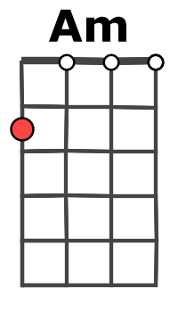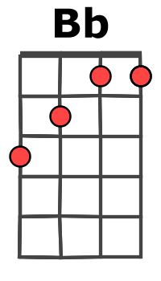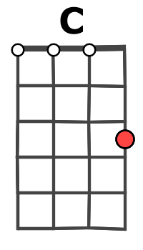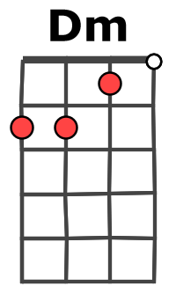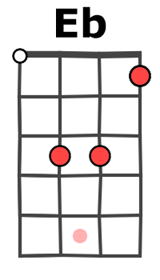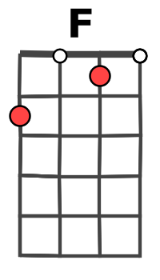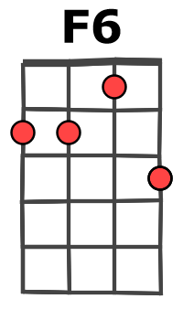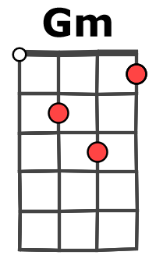
Dm Dm Bb / Eb F
My independence seemed to vanish in the haze.
F F Am Am
But every now and then I feel so insecure,
Dm Dm Bb / Eb F
I know that I just need you like I've never done before.
Refrain

F… (F) Am… (Am)
When I was younger, so much younger than today,
Dm… (Dm) Bb / Eb F
I never needed anybody's help in any way.
F F Am Am
But now these days are gone I'm not so self-assured,
Dm Dm Bb / Eb F
A + G / V2
Now I find I've changed my mind, I've opened up the door.

Gm Gm Gm Gm / F Eb Eb Eb Eb/D
Help me if you can I'm feeling down, and I do appreciate you being 'round.
C C C C F… (F) Dm…
Help me get my feet back on the ground, won't you please please help me.
Dm… F… F6…
Help me, help me, ooo.

