Help ! The Beatles 1965
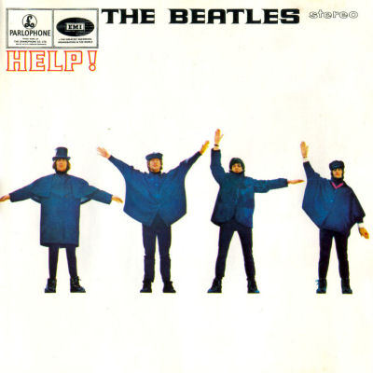
Tonalité originale : A Bpm : 190 Rythme : B Bh hB (couplets)

Am… F…
Help! I need somebody Help! Not just anybody
D… G…
Help! You know I need someone, Help !


G G Bm Bm
When I was younger, so much younger than today,
Em Em C / F G
I never needed anybody's help in any way.
G G Bm Bm
But now these days are gone I'm not so self-assured,
Em Em C / F G
Refrain
Rythme : B Bh hBh

Now I find I've changed my mind, I've opened up the door.

Am Am Am Am / G F F F F / E
Help me if you can I'm feeling down, and I do appreciate you being 'round.
D D D D G… (G…) G G
Help me get my feet back on the ground, won't you please please help me.

G G Bm Bm
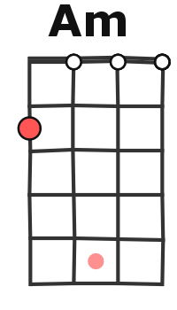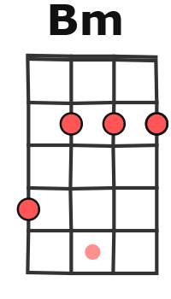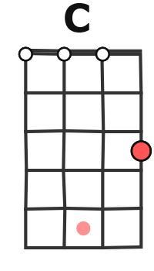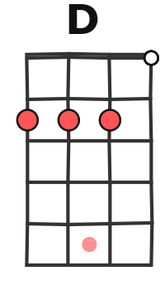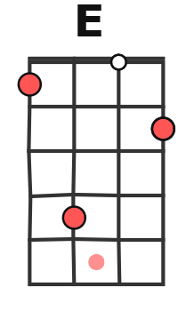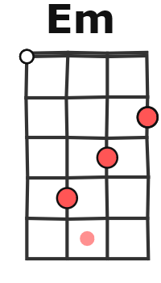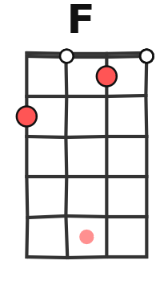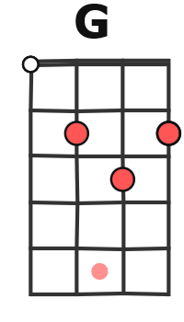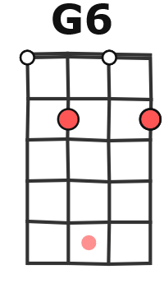
And now my life has changed in oh so many ways,
Em Em C / F G
My independence seemed to vanish in the haze.
G G Bm Bm
But every now and then I feel so insecure,
Em Em C / F G
I know that I just need you like I've never done before.
Refrain

G… (G) Bm… (Bm)
When I was younger, so much younger than today,
Em… (Em) C / F G
I never needed anybody's help in any way.
G G Bm Bm
But now these days are gone I'm not so self-assured,
Em Em C / F G
A + G / V2
Now I find I've changed my mind, I've opened up the door.

Am Am Am Am / G F F F F / E
Help me if you can I'm feeling down, and I do appreciate you being 'round.
D D D D G… (G) Em…
Help me get my feet back on the ground, won't you please please help me.
Em.. G… G6…
Help me, help me, ooo.

