Ukulele Lady - Vaughn De Leath - 1925 - tona originale : Ab  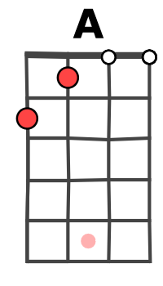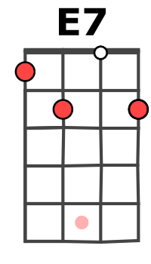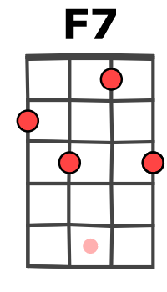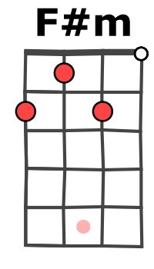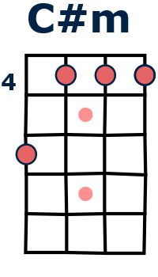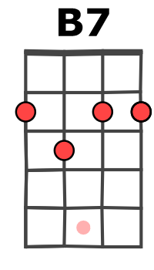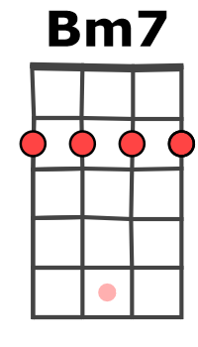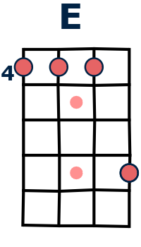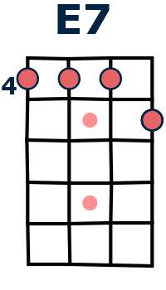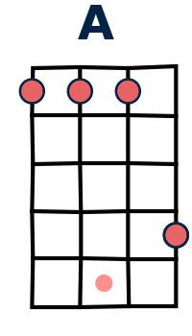  9 | tempo : 122 bpm Strum (ternaire):  

Intro : A / C#m F#m / C#m (2x)
A / E7 A
I saw the splendor of the moonlight
F7 / E7 A
On Honolu—lu-- Bay
A / E7 A
There's something tender in the moonlight
F7 / E7 A
On Honolu—lu-- Bay
F#m F#m
And all the beaches are full of peaches
C#m A
Who bring their ukes along
A / E7 A
And in the glimmer of the moonlight
F7 E7
They like to sing this song
Refrain

A / C#m F#m / E7
If you like a ukulele lady
A / C#m F#m / C#m
Ukulele lady like-a you
Bm7 / E7 Bm7 / E7
If you like to linger where it's shady
Bm7 / E7 A
Ukulele lady lingers too

A / C#m F#m / E7
If you kiss a ukulele lady
A / C#m F#m / C#m
While you promise ever to be true
Bm7 / E7 Bm7 / E7
And she see another ukulele
Bm7 / E7 A
Lady foolin a-round with you

D D
Maybe she'll sigh (or maybe not)
A A
Maybe she'll cry (an awful lot)
B B7
Maybe she'll find somebody else
E(4447) E7(4445)
suite refrain
Bye and bye

A / C#m F#m / E7
To sing to where it's cool and shady
A / C#m F#m / C#m
Where the tricky wicky wacky woo
Bm7 / E7 Bm7 / E7
If you like a ukulele lady
Bm7 / E7 A
* la 2nde fois, doubler cette ligne et finir sur A (9 9 9 12)
Ukulele lady like-a you

A / E7 A
She used to sing to me by moonlight
F7 /E7 A
On Honolu—lu Bay
A / E7 A
Found m’mories cling to me by moonlight
F7 / E7 A
Although I'm-far a- way

F#m F#m
Someday I'm going where eyes are
C#m A
glowing And lips are made to kiss
A / E7 A
To meet somebody in the moonlight

B7 E7
And hear that song I miss
[REFRAIN] et fin*
V2

