
Got my mind set on you George Harrison 1987
Tonalité originale C#m Bpm : 152
Intro : X Xx xXxX Xx xXxX
Refrain 1
B BhBhBh xXx xXx

Am E7 Am* Am C G C* C
I got my mind set on you I got my mind set on you
Am E7 Am* Am C G C* C
I got my mind set on you I got my mind set on you
Verse 1
C F G* G C F G* G
But it's gonna take money A whole lotta spending money
C F G* G C F G* (G)
It's gonna take plenty of money To do it right, child
C F G* G C F G* G
It's gonna take time A whole lot of precious time
C F G* G
B BhBhBh hBh hBh

It's gonna take patience and time, mmm
C F C F C F C C C
B BhB

To do it, to do it, to do it, to do it, to do it, to do it right, child

Refrain 1

B Bh hBhB hBh hBh

Verse 2

C C F F C C F F
And this time I know it's for real The feelings that I feel
C C F F C C G G
I know if I put my mind to it I know that I really can do it
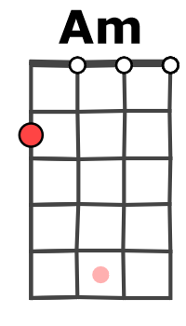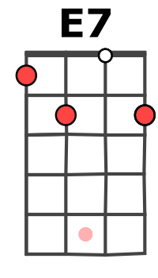
Refrain 2
Am E7 Am* Am C G C* C
I got my mind set on you set on you
Am E7 Am* Am C G C* C
I got my mind set on you set on you

Verse 1 Instru : Am E7 Am* Am C G C* C x2

Refrain 1 Verse 2 Verse 1

Am E7 Am* Am C G C* C
set on you set on you (ad lib)
G / V1

