
Perhaps Cake (reprise de Doris Day) 1996 Bpm : 114

Intro (x2) : Cm Bb G# G
xxxxx
Rythme : B Xh hXh
---3----------------------
--------3-6-----4---3---
---------------5---3------
---------------------------
Cm Fm
You won't admit you love me And so
Cm Fm
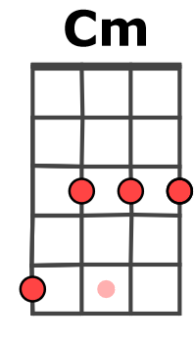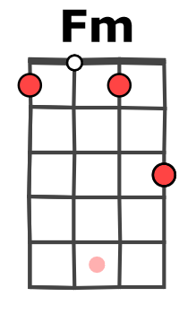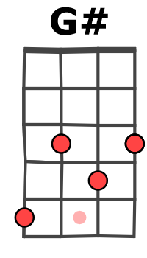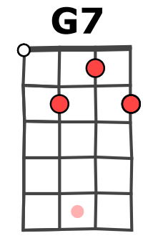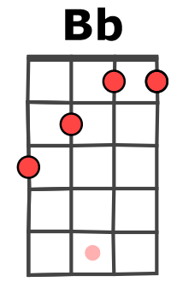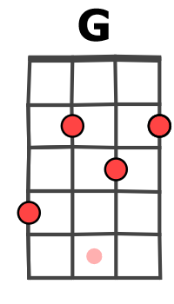
How am I ever To know
Cm G# / G7 Cm -- Bb -- G# - G
You only tell me Perhaps perhaps perhaps
Cm Fm
A million times I ask you And then
Cm Fm
I ask you over Again
Cm G# / G7 Cm
You only answer Perhaps perhaps perhaps
G7 G7 C C
If you can't make your mind up We'll never get started
G7 G7 C C
And I don't wanna' wind up Being parted broken hearted
Cm Fm
So if you really love me Say yes
Cm Fm
But if you don't dear Confess
Cm G# / G7 Cm -- Bb -- G# - G
And please don't tell me Perhaps perhaps perhaps
Instru : Cm Fm Cm Fm Cm G# / G7 Cm

G7 G7 C C
If you can't make your mind up We'll never get started
G7 G7 C C
And I don't wanna wind up Being parted broken hearted
Cm Fm
So if you really love me Say yes
Cm Fm
But if you don't dear Confess
Cm G# / G7 Cm
And please don't tell me Perhaps perhaps perhaps
G# / G7 Cm G# / G7 Cm…
G / V1
Tonalité originale
Perhaps perhaps perhaps Perhaps perhaps perhaps

