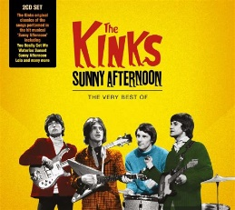
SUNNY AFTERNOON The Kinks 1966
Intro x2 125bpm
Dm Dm A7 A7 b.B.b.B.
C -------------------------5-5-4-4
G -7-7-5-5-4-4-3-3-2-2-0-0--------
4e corde Bh 4e Bh
Dm C7 F C7
The taxman's taken all my dough And left me in my stately home
A / A7 Aaug7 / A Dm C7
Lazin' on a sunny afternoon. And I can't sail my yacht
F C7 A / A7 Aaug7 / A7
He's taken everything I've got. All I've got's this sunny afternoon

REFRAIN 1 b.B.b.B.
Dm Dm D7 D7 G G7
Save me, save me, save me from this squeeze
C C F A7
I got a big fat mama tryin'(to) break me
Dm G Dm G7
And I love to live so pleasantly Live this life of luxury
F A7 Dm Dm A7 A7
Lazin' on a sunny afternoon In a summertime X2

4e Bh 4e Bh
Dm C7 F C7
My girlfriend's run off with my car. And gone back to her ma and pa
A / A7 Aaug7 / A Dm C7
Tellin' tales of drunkenness and cruelty. Now I'm sittin' here
F C7 A / A7 Aaug7 / A7
Sippin' at my ice-cooled beer Lazin' on this sunny afternoon

REFRAIN 2 b.B.b.B.
Dm Dm D7 D7 G G7
Help me, help me, help me sail away
C C F A7
Or give me two good reasons why I oughta stay
Dm G Dm G7
‘cause I love to live so pleasantly. Live this life of luxury
F A7 Dm Dm A7 A7
Lazin' on a sunny afternoon In a summertime X2

Reprise REFRAIN 1 + Dm
Mimi + Arnal - V4


