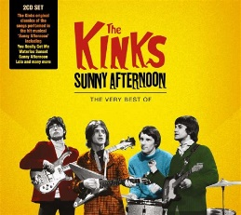
SUNNY AFTERNOON The Kinks
Intro x2 1966 125bpm
Gm Gm D D b.B.b.B.
Gm
A -10-10-8-8-7-7-6-6----------------
E --------------------10-10-8-8-6-6-5-5
4e corde Bh 4e Bh
Gm F7 Bb F7
The taxman's taken all my dough And left me in my stately home
D D Gm F7
Lazin' on a sunny afternoon. And I can't sail my yacht
Bb F7 D D Gm
He's taken everything I've got. All I've got's this sunny afternoon

REFRAIN 1 b.B.b.B.
(Gm) G7 G7 C C7
Save me, save me, save me from this squeeze
F F Bb D7
I got a big fat mama tryin'(to) break me
Gm C Gm C7
And I love to live so pleasantly Live this life of luxury
Bb D7 Gm Gm D D
Lazin' on a sunny afternoon In a summertime
Gm Gm D D
In a summertime In a summertime

Gm F7 Bb F7
My girlfriend's run off with my car. And gone back to her ma and pa
D D Gm F7
Tellin' tales of drunkenness and cruelty. Now I'm sittin' here
Bb F7 D D Gm
Sippin' at my ice-cooled beer Lazin' on this sunny afternoon

REFRAIN 2 b.B.b.B.
Gm G7 G7 C C7
Help me, help me, help me sail away
F F Bb D7
Or give me two good reasons why I oughta stay
Gm C Gm C7
‘cause I love to live so pleasantly. Live this life of luxury
Bb D7 Gm Gm D D
Lazin' on a sunny afternoon In a summertime
Gm Gm D D
In a summertime In a summertime

Reprise REFRAIN 1 + Gm…


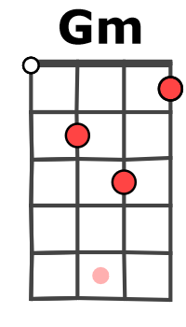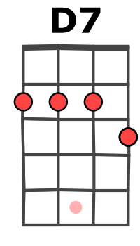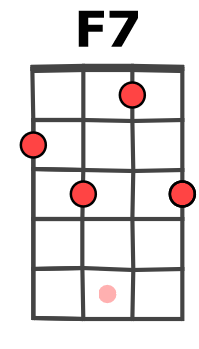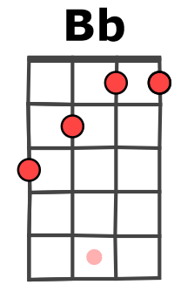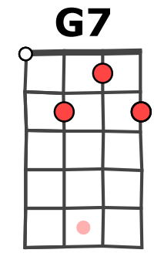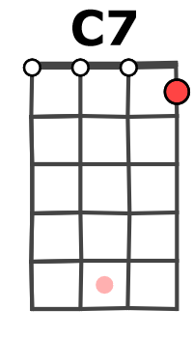
Mimi + Arnal
Version en Gm

