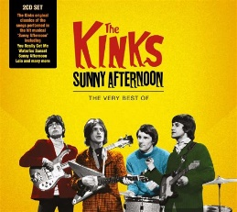
SUNNY AFTERNOON The Kinks 1966
Intro x2 125bpm
Em Em B7 B7 b.B.b.B.
A -7-7-5-5-4-4-3-3----------------
E -----------------7-7-5-5-3-3-2-2
4e corde Bh 4e Bh
Em D7 G D7
The taxman's taken all my dough And left me in my stately home
B / B7 Baug7 / B Em D7
Lazin' on a sunny afternoon. And I can't sail my yacht
G D7 B / B7 Baug7 / B7
He's taken everything I've got. All I've got's this sunny afternoon

REFRAIN 1 b.B.b.B.
Em Em E7 E7 A A7
Save me, save me, save me from this squeeze
D D G B7
I got a big fat mama tryin'(to) break me
Em A Em A7
And I love to live so pleasantly Live this life of luxury
G B7 Em Em B7 B7
Lazin' on a sunny afternoon In a summertime X2

4e Bh 4e Bh
Em D7 G D7
My girlfriend's run off with my car. And gone back to her ma and pa
B / B7 Baug7 / B Em D7
Tellin' tales of drunkenness and cruelty. Now I'm sittin' here
G D7 B / B7 Baug7 / B7
Sippin' at my ice-cooled beer Lazin' on this sunny afternoon

REFRAIN 2 b.B.b.B.
Em Em E7 E7 A A7
Help me, help me, help me sail away
D D G B7
Or give me two good reasons why I oughta stay
Em A Em A7
‘cause I love to live so pleasantly. Live this life of luxury
G B7 Em Em B7 B7
Lazin' on a sunny afternoon In a summertime X2

Reprise REFRAIN 1 + Em
Mimi + Arnal - V4


