Blue Christmas (Elvis Presley, Martina Mc Bride, 1957)
95 BPM en D (Tona originale en E)

1 & 2 & 3 & 4 &
B B h B h B h
1 2 3 2 2 3 3 2 3 4 2 3
i i i i i i i i
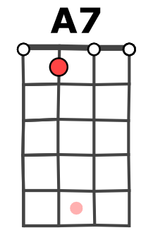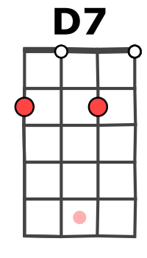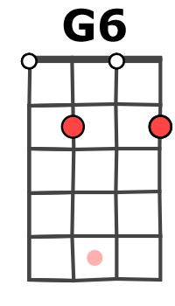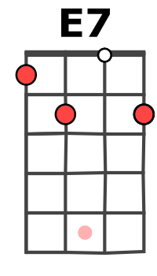
ou

(A7) D D A7 A7
I'll have a blue Christmas without you
A7 A7 D D
1 & 2 & 3 & 4 & 1
G6i 3…3.2...2.1…1(E7)
(sur corde E)
I'll be so blue just thinking a-bout you
D7 / D7 G6 G6(i)
Decora - tions of red on a green Christmas tree
E7 E7 A7 A7i
Won't be the same dear, if you're not here with me

D D A7 A7
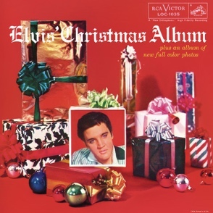
And when those blue snowflakes start falling
A7 A7 D D
That's when those blue memories start calling
D7 D7 G6 E7
You'll be doing all right, with your Christmas of white
A7 A7 D Di
But I'll have a blue, blue, blue, blue Christmas

D D A7 A7
I'll have a blue Christmas without you
A7 A7 D D
I'll be so blue just thinking a-bout you
D7 D7 G6 E7
You'll be doing all right, with your Christmas of white
A7 A7 D D
But I'll have a blue, blue, blue, blue Christmas
A7 A7 D D…
But I'll have a blue, blue, blue, blue Christmas
A7 A7
1 2 3 2 2 3 3 2 3 4 2 3 1 2 3 2 2 3 3 2 3 4 2 3
i i i i i i i 0 1 i i i i i i i i
(sur corde G)

D D
1 2 3 2 2 3 3 2 3 4 2 3 1 2 3 2 2 3 3 2 3 4 2 3
i i i i i i 0 1 2 i i i i i i i i
(sur corde G)

Merci à ukuleleroadtrips.com !
M-A V0

