
Stand By Me – Ben E. King 1961
120 bpm, Do majeur, (tonalité originale, La majeur), pulsation binaire
Intro
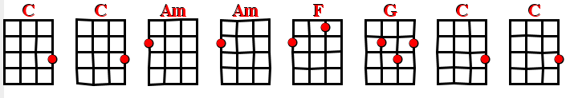

Couplet
C C Am Am
When the night has come And the land is dark
F G C C
And the moon is the only light we'll see
C C Am Am
No, I won't be afraid, No, I won't be afraid
 F G C
Just as long as you stand, stand by me.
Refrain
C C C Am Am
So, darling, darling, stand by me , Oh, stand by me.
F G C C
Oh, stand, stand by me, Stand by me.
Couplet
C C Am Am
If the sky that we look upon Should tumble and fall
F G C C
Or the mountain should crumble in the sea,
C C Am Am
I won't cry, I won't cry, No, I won't shed a tear
 F G C
Just as long as you stand, stand by me.
.
Refrain
C C C Am Am
And, darling, darling, stand by me, Oh, stand by me.
F G C C
Oh, stand now, stand by me, Stand by me.
Pont
C C Am Am F G C C
C C Am Am F G C C
Refrain
C C C Am Am
And, darling, darling, stand by me, Oh, stand by me.
 F G C C
Oh, stand now, stand by me, Stand by me.
Refrain
C C C Am Am
Whenever you’re in trouble won’t you stand by me, Oh, stand by me
F G C C
Oh, stand now, stand by me, Stand by me.

