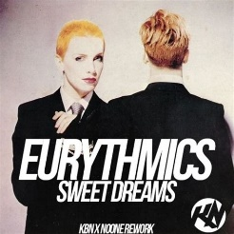
Sweet dreams. Eurythmics. 1983
125 bpm. (Tonalité originale : Cm)

Intro : Am F / E7* x2 strum : B Xh .h Xh x2
(F/E7* anticipé)

Am F / E7* Am F / E7*
Sweet dreams are made of this. Who am I to disagree?
Am F / E7* Am F / E7*
Travel the world and the seven seas. Everybody's looking for something

Am F / E7* Am F / E7*
Some of them want to use you. Some of them want to get used by you
Am F / E7* Am F / E7*
Some of them want to abuse you. Some of them want to be abused

Break : F E7 Am Dm F E7

Am F / E7* Am F / E7*
Sweet dreams are made of this. Who am I to disagree?
Am F / E7* Am F / E7*
Travel the world and the seven seas. Everybody's looking for something

Break : F E7 Am Dm F E7
BH XH BH XH
Am D
X 2
Hold your head up ((movin'on) Keep your head up (movin'on)
Am D (BH XH / )
Hold your head up (movin'on) Keep your head up

Instrumental : Am F / E7* x4

Am F / E7* Am F / E7*
Some of them want to use you. Some of them want to get used by you
Am F / E7* Am F / E7*
Some of them want to abuse you. Some of them want to be abused
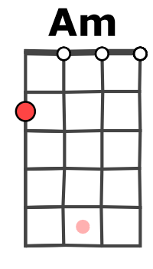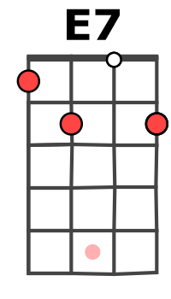
Break : F E7 Am Dm F E7

Reprise Sweet dreams

Reprise N.C. Sweet dreams

Reprise Sweet dreams x2 (2e fois en decrescendo) + Am
M. V1

