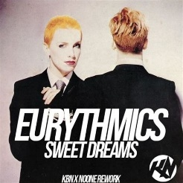
Sweet dreams. Eurythmics. 1983
125 bpm. (Tonalité originale : Cm)
strum : B X/h .h Xh
(F /E7* anticipé)
Intro : Am F / E7* x4

Am F / E7* Am F / E7*
1
Sweet dreams are made of this. Who am I to disagree?
Am F / E7* Am F / E7*
Travel the world and the seven seas. Everybody's looking for something

Am F / E7* Am F / E7*
2
Some of them want to use you. Some of them want to get used by you
Am F / E7* Am F / E7*
Some of them want to abuse you. Some of them want to be abused

B
Break : F E7 Am Dm F E7

1
Am F / E7*
B
F E7 Am Dm F E7
Sweet dreams are made of this…
Am D
x2
Hold your head up ((movin'on) Keep your head up (movin'on)
Am D (BH XH / )
BH XH BH XH
Hold your head up (movin'on) Keep your head up

Instrumental : Am F / E7* x4
2
Am F / E7*
B
F E7 Am Dm F E7
Some of them want to use you…

Reprise Sweet dreams…

1
Reprise N.C. Sweet dreams…

Reprise Sweet dreams… x2 (2e fois en decrescendo) + Am…

Riff version Eurythmics :
A 0-0-7-0-8-0-7-0------3/5-----2/3
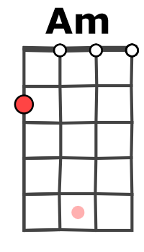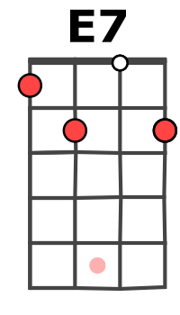
E -----------------1-1-----0-0----

Riff version Marylin Manson :
A 0—-0-0-3-3-0-0------0--------
E ---------------1—-1—--0-0-3-5
M. V2

