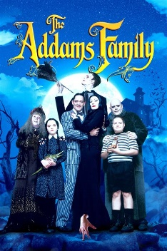
Addams Family Theme Song
1964. tonalité : C
85 bpm
Strum : 1 2 3 4
↓↑ X ↓↑ X
Riff :
A -----0-2--3-------0-2-4--5--------0-2-4--5--0-2-4-5-----0-2--3-------
G - 0 ------- X-X--------------X-X--------------------------0----------X-X-

x 2

Riff
A --------2--3-------------4--5---------------4--5-------4--5--------2--3-------
E --3-5 -------X-X--5-7--------X-X--5-7--------5-7----------3-5--------X-X-

ou

C / Dm G7 / C
They’re creepy and they’re kooky Mysterious and spooky
C / Dm G7 / C ↓
They’re all together ooky The Addams family
Intro : riff

Riff

C / Dm G7 / C
Their house is a museum When people come to see ‘em
C / Dm G7 / C ↓
They really are a scream The Addams family

Riff
A --------2--3-------------4--5---------------4--5-------4--5--------2--3-------
E --3-5 -------X-X--5-7--------X-X--5-7--------5-7--------3-5--------X-X-
neat sweet pe-tite

C / Dm G7 / C
So get a witch’s shawl on a broomstick you can crawl on
C / Dm G7 / C ↓
We’re gonna pay a call on the Addams family

M. V1

Riff
