Police on my back The Clash 1980 BPM : 146
Rythme couplet : B B BhBh
Rythme pont : BhBxBhBx
Rythme refrain : B . BhBh
Tonalité originale

Intro : ( )¹ ( )¹ D¹ G¹ D¹ G¹ D² G² D² G²
D G D G
Well, I'm running Police on my back I've been hiding Police on my back
D G D G
There was a shooting Police on my back And the victim Well, he won't come back
Pont
A A G G
I been running Monday, Tuesday, Wednesday Thursday, Friday, Saturday, Sunday
A A G G
Runnin' Monday, Tuesday, Wednesday Thursday, Friday, Saturday, Sunday
D¹ G¹ D¹ G¹ D² G² D² G²
What have I done? What have I do-one?
D G D G
Refrain
I started running Down the railway track Could you help me? Police on my back
D G D G
They will catch me If I dare drop back Won't you give me All the speed I lack?
Pont
D¹ G¹ D¹ G¹ D¹ D¹ D¹ D¹
What have I done? What have I do-one?
D² G² D² G² D² G² D² G²
I'm running I am running I've been running
D G D G
Yes, I'm running Down the railway track Won't you help me? Police on my back
D G D G
They will catch me If I dare drop back Won't you help me Find the speed I lack?
Pont (G…) (G)¹… (G)¹…
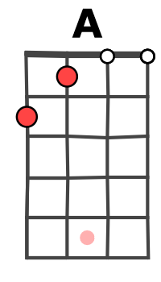

D¹ G¹ D¹ G¹ D² G² D² G²
What have I done? What have I do-one?
D² G² D² G²
And I'm running Police on my back Hiding Police on my back
D² G² D² G² D³ G³ D³ G³ Running Police on my back Hiding Police on my back
D³ G³ D³ G³
Yes, I'm running Down the railway track Could you help me? Police on my back
D³ G³ D³ G³
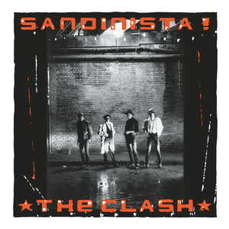
They will catch me If I dare drop back Oh Lord, give me All the speed I lack?
D³ G³ D³ G³ D…
I've been running I've been running
G / V2
Riff 3
A --9-----9----9----9------9--10--9----9-----9----E ----10---10---10---10------------10---10---10-
C ------------------------------------------------------

Riff 2
A ----------------------------
E --10---10---10---10----
C ------9-----9----9----(9)-

Riff 1
A --9-----9----9----9------
E ----10---10---10---10-
C -----------------------------

