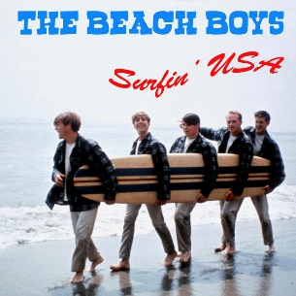
Surfin’ USA The Beach Boys (Chuck Berry) 1963 BPM : 158
Tonalité originale : A#

G G C C
If everybody had an ocean (Uuuu) Across the U.S.A. (Uuuu)
G G C C
Then everybody'd be surfin' (Uuuu) Like Californi-a (Uuuu)
F F C C
You'd seem 'em wearing their baggies (Uuuu) Huarachi sandals too (Uuuu)
G F C C
A bushy bushy blonde hairdo (Uuuu) Surfin' U.S.A. (Uuuu)
G G C C
You'd catch 'em surfin' at Del Mar (Inside Outside USA) Ventura County line (Ins. Out. USA)
G G C C
Santa Cruz and Trestle (Inside Outside USA) Australia's Narrabeen (Inside Outside USA)
F F C C
All over Manhattan (Inside Outside USA) And down Doheny Way (Inside Outside USA)
G F C C
Everybody's gone surfin' Surfin' U.S.A.
Partie 1

G G C C
We'll all be planning out a route (Uuuu) We're gonna take real soon (Uuuu)
G G C C
We're waxin’ down our surfboards (Uuuu) We can't wait for June (Uuuu)
F F C C
We'll all be gone for the summer (Uuuu) We're on surfari to stay (Uuuu)
G F C C
Tell the teacher we're surfin' (Uuuu) Surfin' U.S.A. (Uuuu)
G G C C
Haggerties and Swamies (Inside Outside USA) Pacific Palisades (Inside Outside USA)
G G C C
San Anofree and Sunset (Inside Outside USA) Redondo Beach L.A. (Inside Outside USA)
F F C C
All over La Jolla (Inside Outside USA) ,At Waimia Bay (Inside Outside USA)
G F C C
Partie 2
Everybody's gone surfin' Surfin' U.S.A.
Instru : G G C C G G C C F F C C
Rythme :
G = G G Em G G G Em G

C = C C Am5 C C C Am5 C

F = F F Dm F F F Dm F

G F C C
Everybody's gone surfin' Surfin' U.S.A.

Partie 2

G F C C
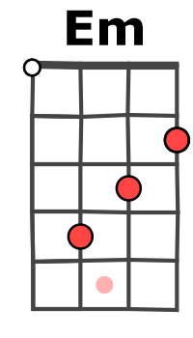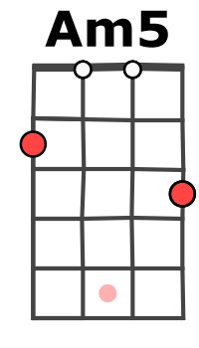

Everybody's gone surfin' Surfin' U.S.A. (x2)
G / V1

