
Happy together The Turtles 1967 BPM : 120
Tonalité originale : F#m
Rythme couplet :
B BhB Bh

Intro : Em Em Em Em
Em Em D D
Imagine me and you I do I think about you day and night it's only right
C C B B
To think about the girl you love and hold her tight So happy together
Em Em D D
If I should call you up invest a dime And you say you belong to me and ease my mind
Call you up ease my mind
C C B B
Imagine how the world could be so very fine So happy together
ve ry fine
Refrain
E D E G
I can't see me lovin' nobo_dy but you For all my life
E D E G
When you're with me baby the skies'll be blue For all my life
Rythme refrain :
BhBh hBh
Em Em D D
Me and you and you and me No matter how they toss the dice it has to be
you and me has to be
C C B B
The only one for me is you and you for me So happy together
you for me
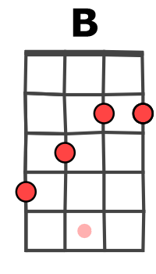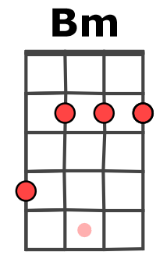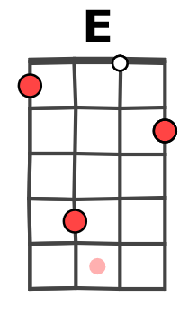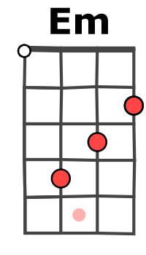
Refrain
Em Em D D
Me and you and you and me No matter how they toss the dice it has to be
C C B B
The only one for me is you and you for me So happy together
E D E G
Ba ba ba ba ba ba-ba-ba ba-ba-ba ba-ba-ba baa
E D E Bm Bm
Ba ba ba ba ba ba-ba-ba ba-ba-ba ba-ba-ba baa

Em Em D D
Me and you and you and me No matter how they toss the dice it has to be
Aaaa aaaa aaaa Aaaa aaaa aaaa
C C B B
The only one for me is you and you for me So happy together
Aaaa aaaa aaaa
Em B Em B
So happy together How is the weather
Uuu-u-u-u-u Uuu-u-u-u-u
Em B Em B
So happy together We're happy together
ba-ba-ba – ba ba-ba-ba – ba ba-ba-ba – ba ba-ba-ba - ba
Em B Em B (x2) E…
So happy together So happy together
ba-ba-ba – ba ba-ba-ba – ba ba-ba-ba – ba ba-ba-ba – ba ba-ba-ba – ba
G / V1

