
Happy together The Turtles 1967 BPM : 120
Tonalité originale : F#m
Rythme couplet :
b b b b
b bh b bh (avancé)
Intro : Em Em Em Em
Em Em D D
Imagine me and you I do I think about you day and night it's only right
couplet
C C B B
To think about the girl you love and hold her tight So happy together
Em Em D D
If I should call you up invest a dime And you say you belong to me and ease my mind
Call you up ease my mind
C C B B

avancé : BhbHbh x 2
(triolets sur le dernier B)
couplet + ❤️
Imagine how the world could be so very fine So happy together
ve ry fine
Refrain
E D E G
I can't see me lovin' nobo_dy but you For all my life
E D E G
When you're with me baby the skies'll be blue For all my life
Rythme refrain :
B B B B
avancé : BhBh hBh
Em Em D D
Me and you and you and me No matter how they toss the dice it has to be
you and me has to be
C C B B
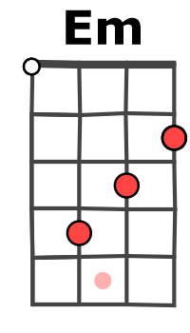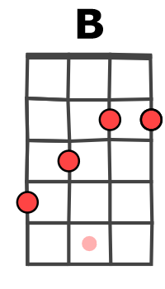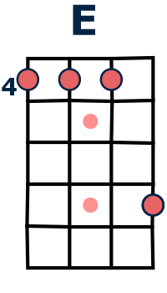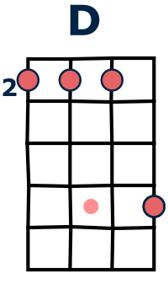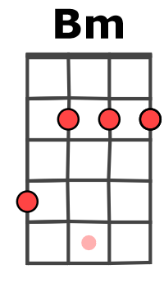
couplet + ❤️
The only one for me is you and you for me So happy together
you for me
Refrain
Em Em D D
Me and you and you and me No matter how they toss the dice it has to be
C C B B
couplet
The only one for me is you and you for me So happy together
E D E G
Ba ba ba ba ba ba-ba-ba ba-ba-ba ba-ba-ba baa
E D E Bm Bm
Ba ba ba ba ba ba-ba-ba ba-ba-ba ba-ba-ba baa

Em Em D D
Me and you and you and me No matter how they toss the dice it has to be
Aaaa aaaa aaaa Aaaa aaaa aaaa
C C B
couplet + ❤️
The only one for me is you and you for me So happy together
Aaaa aaaa aaaa
Em B Em B
So happy together How is the weather
Ouh ou ou ou Ouh ou ou ou Pa pa-pa-pa – pa
Em B Em B
So happy together We're happy together
pa-pa-pa – Pa pa-pa-pa – pa pa-pa-pa - Pa
Em B Em B (x2) E…
So happy together So happy together
pa-pa-pa – pa pa-pa-pa – Pa pa-pa-pa – pa pa-pa-pa – Pa pa-pa-pa – pa
G+A / V2

