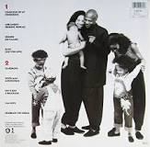
Teardrops (Womack and Womack, 1988)
134 BPM en Gm (originale : G#m)
1 & 2 & 3 & 4 & 1 & 2 & 3 & 4 &
Gm F Gm* F Gm*
i i h . h i h i i h . h i h

( Eb Cm7* F Gm* ) x 2

Eb Cm7* F Gm*
B Bh hBh
Whenever I hear goodbyes, reminds me baby of you
Eb Cm7* F Gm*
I break down and cry, next time I'll be true, yeah
Fever for lost romance reminds me baby of you
Eb Cm7* F Gm iih.h Fi Gm*hiih.h Fi Gm*h
I took a cra-zy chance and next time I'll be true, I'll be true, I'll be true
REFRAIN
Eb Cm7* F Gm*
Footsteps on the dance floor, remind me baby of you
Teardrops in my eyes, next time I'll be true, yeah
Eb Cm7* F Gm iih.h Fi Gm*hiih.h Fi Gm*h
Whispers in the powder room, she cries on every tune, every tune, every tune
iih.hFi Gm* Dm7* Cm7 F
And the mu-sic don't feel like it did when I felt it with you
Gm Dm7* Cm7
B Xh hXh
Nothing that I do or feel ever feels like I felt it with you
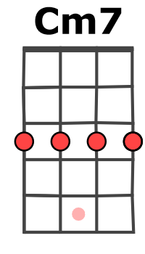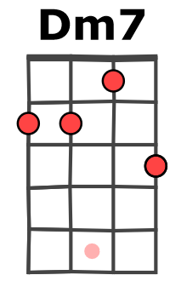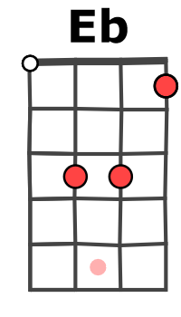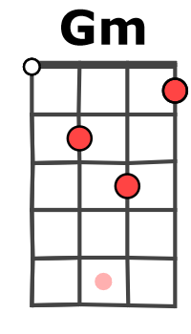
( Eb Cm7* F Gm* ) x 2

Eb Cm7* F Gm*
When I'm dan-cin' 'round, reminds me baby of you
Eb Cm7* F Gm*
I really let you down, the next time I'll be true, yeah
Eb Cm7* F Gm iih.h Fi Gm*hiih.h Fi Gm*h
I took a cra-zy chance, she cries on every tune, every tune, every tune

REFRAIN Eb Cm7* F Gm*

Eb Cm7* F Gm*
Hurting deep inside, she cries on every tune
Eb Cm7* F Gm iih.h Fi Gm*hiih.h Fi Gm*h
I break down and cry, she cries on every tune, every tune, every tune

REFRAIN

F Gm Dm7* Cm7 F
No, no and the mu-sic don't feel like it did when I felt it with you
Gm Dm7* Cm7
Nothing that I do or feel ever feels like I felt it with you
F F F Dm7 ( Eb Cm7* F Gm* ) x 2
Oh oh, oh oh, oh oh, oh oh oh
Eb Cm7* F Gm* Eb Cm7* F Gm*
Fever for lost romance I took a cra-zy chance
Eb Cm7* F Gm↓
M-A V1
Lovers hold-ing hands, remind me baby of you

