Enola Gay – Orchestral Manoeuvre in the Dark - (1980) 143 bpm
Intro : G Em C D (riff) G Em C D (refrain)

G Em
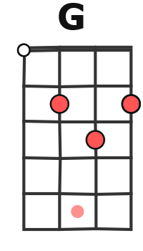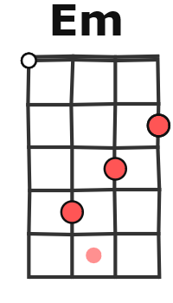

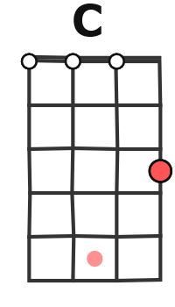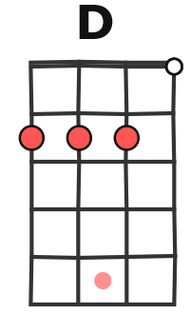
1. Enola Gay, you should have stayed at home yesterday,
C D
uh-huh, this can't describe the feelin' and the way you lied.
G Em
These games you play, they're gonna end in all the tears someday,
C D
uh-huh, Enola Gay, it shouldn't ever have to end this way

G Em C D (refrain)
G Em
2. It's eight fifteen, that's the time that it's always been, we got message

C D
on the radio, condition's normal and you're comin' home
G Em C D ( solo ) x 2

G Em
3. Enola Gay, is mother proud of little boy today ?
C D
Uh-huh, this kiss you give, it's never ever gonna fade away !

G Em C D ( riff) G Em C D (refrain )

G Em
4. Enola Gay, it shouldn't ever have to end this way, uh-huh,
C D
Enola Gay, it should have faded our dreams away.
G Em
It's eight fifteen, that's the time that it's always been, we got your
C D
message on the radio, condition's normal and you're comin' home.
G Em
Enola Gay, is mother proud of little boy today ?
C D
Uh-huh, this kiss you give, it's never ever gonna fade away !
G Em C D (riff)

