Heroes – David Bowie  (1977) - 113 à la noire | 
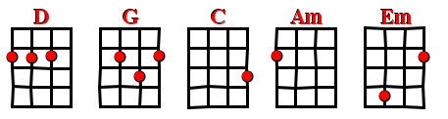

Intro /  Interlude | D | G | D | G


V1
Couplet | D | G | D | G
Refrain | C | D | Am/Em | D
Refrain | C/G | D

Intro
Couplet Refrain
Interlude
Couplet Refrain

Couplet ( 2x )
Refrain
Interlude (3x)

