HEROES – David Bowie (1977) | 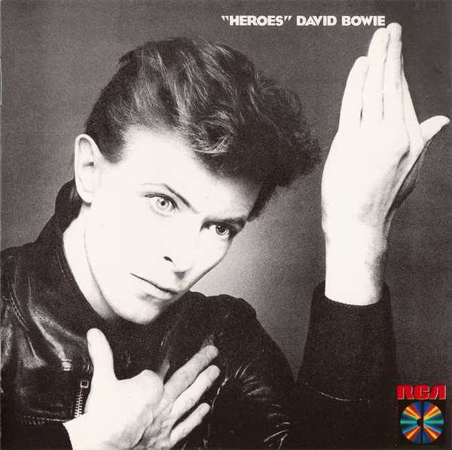
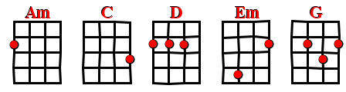


BPM : 113 (4/4) STRUM :

[Intro] D G D G

D G
I - I wish you could swim
D G
Like the dolphins - like dolphins can swim
C D
Though nothing - nothing will keep us together
Am / Em D
We can beat them forever and ever
C / G D
Oh we can be Heroes just for one day

[Interlude] x2 D G D G

D G
I - I will be King
D G
And you - you will be Queen
C D
For nothing will drive them away
Am / Em D
We can beat them forever and ever
C / G D
Oh we can be Heroes just for one day

D G
V3
I - I can remember
- I remember -
D G
Standing by the wall
- By the wall -
D G
And the guards shot above our heads
– Over our heads -
D G
And we kissed as though nothing would fall
- Nothing could fall -

C D
And the shame was on the other side
Am Em D
Am / Em D
Oh we can beat them forever and ever
C / G D
Then we can be Heroes just for one day

[Interlude] D G D G

D G D
We can be Heroes
G D
We can be Heroes
G D
We can be Heroes just for one day
G
We can be Heroes

