Activity 1 Teacher Guide: What is Coding?

Chapter Overview
In this chapter, students become robot programmers. They start by recording a program with the IR remote — no computer needed — then discover their recording as visual code blocks in the webapp, simplify it, fix it when conditions change, and finally use loops to draw patterns. Every concept is introduced through the robot first and named afterward, so students experience sequences, debugging, and loops before they hear the words.
Focus: Introduction to programming through hands-on robotics
Audience: Grades 7-9 (ages 12-15) | Prerequisites: None
Total time: 4-5 hours across 5 sessions

Learning Objectives
Students will be able to:
- Explain that programs are commands executed in order
- Use the IR remote to control the robot car and record programs
- Connect the robot to the webapp and view/edit visual blocks
- Use the debugging cycle: observe → edit → test
- Combine repeated blocks for efficiency
- Use the repeat number to create patterns

Chapter Structure
Session | Activity | Time | Setup
1 | 1.1 Navigate the Maze — by Hand | 60 min | Robots, remotes, maze materials, targets (no computers)
2 | 1.2 Navigate the Maze — with Code | 45 min | Add computers, webapp access
3 | 1.3 Fix the Code When the Maze Changes | 45 min | Maze from Activity 1.1
4 | 1.4 Draw Patterns with Code | 45 min | Open floor space, pens/markers
5 | Assessment: Draw a Letter | 30-45 min | Testing area

Materials Per Group
- 1 robot car with GoGo Board
- 1 IR remote control
- 1 computer (Sessions 2-5)
- 1 pen or marker with a rubber band (Session 4)
- Student workbook

Before the Chapter: Preparation

Configure Each Robot
Each robot must be configured via USB before it can respond to the IR remote. Configuration takes about 2 minutes per robot and can be done by the teacher before class or by students during Session 1. Open pgc.gogoboard.org and follow the 4 steps in the Robot Settings menu.
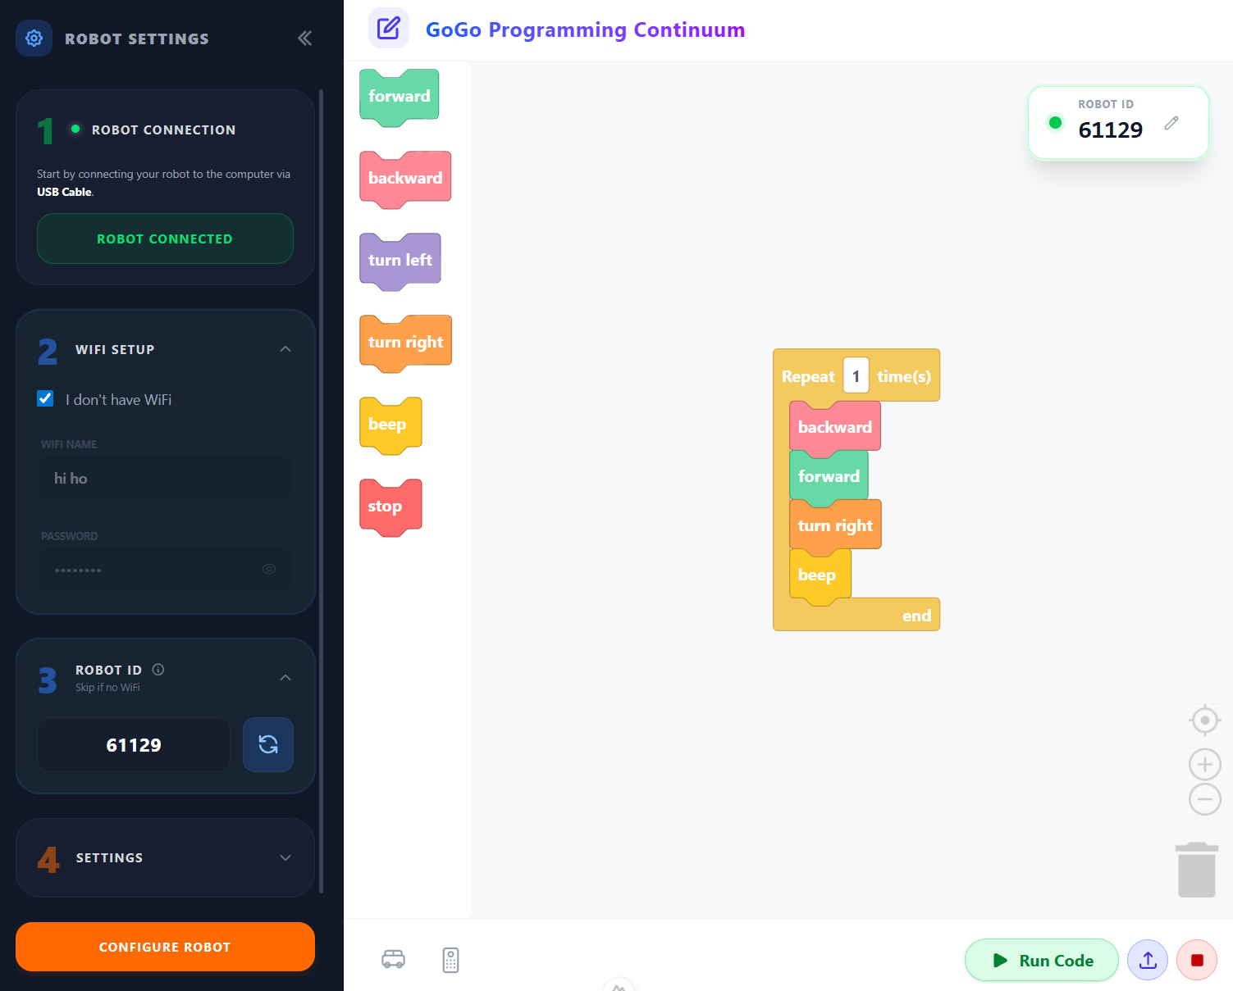
The pgc.gogoboard.org webapp — the menu on the left walks through the 4 setup steps; the right side is where block code appears after recording.
Step 1: Robot Connection
- Connect the robot to the computer using a USB cable
- Press the “Connect to Robot” button
- A browser popup will appear — select “GoGo Board 7 - Paired” and press “Connect”
- The button changes to “Robot Connected” (shown in green)
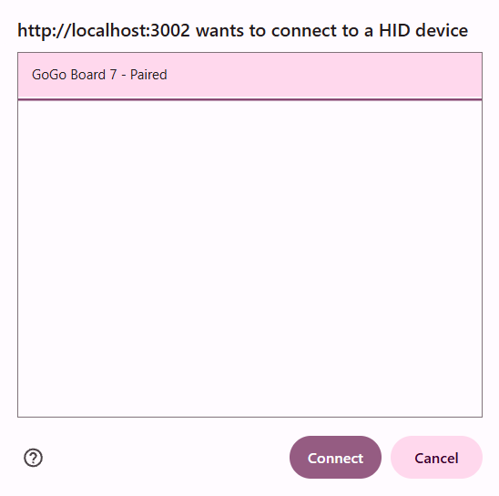
Note: If this robot has been connected to this computer before, the webapp reconnects automatically — the manual steps are only needed the first time.
Step 2: WiFi Setup
- Enter the WiFi Name (SSID) and Password
- Check “I don’t have WiFi” if no network is available
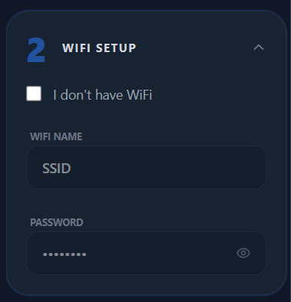
Important: WiFi is required for block-based programming (Activities 1.2-1.4). Without WiFi, the robot can only be controlled and recorded using the IR remote — the webapp block editor will not be available.
Note: The GoGo Board requires WiFi with no web authentication screen (captive portals will not work).
Step 3: Robot ID
- The webapp auto-generates a unique 5-digit Robot ID; the default value can be used
- Have students enter this number to connect to the robot from the webapp
- Skip this step if WiFi is not available
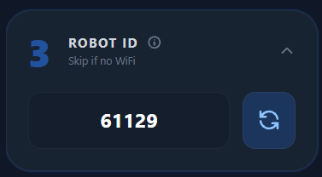
Step 4: Settings (Optional)
Press the Step 4 card to expand the settings menu. The default values can be used (times are in milliseconds):
Setting | Default | Description
Pause Time Between Commands | 500 ms | Delay between each command during playback
Turn Duration | 200 ms | How long the robot turns per turn command — longer = greater rotation angle
Move Duration | 1000 ms | How long the robot moves per forward/backward command
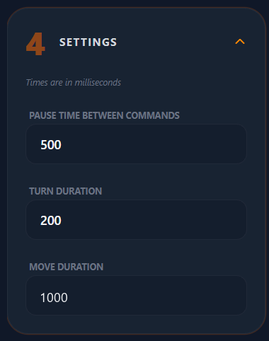
Final step: Press the orange “Configure Robot” button to save all settings to the robot, then disconnect the USB cable.
Note: Configuration uses USB, but sending and receiving block code uses WiFi only — USB cannot transfer block code.

Preparation Checklist
Robots:
- Charge all power banks used with the GoGo Boards
- Configure each robot via the webapp (see above)
- Test that each robot responds to its IR remote
- Optionally label each robot with its Robot ID for easy identification in class
WiFi (Sessions 2-5):
- Configure robots with classroom WiFi during setup
- Test sending and receiving block code between a robot and the webapp: pgc.gogoboard.org
Classroom:
- Clear floor space (at least 2m x 2m per group)
- Gather maze materials (chairs, books, boxes, tape)
- Prepare targets (books standing on edge, paper cups)
- Prepare computer stations (1 per group) — tablets can be used for viewing and sending block code, but USB configuration requires a computer

Activity 1.1: Navigate the Maze — by Hand
Time: 60 minutes | Setup: Maze materials, targets, no computers | Grouping: Pairs or up to 4
Key concepts:
- Programs are sequences — commands execute in order and can repeat reliably
- Starting conditions matter — the same program succeeds or fails based on position
Preparation:
- Build 3-4 mazes with 2-3 turns each using chairs, books, boxes, or wooden blocks
- Mark starting positions with tape
- Place targets at the end — books standing on edge work well
- The target should fall easily when touched, providing clear success/failure feedback
Facilitation flow:
- Build the Maze (10 min): Students build or adjust mazes
- Practice Run (10 min): Show the remote controls, let every student practice driving
- Record the Program (10 min): Place the car at the start, press * to record, navigate, press * to stop
- Test the Program (15 min): Replay 3 times, then move the starting position to show failure
- Reflection (10 min): Why does starting position matter? What is the difference between manual control and a program?
Key message: “Same program + different starting position = different result. This is why precision matters in programming.”
Common issues:
Issue | Response
Robot does not respond | Check if the program is running (the purple LED strip above the screen should be active). Point the remote directly at the robot. Check the battery charge
Differentiation:
- Easier: Fewer turns, wider paths
- More challenging: Narrower paths, more turns, add obstacles

Activity 1.2: Navigate the Maze — with Code
Time: 45 minutes | Setup: Computers, maze program from Activity 1.1 | Grouping: Pairs or up to 4
Key concepts:
- Physical actions become visual code blocks
- Repeated blocks can be combined: forward forward forward becomes forward(3)
Facilitation flow:
- Connect and View (15 min): Demo on the projector — open the webapp, check the Robot ID, record, sync, identify blocks
- Too Many Blocks (5 min): Students count total and repeated blocks
- Combine Repeated Blocks (15 min): Demo the Combine feature, students combine their blocks and re-test
- Reflection (5 min): Why is forward(5) better than 5 separate forward blocks?
Key message: “Combining makes code easier to read and easier to change — and the program still behaves the same.”
Common issues:
Issue | Response
Cannot connect | Verify the Robot ID, check WiFi
Wrong blocks appear | The group entered another group’s Robot ID
Combine not available | Select blocks of the same type
Differentiation:
- Easier: Focus on combining forward blocks only
- More challenging: Try the “Separate” feature, count the efficiency improvement

Activity 1.3: Fix the Code When the Maze Changes
Time: 45 minutes | Setup: Computers, maze from Activity 1.1 | Grouping: Pairs or up to 4
Key concepts:
- The debugging cycle: observe → edit → test
- Editing combined blocks is easier than editing many separate blocks
Facilitation flow:
- The Maze Changed (5 min): Students make ONE change to their maze, run the original program, and watch it fail
- Debug and Fix (30 min): Write the debugging cycle on the board, students debug until the program works
- Reflection (5 min): Why is it easier to edit combined blocks? How many debug cycles did it take?
Key message: “Change one thing at a time, so we can clearly see what effect each change has.”
Students may spend considerable time debugging without consciously thinking about the debugging cycle. It is important to have them reflect afterward on what their debugging process looked like.
Common issues:
Issue | Response
Cannot connect | Verify the Robot ID, check WiFi
Changing too much at once | “Undo (Ctrl-Z) and try just ONE change”
Frustrated by failure | “Debugging is what professional programmers do every day”
Differentiation:
- Easier: A simpler maze change, step-by-step guidance
- More challenging: Make TWO maze changes, or a minimum-blocks challenge

Activity 1.4: Draw Patterns with Code
Time: 45 minutes | Setup: Open floor space, computers, pens, rubber bands, paper | Grouping: Pairs or up to 4
Key concept:
- The Repeat block runs the entire program multiple times — changing the repeat number creates patterns
Facilitation flow:
- Preparation (5 min): Attach pens to the robots with rubber bands, pen tip touching the floor
- How to Do It (10 min): Demo forward + turn with Repeat = 4, then try 6 and 8
- Design a Pattern (20 min): Students experiment with base movements and repeat numbers
- Share (5 min): Groups demonstrate their patterns
- Reflection (5 min): How does changing the repeat number change the pattern? Why is repetition useful?
Key message: “A small base movement + repetition = a large pattern. Loops do the repetitive work for us.”
This activity lets students program with blocks without using the remote — showing them that programming does not have to come from recording commands alone.
Differentiation:
- Easier: Provide a base pattern, focus on changing the repeat count only
- More challenging: Create 3 different patterns, combine with combined blocks

Session 5 Assessment: Draw a Letter
Time: 30-45 minutes | Format: Practical demonstration + reflection
Note: This is an additional activity designed specifically for assessment, so it does not appear in the student workbook. Present the challenge using the Session 5 slides, and copy or display the student task sheet at the end of this section. Students write their answers on the sheet or on paper.

The Challenge
Program the robot to draw a letter from the student’s initials.
Rules:
- Use straight lines only (curves not required)
- Use the fewest blocks possible — combine all repeated commands
- The letter must be recognizable
Facilitation flow:
- Introduction (5 min): Read the challenge, show example letters (L, T, E, F, H, A)
- Student Work (20-25 min): Plan movements, create and test the program, debug until the letter is recognizable
- Presentations (5-10 min): 3-5 students demonstrate and explain
- Reflection (10 min): Students answer the 2 reflection questions on the task sheet
Note: Easier letters: L, T, I. Harder letters: E, F, H, A. Let students choose based on their confidence.
While students work, observe their debugging strategies — who tests systematically, who changes things at random. This informs the rubric scoring below.

Assessment Rubric
Practical (60%):
Criterion | Not yet (1-2) | Developing (3-4) | Proficient (5-6)
Program works | Incomplete | Partial | Recognizable letter
Combined blocks | None used | Some used | Appropriate use
Debugging | Random | Some testing | Systematic cycle
Explanation | Cannot explain | Partial | Clear
Presentation (40%):
Criterion | Not yet (1-2) | Developing (3-4) | Proficient (5-6)
Depth of explanation | Surface-level | Some examples | Specific, clear
Communication | Unclear | Adequate | Clear, organized

Student Task Sheet (copy or display)
This page presents the assessment activity in the student-facing voice — copy it for each student or display it on the projector.
The Challenge: Draw a Letter
Program the robot to draw a letter from our initials.
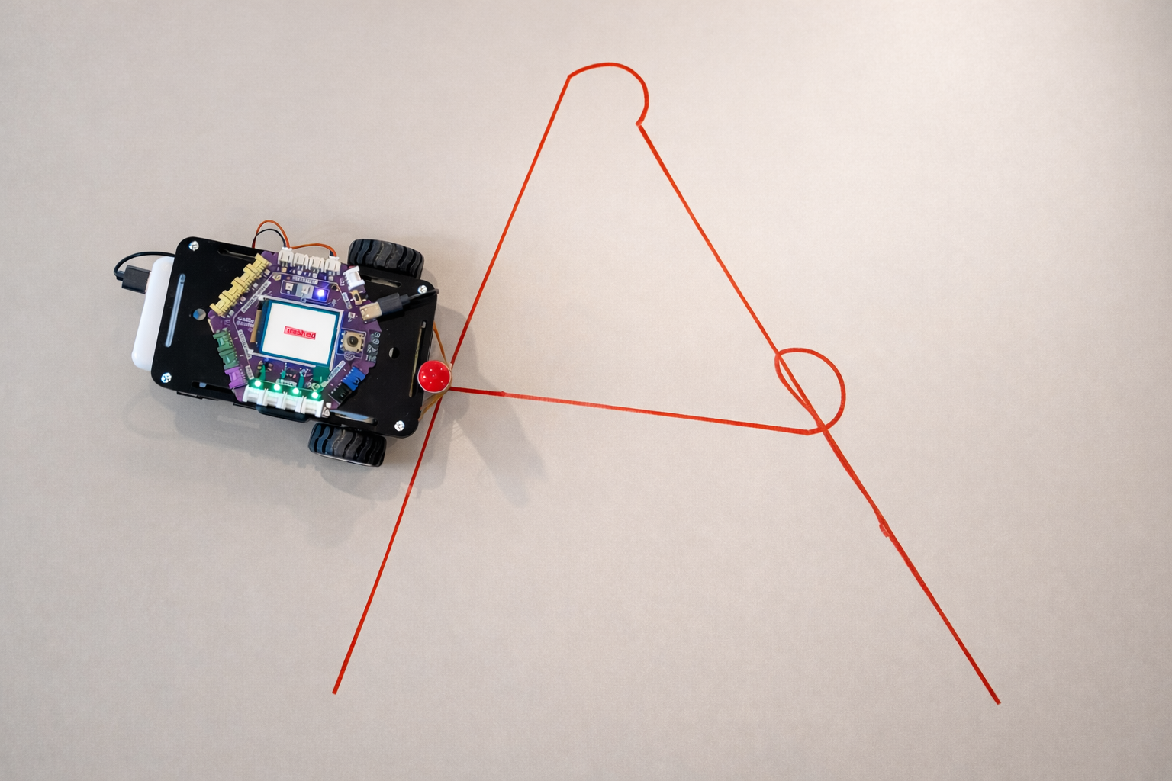
Example: The letter “A” drawn by a robot
Rules:
- Use straight lines only (curves not required)
- Use the fewest blocks possible — combine all repeated commands
- The letter must be recognizable
Checklist:
- Plan the movements for the letter
- Create and test the program
- Combine repeated blocks (no duplicates)
- Explain the program
Letter: . . . . . . . | Total blocks: . . . . . . .
Reflection:
1. What was the most challenging part of this chapter?
. . . . . . . . . . . . . . . . . . . . . . . . . . . . . . . . . . . . . . . . .
2. What was surprising about programming?
. . . . . . . . . . . . . . . . . . . . . . . . . . . . . . . . . . . . . . . . .

Troubleshooting
Robot configuration:
Problem | Solution
Robot not detected via USB | Make sure the USB cable supports data transfer (some cables are charge-only). Try a different USB port
Configuration fails | Refresh the webapp, reconnect USB, try again
Robot:
Problem | Solution
No response to the remote | Check that the robot is configured. Charge the battery, check the IR sensor
Recording will not start | Press * again — the screen should turn red during recording. Check that the purple LED strip above the screen is running; if not, power cycle. If still not working, reconfigure
Program forgotten | Click Upload in the webapp. Check whether the robot’s WiFi connection was lost
Webapp:
Problem | Solution
Blocks do not appear | Click the “Upload” button, verify the Robot ID, check WiFi
Run Code fails | Check the robot’s WiFi connection, try again
Webapp will not load | Check the internet connection, try a different browser

Vocabulary Reference
Term | Definition
Program | A sequence of instructions for a computer or robot
Block | A visual command in block-based programming
Debug | Finding and fixing errors in a program
Combined block | Repeated commands merged into one (e.g., forward(5))
Repeat block | A container that runs the program multiple times
Loop | A structure that repeats commands

