Code Test - Grid

In an n x n grid, find the largest product of 4 (four) consecutive numbers. In this context, consecutive numbers are next to each other either horizontally, vertically or diagonally.
In the following example, the largest product is found from row 18, column 15 to row 15, column 18 and equals 93168306.
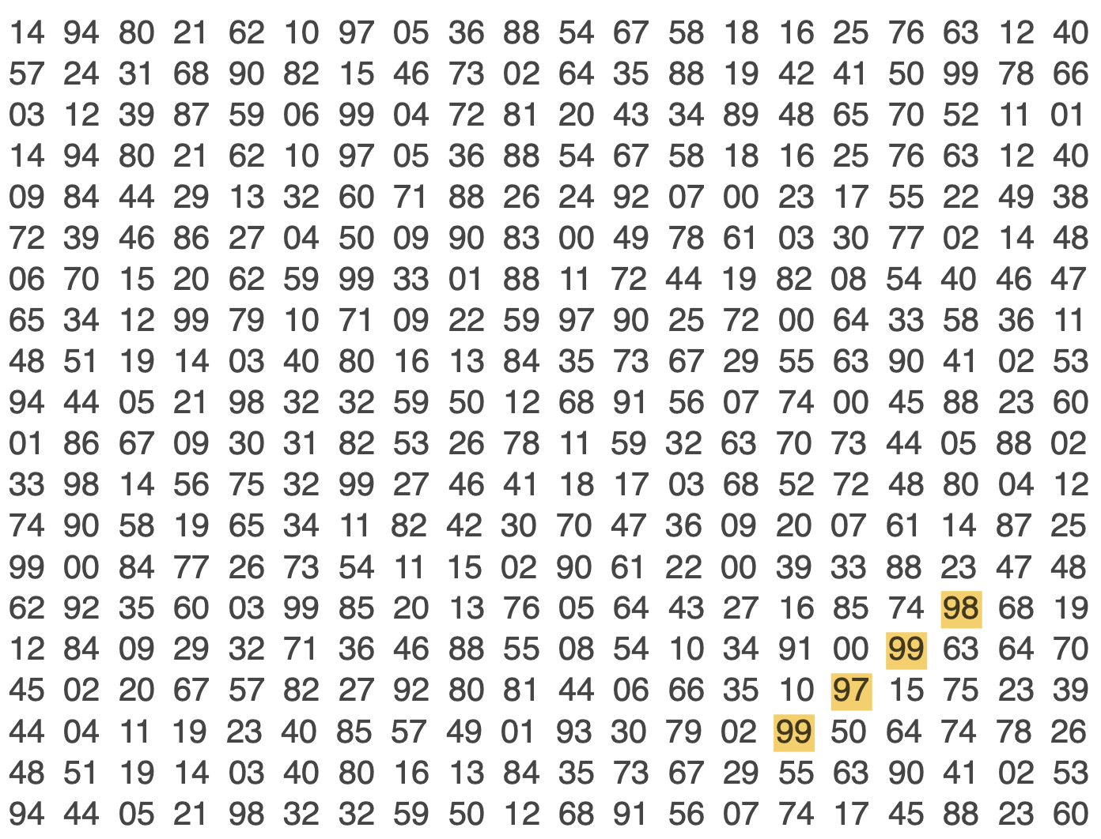

Given the file “grid.txt”, containing a 20 x 20 grid:
- Parse the file into a suitable format
- Find the largest product of 4 consecutive numbers and their indices

