Learning Goals

By the end of this activity, you will be able to:

* Interact with Hadoop using the command-line application.
* Copy files into and out of the Hadoop Distributed File System (HDFS).

Instructions

1.**Open a browser.**Open the browser by click on the browser icon on the top left of the screen.



**2. Download the Shakespeare.**We are going to download a text file to copy into HDFS. Enter the following link in the browser: <http://ocw.mit.edu/ans7870/6/6.006/s08/lecturenotes/files/t8.shakespeare.txt>

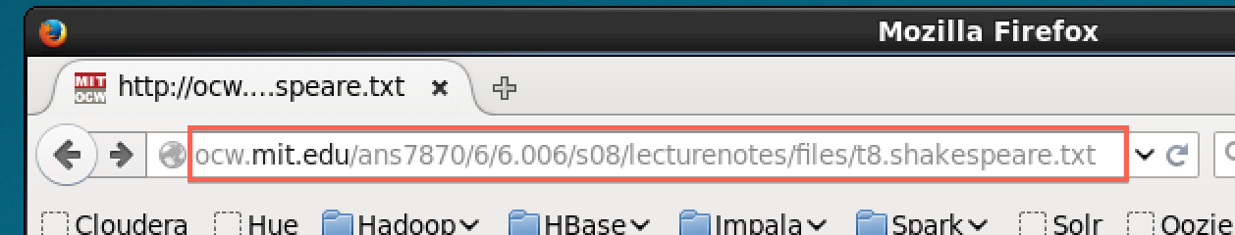

Once the page is loaded, click on the Open menu button.



Click on Save Page

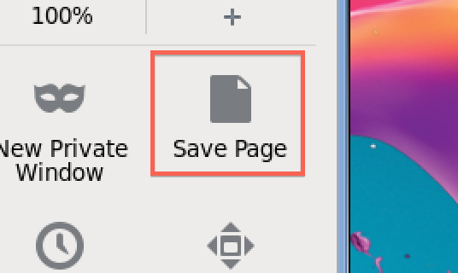

Change the output to words.txt and click Save.

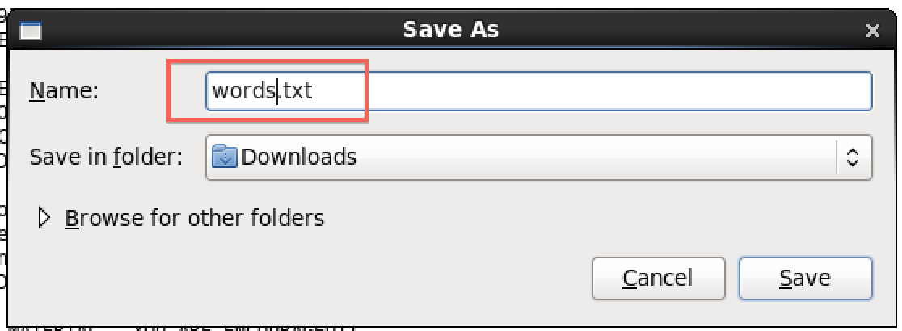

**2. Open a terminal shell.** Open a terminal shell by clicking on the square black box on the top left of the screen.



Run *cd Downloads* to change to the Downloads directory.

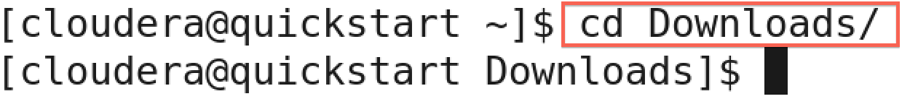

Run *ls* to see that words.txt was saved.

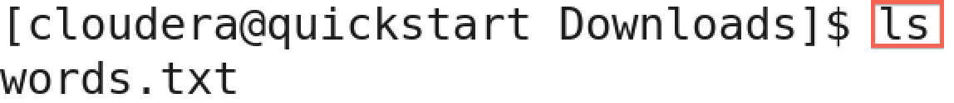

3. **Copy file to HDFS.** Run *hadoop fs –copyFromLocal words.txt* to copy the text file to HDFS.



4. **Verify file was copied to HDFS.** Run *hadoop fs –ls* to verify the file was copied to HDFS.

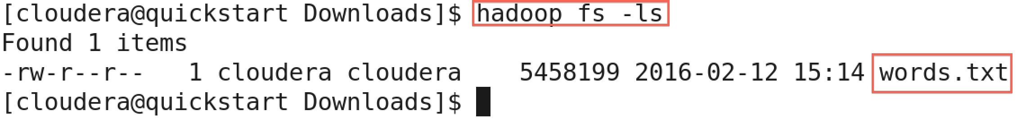

5. **Copy a file within HDFS**. You can make a copy of a file in HDFS. Run *hadoop fs -cp words.txt words2.txt* to make a copy of words.txt called words2.txt



We can see the new file by running *hadoop fs -ls*

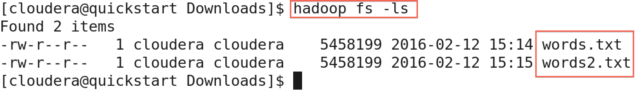

6. **Copy a file from HDFS.** We can also copy a file from HDFS to the local file system. Run *hadoop fs -copyToLocal words2.txt .*to copy words2.txt to the local directory.



Let's run *ls* to see that the file was copied to see that words2.txt is there.

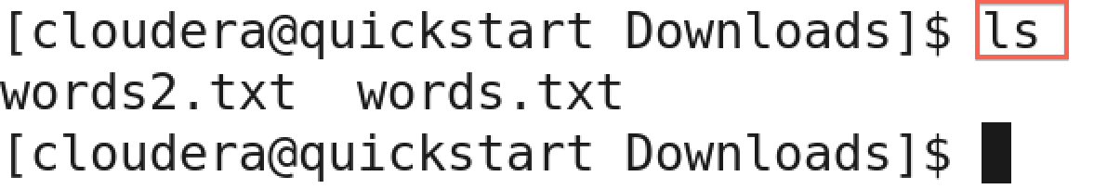

7. **Delete a file in HDFS.** Let's the delete words2.txt in HDFS. Run *hadoop fs -rm words2.txt*

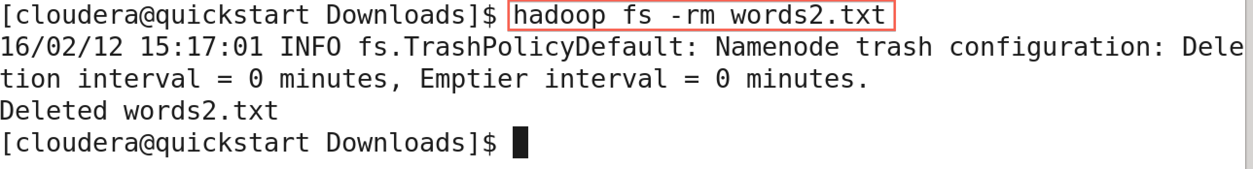

Run *hadoop fs -ls* to see that the file is gone.

